Name_______________ Date _______________
Geometry
Chapter Quiz
8.1-8.5

Polygons
Fill in the blank.

- A ___________ is a closed plane figure that is formed by line segments.
- All the sides of a _________ polygon are the same length and all the angles are the same measure.
- A __________ has three sides and three angles.
- A __________ has four sides and four angles.
- A pentagon has _____ sides and ______ angles.
- A __________ has six sides and six angles.
- An __________ has eight sides and eight angles.
- A decagon has ________ sides and ______angles.

Draw each of the following.
1. Opened Figure | 2. Closed Figure
3. Irregular Polygon | 4. Regular Polygon
5. Triangle | 6. Quadrilateral
7. Pentagon | 8. Hexagon
9. Octagon | 10. Decagon
Language of Geometry
Fill in the blank.

- A __________ is an exact location in space.
- A __________ is a flat surface that is endless in all directions.
- A __________ is a series of points in a straight path that is endless in all directions.
- A ________ ________ is part of a line between two endpoints.
- A ______ is part of a line and has one endpoint.
- An _________ is formed by two _____ with a common endpoint.
- The endpoint of an angle is its ________.

Draw each of the following.
1. Angle | 2. Ray
3. Line | 4. Line Segment
5. Point | 6. Plane

Angles and Lines
Fill in the blank.

- You can use a _________ to measure an angle in degrees.
- Place the center of the protractor at the ________ of the angle.
- A ________ angle is exactly 90°.
- An _______ angle is less than 90°.
- An _______ angle is greater than 90° but less than 180°.
- A ________ angle is exactly 180°.
- ____________ lines cross each other.
- ____________ lines intersect each other at right angles.
- ____________ lines are lines in the same plane that never intersect.

Draw each of the following.
1. Right angle | 2. Acute Angle
3. Obtuse Angle | 4. Parallel Lines
5. Intersecting Lines | 6. Perpendicular Lines

Triangles
Fill in the blank.

- An ____________ triangle has three sides that are the same length.
- An ____________ triangle has two sides that are the same length.
- A ____________ triangle has no sides that are the same length.
- A ________ triangle has one right angle.
- An ________ triangle has three acute angles.
- An _________ triangle has one obtuse angle.
- The sum of the angle measures of any triangle is ____°.

Draw each of the following.
1. Scalene Triangle | 2. Isosceles Triangle
3. Equilateral Triangle | 4. Right Triangle
5. Acute Triangle | 6. Obtuse Triangle

Answer True or False. Write out the entire word.

______1. A scalene triangle can also be called an obtuse triangle.
______2. A scalene triangle can also be called a right triangle.
______3. An equilateral triangle can also be called an acute triangle.
______4. An equilateral triangle can also be called an obtuse triangle.
Quadrilaterals
Fill in the blank.

- _____________ and ___________ are examples of quadrilaterals, or four sided figures.
- A ________ has four right angles and four equal sides.
- A ___________ has four right angles with opposite sides that are equal in length.
- A ______________ has opposite sides that are equal in length and opposite sides that are parallel.
- A ____________ has all sides equal in length with opposite sides parallel.
- A ___________ has only one pair of parallel sides.
- A ___________ has two pairs of equal adjacent sides.
- A ____________ connects two nonadjacent vertices of a polygon.
- The sum of the angle measures of any quadrilateral is ____°.

Draw each of the following.
1. Kite | 2. Rhombus
3. Rectangle | 4. Trapezoid
5. Square | 6. Parallelogram

Answer True or False. Write out the entire word.

______1. All rectangles are squares.
______2. Every trapezoid is a rhombus.
______3. All squares are rectangles.
Word Bank
Some may be used more than once and some may not be used at all.

kite | octagon | ten
rectangle | 240 | quadrilateral
parallel | rectangles | protractor
straight | parallelogram | 190
vertex | vertex | Fortier transform graph
square | five | right
equilateral | obtuse | acute
triangle | isosceles | line segment
fractal | diagonal | polygon
acute | hexagon | dot
perpendicular | 180 | trapezoid
angle | scalene | point
regular | right | intersecting
line | squares | ray
plane | 360 | obtuse
ten | five | six
decahedron | rays | rhombus

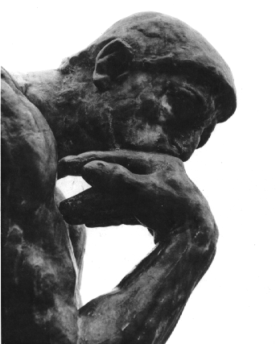 | “Never be afraid to sit awhile and think. “  ~Lorraine Hansberry,  A Raisin in the Sun

