Brooklyn Technical High School Per. _____ Date ________ Name ___________________________
Computer Repair, Upgrade, Management & Maintenance Marking Period 2 Review #1a Part 2 Lessons 14-22
75) What is the best method to bypass a BIOS password?
A) Remove CPW (Clear Password) motherboard jumper?
B) Use the Reset CMOS Settings options from the Windows boot menu
C) Remove the battery D) Erase CMOS settings Ans. ____

- What is the first thing you should check if the date or time on the computer starts lagging?
A) The CMOS date/time setting B) The operating system version
C) The BIOS version D) The CMOS battery Ans. ____

77) Which universal command is used to access a computer’s CMOS settings?
A) During the computer’s startup, press F1
B) During the computer’s startup, press the Delete key
C) During the computer’s startup, press CTRL-Shift-Esc
D) There is no universal way of accessing CMOS Ans. ____

78) Where does the motherboard store the keyboard controller support program?
A) DRAM B) RAM C) Hard drive D) ROM chip Ans. ____

79) Which of the following components is read-only?
A) DRAM B) RAM C) Hard disk D) ROM Ans. ____

80) Which chip acts as a clock to keep the current date and time?
A) CMOS B) RAM C) DVRAM D) ROM Ans. ____

81) Which chip is used to store information that describes specific device parameters?
A) BIOS B) ROM C) CMOS D) System BIOS Ans. ____

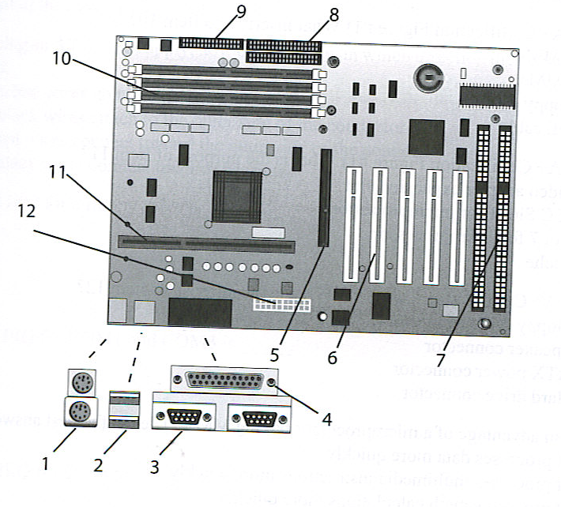
82) What is represented by item #7?
A) ISA B) PCI C) CNR D) AGP

83) What is represented by item #5?
A) ISA B) PCI C) CNR D) AGP

84) What is represented by item #6?
A) ISA B) PCI C) CNR D) AGP

85) A/an ________ is a number assigned that allows the adapter to bypass the microprocessor and communicate directly with RAM.
A) I/O address B) IRQ
C) DMA Channel D) USB Ans. ______

86) What does the small “h” following an I/O address indicate?
A) The address is a hot fix
B) The address is in hexadecimal
C) The I/O address is in the high memory area
D) The address is a high order bit Ans. ______

87) Which of the following terms describes a range of hexadecimal numbers assigned to a device that allows communication with the microprocessor?
A) I/O address B) Bus numbers C) DMAs D) IRQs Ans. ______

88) A new plug and play device has just been added, but it does not work. Which of the following might help?
A) Replace the device with a duplicate to see if hardware is at fault.
B) Reload the operating system C) Change CMOS settings
D) Check Device Manager for a resource conflict Ans. _____

89) What is shadowing?
A) When the operating system loads into the High Memory Area
B) When the contents of ROM chips are copied into RAM.
C) When the contents of RAM is pressed to a CD
D) The process of refreshing memory chips Ans. _____

90) What is the last step of POST?
A) CMOS setup is run if requested B) The DMA and interrupt controllers are checked
C) BIOS begins its search for an OS D) Some devices are setup to go into sleep mode to conserve electricity Ans. ______
91) What is a COM port?
A) A serial port B) A parallel port

C) A preset combination of I/O addresses and IRQ for a serial device
D) A preset combination of I/O addresses and IRQ for a parallel device Ans. _____
92) How does a device initiate a conversation with the CPU?
A) By using I/O addresses B) By using polling C) By using an IRQ
D) The device has to wait for the CPU to initiate all conversations Ans. _____

93) How does the CPU communicate with a device?
A) The CPU uses the device’s I/O addresses over the address bus.
B) The CPU uses the device’s I/O addresses over the data bus.
C) The CPU uses the device’s IRQ over that address bus.
D) The CPU uses the device’s IRQ over the data bus. Ans. _____

94) The Industry Standard Architecture (ISA) expansion slot came in two flavors. What were they?
A) 4.77 MHz and 7.16 MHz B) 8-bit and 16-bit C) 16-bit and 24-bit D) 8 MHz and 16MHz Ans. ____

95) Steve adds two expansion cards to his system: a sound card and a network card. The sound card uses I/O addresses 300-330 and IRQ5. The network card uses I/O addresses 310-340 and IRQ2. When he boots the computer, it completely locks up. What is most likely the problem?
A) The network card cannot use IRQ2; it’s a reserved IRQ. B) A buggy device driver.
C) IRQ conflict between the sound card and the network card.
D) I/O address conflict between the sound card and the network card. Ans. ____

96) Jill installs a new SCSI host adapter in a system. When she boots the system, a new text message appears and seems to cause the system to halt for a minute. Then the system continues, and Windows loads normally. The host adapter appears in her Device Manager and seems to be working. What could be the cause of the odd text message and slowdown at boot?
- The SCSI host adapter must have buggy drivers
- The SCSI host adapter must need drivers to load
- The SCSI host adapter has option ROM that loads BIOS for the card
- The SCSI host adapter has option RAM that has to search the hard drive for drivers before it can load

97) Jill decided to go retro and added a second floppy disk drive to her computer. She thinks she got it physically installed correctly, but, it doesn’t show up in Windows. Which of the following options will most likely lead Jill where she needs to go to resolve the issue?
A) Reboot the computer and press the F key on the keyboard twice. This signals that the computer has two floppy disks.
B) Reboot the computer and watch for instructions to enter the CMOS setup utility (for example, a message may say to press the DELETE key). Do what it says and go into CMOS setup.
C) In Windows, press the DELETE key twice to enter the CMOS setup utility.
D) IN Windows, go to START | RUN | and type “floppy”. Click OK to open the Floppy Disk Drive Setup Wizard.

98) Henry bought a new card for capturing television on his computer. When he finished going through the packaging, however, he found no driver disc, only an application disc for setting up the TV capture software. After installing the card and software, it all works flawlessly. What’s the most likely explanation?
A) The device doesn’t need BIOS, so there’s no need for a driver disc
B) The device has an option ROM that loads BIOS, so there’s no need for a driver disc
C) Windows supports TV capture cards out of the box, so there’s no need for a driver disc
D) The manufacturer made a mistake and didn’t include everything needed to set up the device.

99) Davos finds that a disgruntled former employee decided to sabotage her computer when she left by putting a password in CMOS that stops the computer from booting. What can Davos do to solve the problem?
Davos should boot the computer holding the left SHIFT key. This will clear the CMOS configuration.
Davos should try various combinations of the former employee’s name. The vast majority of people use their name or initials for CMOS passwords.
Davos should find the CMOS clear jumper on the motherboard. Then he can boot the computer with a shunt on the jumper to clear the CMOS information.
Davos should find a replacement motherboard. Unless he knows the CMOS password, there’s nothing he can do.

100) Richard, over in the Sales department, went wild in CMOS and made a bunch of changes that he thought would optimize his PC. Now most of his PC doesn’t work. He can boot, but only to CMOS, not into Windows. Which of the following tech call answers would most likely get him up and running again?
Reboot the computer about three times. That’ll clear the CMOS and get you up and running
- Open up the computer and find the CMOS clear jumper. Remove a shunt from somewhere on the motherboard and put it on the CMOS clear jumper. Reboot and then put the shunt back where you got it. Reboot, and you should be up and running in no time.
- Boot into CMOS setup program and then find the option to load a plug-and-play operating system. Make sure it’s set to ON. Save and exit CMOS; boot normally into Windows. You should be up and running in no time.
- Boot into the CMOS setup program and find the option to load Optimized Default settings. Save and exit CMOS; boot normally into Windows. You should be up and running in no time.

101) Which of the following statements about the expansion bus is true?
A) The expansion bus runs at the speed of the system clock
B) The expansion bus crystal sets the speed of the expansion bus
C) The CPU communicates with RAM via the expansion bus
D) The Front Side Bus is another name for the expansion bus

102)AGP stands for
A) Accelerated Graphics Port, PCI
B) Alternative Graphics Port, PCI
C) Accelerated Graphics Port, ISA
D) Alternative Graphics Port, ISA
103)Which one of the following devices is likely to still use DMA?
A) USB flash drive B) Floppy Drive C) Hard Drive D) CD-ROM Drive

104)Which variation of the PCI bus was specifically designed for laptops?
A) PCI-X B) PCIe C) Mini-PCI D) AGP

105)After the POST is completed, the hardware settings it finds will be compared with those stored in _______. Any differences will be displayed as POST error codes on the display and/or beeps.
A) SYSTEM.INI B) CMOS C) CONFIG.SYS D) ROM

106)A procedure that copies the Bios code from ROM into RAM when the computer boots is called __. This is done because the CPU can access RAM much quicker than sending the request over the bus to access the information in ROM?
A) Switching B) Mirroring C) Striping D) Shadowing

107)Which of the following is not motherboard form factor?
A) AT B) ATI C) ATX D) Flex ATX

108)Of the following, which motherboard design style is the most popular?
A) ATX B) AT C) Baby AT D) NLX ____________

109)Which motherboard form factor places expansion slots on a special riser card and is used in low-profile PCs?
A) AT B) Baby AT C) ATX D) NLX

110)Of the following which is the most common motherboard form factor used with today’s computers?
A) AT B) Baby AT C) NLX D) ATX

111)Where is hard disk information stored (Such as type, number of cylinders, heads, tracks per sector, etc.)?
A) BOOT.INI B) CMOS C) RAM D) SYSTEM.INI

112)How many IDE controllers are typically built into an ATX motherboard?
A) 2 B) 4 C) 1 D) 8

113)What is the first program to run during a system boot sequence?
A) Config.sys D) BIOS C) Autoexec.bat D) Command.com

114)Which device usually contains its own BIOS on Option ROM?
A) Video Adapter B) DRAM C) Diskette Drive D) Hard Drive

115)What is modified when changing the system start up boot sequence?
A) Autoexe.bat B) BIOS/CMOS C) Command.com D) config.sys

116) Which of the following form factors is most dominant in the PC industry?
A) AT B) ATX C) BTX D) CTX

117) Which of the following form factors offers the best cooling?
A) AT B) ATX C) BTX D) CTX

118) On Intel based motherboards, which chip enables the CPU to interact with RAM?
A) Memorybridge B) Northbridge C) Southbridge D) Super I/O

119) Brian bought a new motherboard that advertised support for eight USB ports. When he pulled the motherboard out of the box, however, he found that it only had four USB ports! What’s likely the issue here?
A) The extra four USB ports will connect to the front of the case or via a dongle to an expansion slot
B) The extra four USB require an add-on expansion card.
C) The Firewire port will have a splitter that makes it four USB ports
D) The motherboard chipset might support eight USB ports, but the manufacturer only included four ports

120) Martin bought a new motherboard to replace his older ATX motherboard. As he left the shop, the tech on duty called after him, “Check your standouts!” What could the tech have meant?
A) Standouts are the connectors on the motherboard for the front panel buttons. Like the on/off switch and reset button.
B) Standouts are the metal edges on some cases that aren’t rolled
C) Standouts are the metal connectors that attach to the motherboard case.
D) Standouts are the dongles that enable a motherboard to support more than 4 USB ports.

121)When testing an AC outlet in the United States, what voltage should the multimeter show
between the hot and ground wires?
A) 120 Volts B) 60 Volts C) 0 Volts D) -120 Volts

122)What voltages does the ATX 12V P1 connector provide for the motherboard?
A) 3.3V, 5V B) 3.3V, 12V C) 5V, 12V D) 3.3V, 5V, 12V

123)What sort of power connector does a floppy disk drive typically use?
A) Molex B) Mini C) Sub-mini D) Micro

124)Joachim ordered a new power supply but was surprised when it arrived because it had an extra, 4-wire connector. What is that connector?
A) P2 connector for plugging in auxiliary components
B) P3 connector for plugging in case fans
C) P4 connector for plugging into Pentium 4 and later motherboards
D) Aux connector for plugging into a secondary power supply

125)What should you keep in mind when testing DC connectors?
A) DC has polarity. The red lead should always touch the hot wire; the black lead should always touch the ground wire.
B) DC has polarity. The red lead should always touch the ground wire; the black lead should always touch the hot wire.
C) DC has no polarity, so you can touch the red lead to either hot or ground
D) DC has no polarity, so you can touch the black lead to either the hot or neutral, but not to ground.

126)What voltages should the two hot wires on a Molex connector read?
A) Red = 3.3 V; Yellow = 5V B) Red = 5V; Yellow = 12V
C) Red = 12V; Yellow = 5V D) Red = 5V; Yellow = 3.3V

127A PCs power supply provides DC power in what standard configuration?
A) Two primary voltage rails, 12 Volts, and 5 Volts, and an auxiliary 3.3 volt connector
B) Three primary voltage rails, one each for 12-volt, 5-volt and 3.3 volt connector
C) One primary DC voltage rail for 12-volt, 5-volt, and 3.3-volt connectors
D) One voltage rail with a 12-volt connector for the motherboard, a second voltage rail with a 12-volt connector for the CPU, and a third voltage rail for the 5-volt and 3.3-volt connectors.

128)What feature of the ATX systems prevents a user from turning off a system before the operating system has been shut down?
A) Motherboard power connector B) CMOS setup C) Sleep mode D) soft power

129) Which of the following is most likely to be found connected to a min-DIN connector?
A) Printer B) Phone C) Monitor D) Keyboard

130) Where are you least likely to see a USB B connector?
A) On a PC B) On a printer C) On a scanner D) On a camera

131) What are USB mini style connectors used for?
A) On a scanner B) On a printer C) On a camera D) On a computer
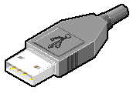
132) What is the IEEE specification for Firewire?
A) 1284 B) 1394 C) 586 D) 484

133) Identify the connector
A) Firewire B) USB C) DB D) RJ E) VGA

134) Identify the connector
A) Firewire B) USB C) DB D) RJ E) VGA

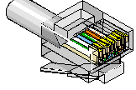
135) Identify the connector
A) Firewire B) USB C) DB D) RJ E) VGA
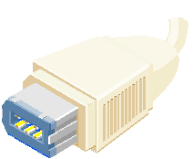

136) Identify the connector
A) Firewire B) USB C) DB D) RJ E) VGA

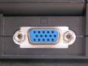

137) Identify the connector
A) Firewire B) USB C) DB D) RJ E) VGA

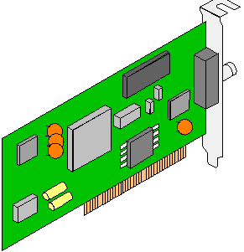
138) Identify the picture
A) RAM B) CPU
C) BIOS D) Motherboard
E) Expansion Card

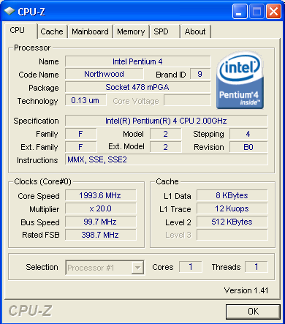
You get a computer to work on that is lagging. You want some stats on this machine, so you run CPU-Z which displays the above dialog box. Answer the following questions based on that dialog box?

139) What kind of CPU does this computer have?
A) AMD Athlon B) Pentium Dual Core C) Pentium Core Duo Quad Core D) Pentium 4 E) Pentium

140) What is the speed of the processor?
A) 2 MHz B) 2GHz C) 100MHz D) 2000GHz E) 400MHz

141) What is the speed of the Front Side Bus?
A) 100 MHz B) 20 C) 1993.6 MHz D) 2GHz E) 997 Hz

142) You are asked to upgrade a computer’s memory (with DDR2 SDRAM)? Of the following which is most important?
A) The amount of RAM you are going to add.
B) The amount of SRAM you are going to add.
C) The type of RAM you are going to add
D) The number of sticks of RAM you are going to add.
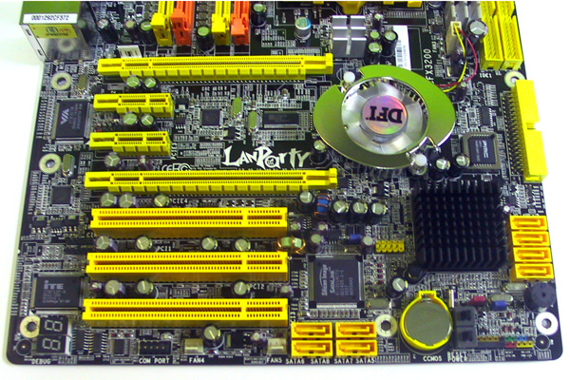
143) At right is a motherboard that has 2 PCI Express x16 slots with 2 PCI Express x1 slots in between them and 3 PCI slots toward the bottom. What would be a good use of the fastest PCI slot, namely the PCI Express x16 slot.
A) Graphics card B) Sound Card
C) USB Card D) Network Card

144) What makes the motherboard below an ATX motherboard?
A) It doesn’t have any ISA slots
B) It has an odd number of RAM slots
C) The processor is not in the way of the expansion slots.
D) It has an AGP slot

145) Which letter represents the motherboard power connector?
A) A B) B C) C D) D E) E

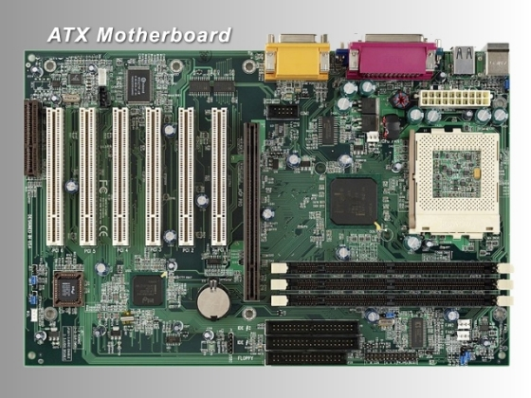

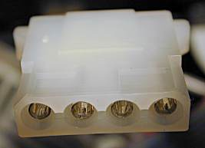
146) Identify the picture at right?
A) Mini Molex B)Molex C) ATX P1 D) ATX P4

147) In a Surge Protector, what diverts the extra voltage to ground?
A) Hot Wire B) MOVs C) Fuse D) Neutral Wire

148) What is the purpose of a UPS (Uninterruptible Power Supply)
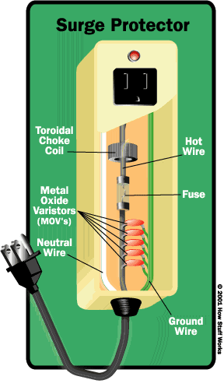
A) Provide battery power when you take your laptop on the road
B) Provide generator power for a couple of days
C) It acts as a power strip allowing you to connect multiple devices
D) It allows you enough time to save and/or backup your files in case of power failure.

