Brooklyn Technical High School Per. _____ Date ________ Name ___________________________
Computer Repair, Upgrade, Management & Maintenance Marking Period 2 Review #1a Part 1 Lessons 14-22

- What power supply connector most commonly attaches to a 3.5-inch floppy drive?
A) Molex B) Submini C) Mini D) P1 Ans. ____

- Which of the following connectors would you not see on an AT-style power supply?
A) P1 B) P8 C) P9 D) Molex Ans. ____

- Which of the following is least likely to cause a PC to overheat?
A) Missing slot covers B) Broken room air conditioner C) Dead power supply fan
D) Replacing a 250-watt power supply with a 300-watt power supply Ans.____

- What is an electrical spike?
A) Unexpected reduction in power B) Steady, and consistent increase in power
C) Power alternating from AC to DC D) Short, unexpected, and sudden increase in power Ans. ____

- What rule should you follow when inserting P8 and P9 into a motherboard?
A) Orient the connectors so that the black wires go to the center.
B) Orient the connectors so that the black wires go on the outside.
C) Remember to “face” them correctly
D) Skip the center pin on the motherboard connection in order to provide proper grounding Ans. ____

- ATX power supplies provide all of the following voltages except
A) 2.0 V B) 3.3 V C) 5.0 V D) 12 V Ans. ____

- Which of the following best describes soft power?
A) Soft power enables AT systems to handle power management

B) Soft power enables ATX systems to handle power management
C) Soft power enables power supplies to deliver smooth DC voltage
D) Soft power enables techs to swap out components safely while the PC is on. Ans. ____

- George turns on his PC and nothing happens. The drives do not spin, the LEDs on the case do not light up, and the fans do not light up, and the fans do not turn on. What should he do first?
A) Check the AC power source first to make sure the PC is plugged in.
B) Unplug all the power to devices except for the motherboard, and turn the PC on again to try to isolate the problem.
C) Unplug the motherboard power connector and turn the PC on again to try to isolate the problem
D) Remove the power supply and check the internal fuse. Ans. ____

- Floppy Drives use DMA channel ______
A) 2 B) 3 C) 4 D) 5 Ans. ____

- The old AT power supplies use _____ to provide power to the motherboard
A) A P1 connector B) P8 and P9 connectors C) A Molex connector D) A DIN connector Ans. ____

- Which power device would be best to attach to your computer if you were having UNDERVOLTAGE power problems?
A) Surge protector B) UPS C) Line conditioner D) SPS Ans. ____

- Which power problem is an over-voltage condition that lasts for up to several seconds?
A) Spike B) Surge C) Sag D) Blackout Ans. ____

- You smell smoke and notice that a fire has started inside your computer. The fire extinguisher you reach for should have what rating?
A) Class A B) Class B C) Class C D) Class D Ans. ____

- What type of fire extinguisher should be used with electrical fires?
A) Type A B) Type B C) Type C D) Type D Ans. ____

- Which of the following provides constant power to the computer through a battery?
A) Surge suppressor B) SPS C) UPS D) Line conditioner Ans. ____

- When checking a wall outlet for the correct output, what outlet slot is considered “hot”?
A) The largest vertical slot B) The smallest vertical slot
C) The round slot D) Both vertical slots Ans. ____

- When checking a wall outlet in the United States, one meter lead is inserted into the neutral slot and another lead is inserted into the hot slot. What meter reading would you expect to show?
A) 0 volts B) 5 volts C) 120 volts D) 220 volts Ans. ____

- What color code are the power supply’s ground wires?
A) Red B) Yellow C) Black D) Orange Ans. ____

- What device converts AC to DC, provides cooling, and provides DC power to peripheral devices and the motherboard?
A) CPU B) Power Supply C) Fan D) AC Line conditioner Ans. ____

- The single greatest problem with AT and Baby AT motherboards was the lack of ____?
A) external ports B) internal ports C) expansion slots D) physical ports Ans. ____

- A standby UPS removes the battery from the AC circuit until the AC power drops below ____ V?
A) ~80-90 Volts B) ~140-150 Volts C) ~110-120 Volts D) ~180-190 Volts Ans. ____

- The UL 497A rating of surge suppression is for the ____
A) Keyboard B) motherboard C) monitor D) modem Ans. ____

- The standard IRQ for a floppy drive is _____
A) 4 B) 6 C) 3 D) 2 Ans. ___

- The ____ option enables a user to manage the booting devices and their order.
A) Boot Up Floppy Seek B) Swap Floppy Device C) Boot Sequence CMOS D) First Boot Device Ans. ___

- Missing slot covers on a computer can cause ______
A) overheating B) power surges C) electromagnetic interference
D) An incomplete path for ESD Ans. ___

- In the graphic shown, what is the circled area?
A) The power plug B) The system fan C) The voltage selector D) None of the above Ans. ___
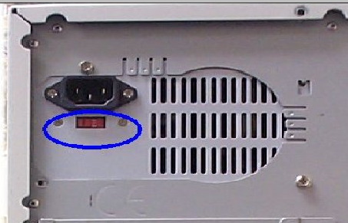

- Which type of motherboard uses the soft power switch?
A) AT B) ATX C) EISA D) XT
Ans. _____

- Which connector from the power supply usually connects with a PATA hard drive?
A) Mini-molex B) P8 C) P9 D) Molex Ans. ___

- Which type of connector from the power supply usually provides power for a 3.5 inch floppy drive?
A) Mini-molex B) P8 C) P9 D) Molex Ans. ___

- Which piece of equipment will protect a computer from a power sag?
A) A grounded AC outlet B) A UPS C) A surge suppressor D) a UL-1449 rated outlet Ans. ___

- Larry’s PC runs fine but the fan in the power supply is not turning. Which of the following should he do?
A) Check the power switch B) Replace the power supply C) Check the fuse in the power supply
D) Replace the fan in the power supply Ans. ___

- What piece of equipment will protect a computer from power spikes?
A) A power strip B) A power supply C) A surge suppressor D) A UL-1449 rated outlet Ans. ___

- Most power supplies used in PCs have large ______ which absorb most electrical spikes
A) resistors B) capacitors C) potentiometers D) coils Ans. ___

- A power supply of +12V DC output has dropped to +11.5 V DC. You should:
A) replace the power supply with a lower wattage unit

B) do nothing as the slight drop is acceptable
C) replace the power supply with a higher wattage unit
D) check the capacitors Ans. ___

- What would a multimeter be used to measure?
A) CD-ROM data B) Power supply voltage C) Floppy Drive Speed D) RAID controller synchronization

- What should you do if the fan in the power supply stops working?
A) Replace the fan B) Replace the case C) Lubricate the fan D) Replace the bearing
E) Replace the power supply Ans. ____

- Which motherboard type allows you to turn off the computer via software?
A) AT B) ATX C) MCA D) VESA Ans. ____

- You are a technician. The sales director’s computer shuts down and reboots unexpectedly. Which of the following could be a cause of this problem?
A) The BIOS is set to reboot automatically everyday
B) His external SCSI CD-RW is using too much power
C) The CMOS is configured to cycle power at a certain time
D) The power supply is not providing enough power to the system Ans. ____

- What are the benefits of cleaning the inside of the computer?
A) Increased connectivity speed B) Provide better system cooling C) Increase CPU speed
D) Increase the value of your computer Ans. ____

- What is a major difference between AT and ATX motherboards?
A) BNC connector B) Soft power switch C) serial connections D) parallel connections Ans. ____

- Which of the following is an FRU?
A) ROM B) ZIFF socket C) CMOS D) Case E) RAM Ans. ____

- Why should you have slot covers installed in a computer?
A) Keep dust out B) Protect ESD C) CPU warmer D) Prevent installing unnecessary components Ans. ____
- Uninterruptible power supply is also known as?
A) Surge strip B) Power heater C) Battery backup D) Circuit Breaker Ans. ____

- Due to the possibility of brownouts, which of the following items will help electronic equipment perform in an uninterrupted manner?
A) Power strip B) extension cord C) surge suppressor D) Battery backup devices Ans. ____

- Which tools can be used to clean the inside of a computer?
A) Magnet B) Canned air C) SIMM extractor D) Ammonia based cleaner Ans. ____

- A customer calls and says that his computer will not boot. You have determined that no sounds are coming from the system and none of the lights are on. What should you take to the customer’s house to fix the problem?
A) CPU B) Modem C) Video card D) Power Supply Ans. ____

- What causes chip creep?
A) Thermal expansion and contraction B) Overheating of chips due to electrical shorts
C) Chips that don’t communicate with other chips D) Chips memory that is incompatible with the motherboard

Ans. ____
- The fan in the power supply on the manager’s computer stopped working but the computer is still running. What is the proper procedure to repair the computer?
A) Replace the fan B) Replace the transformer C) Lubricate the fan with oil D) Replace the power supply
E) No action needs to be taken. There would still e a sufficient number of other fans in the system Ans. ____

- The managing director at Certkiller has a PC that is NOT protected with a UPS. What problem can occur if a power failure occurs and the power is restored?
A) ROM needs to be programmed B) There is a danger of a power surge
C) The CMOS RAM has a battery failure D) The motherboard switch needs to be reset Ans. ____

- The CD-ROM does not work on your system. You suspect that the CD-ROM is not getting the proper voltage. What should you use to test the power connector?
A) Multimeter B) Continuity tester C) Loopback tester D) High voltage proble Ans. ____

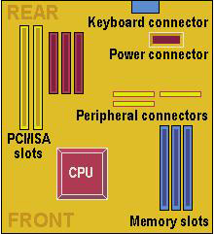
- What is the first step in diagnosing a completely dead computer that was working fine the day before?
A) Test the power supply B) Replace the CMOS battery C) Check the AC outlet for voltage Ans. ____
D) Reset the hard drive cable controller

- If the computer suddenly restarts and lights flicker, which event probably occurred?
A) Electrical sag B) Electrical surge C) prolonged power outage
D) power overload and circuit shutdown

- What motherboard form factor is shown?
A) NLX B) LPX C) Baby AT D) ATX Ans. ____

Which bus signal allows a device to send data directly to a computer’s memory, bypassing the CPU?
A) I/O addresses B) DMA address C) Clock addresses
D) Interrupt request (IRQ) Ans. ____

- George wants the boot sequence of his computer to be A, C, SCSI. Where does he go to change the boot sequence?
A) BIOS B) He can’t change it C) My Computer D) CMOS Setup
Ans. ____
- Which of the following expansion bus types is used exclusively for graphics cards?
A) ISA B) AGP C) PCI D) CardBus Ans. ____

- Which bus signal line allows a device to request the processor’s attention?
A) I/O address B) DMA address lines C) Clock address lines D) Interrupt request (IRQ) address lines
Ans. ____
- At, approximately, what speed does an ISA memory adapter in a Pentium III 300MHz run?
A) 10MHz B) 33MHz C) 66MHz D) 133MHz Ans. _____

- The standard IRQ for a floppy drive is _______
A) 4 B) 6 C) 3 D) 2 Ans. _____

- What DMA channel is used by the floppy drive?
A) 0 B) 1 C) 2 D) 4 Ans. _____

- How many DMA channels are available in today’s computers?
A) 1 B) 3 C) 7 D) 15 Ans. ______

- How many IRQs are available on a computer today?
A) 3 B) 7 C) 15 D) 23 Ans. _____

- Taylor thinks his CMOS battery is dead. Which of the following would best verify this?
A) Reset the CMOS settings B) Clear CMOS and restore
C) Reboot and see if the CMOS data is still there D) Use a voltmeter to test the battery Ans. ____

- Which is not a common BIOS software brand?
A) American Megatrends B) Western Digital C) Phoenix Technologies D) Award Software
Ans. ____
- What does BIOS provide for the computer? (Choose the best answer.)
- BIOS provides the physical interface for various devices, such as the serial and parallel ports
- BIOS provides the programming that enables the CPU to communicate with other hardware
- BIOS provides memory space for applications to load into from the hard drive
- BIOS provides a memory space for applications to load into from the main system RAM Ans. ____

- Jill boots up an older Pentium system that has been the cause of several user complaints at the office. The system powers up and starts to run through POST, but then stops. The screen displays a “CMOS configuration mismatch” error? What is the cause of this problem?
- Dying CMOS battery B) Bad CPU C) Bad RAM D) Corrupt system BIOS Ans. ____

What is the correct boot sequence for a PC?
A) CPU, POST, Power Good, Boot Loader, Operating System
B) POST, Power Good, CPU, Boot Loader, Operating System
C) Power Good, Boot loader, CPU, POST, Operation System
D) CPU, Power Good, POST, Boot loader, Operating System Ans. ____

68) Which of the following most accurately describes the relationship between BIOS and hardware?
A) All hardware needs BIOS
B) All hardware that attaches to the motherboard via ribbon cables needs BIOS
C) All hardware built into the motherboard needs BIOS
D) Some hardware devices need BIOS Ans. ____

69) What does BIOS stand for?
Bootable Integrated Output System B) Basic Input/Output System
C) Bootable Initial Operating System D) Basic Instruction Operating System Ans. ____

    - Which of the following components initializes first when a computer turns on?
A) RAM B) ROM BIOS C) Hard Drive D) CMOS Ans. ____

71) What component allows the computer’s current configuration to remain in CMOS when the computer is powered off?
A) A battery B) ROM BIOS C) CPU D) Power Supply Ans. ____

- What component holds POST?
A) CMOS B) Hard Drive C) ROM BIOS D) CD-ROM Ans. ____

- A type of BIOS that can be updated electronically is ________
A) CMOS B) WRAM C) WROM D) Flash BIOS Ans. ____

- A computer’s CMOS settings are set to defaults. You suspect that someone erased or reset them to the defaults, but you are not sure. You reconfigure the CMOS settings and save them. What is your next step? (Select the best answer)
A) Check the hard drive power connection
B) Check the BIOS version to see if it is the latest
C) Reboot the computer to see if the changes remain
D) Check the computer’s logon script to see if it has the command to reset the BIOS settings. Ans. ____

Lab Analysis Test
John has a system that runs at 2.4 GHz and uses a 64 MB AGP video card. He uses Windows XP Professional and wants to try its multiple-monitor support feature. Can he add another AGP video card? Why or why not?

Steve has a legacy ISA sound card on his system. The sound card uses I/O addresses 300-330 and IRQ 5. He installs a NIC (Network Interface Card) and restarts the PC, which proceeds to lock up completely. What is most likely the problem?

Ellen opened her computer case and installed a PCI card to add a second parallel port for a printer. What IRQ will this card most likely use?

John tried to use an old (but working) AT power supply he had lying around to replace a dead ATX power supply
for his system, but he couldn’t plug it in. Why?

Keith bought a new fancy case for his system. He removed the motherboard from his old case, but discovered it wouldn’t fit in the new one. What did Keith forget to check?

After Joe reassembled his PC and turned it on, he noticed that the green LED and the disk active LED never light up, but everything seems to work OK. What is the problem?

John wants to upgrade his system by replacing his CPU. His friend has an extra Pentium 4 CPU. John’s current CPU is a Pentium III. Will this work? Why or why not?

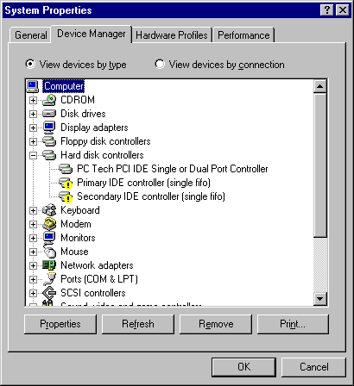
A black exclamation point (!) on a yellow field indicates the device is in a problem state. Note that a device that is in a problem state can be functioning.

You’ve installed a NIC and a PCI FireWire controller card on Susan’s Windows XP Professional system. The system starts up fine, but when you check Device Manager, you see a yellow circle with a black exclamation mark beside the NIC icon. What is the problem?

Key Term Quiz:
Use the following vocabulary terms to complete the following sentences.
1) AGP
2) DMA
3) expansion card
4) IEEE 1394 (FireWire)
5) I/O address
6) IRQ
7) PCI
8) ISA
9) system resources
10) USB
11) Memory address

- Most modern motherboards provide several______________ slots

- Modern video cards can use the ___________ slot

- The LPT1 port generally uses the default setting of 378 for its ________________

- COM1 and COM3 share the same ______________ of 4

- It’s common for modern systems to provide at least two external ____________ ports for adding peripheral devices.

Do Internet research on your computer model and answer the following questions:

What is the name of your motherboard manufacturer?

What type of chipset do you have on your motherboard?

The Northbridge and Southbridge are components of a motherboard’s

During installation of the motherboard, why should you need to place expansion cards in their original slots?

Why should you sketch the cable and wire connections between the motherboard and the case?

When choosing a motherboard, what should be your first consideration?
A) Form factor B) Desired CPU C) Price D) Feature set

The first step in preparing the motherboard to go in the case is to
A) add the CPU B) set the jumpers
C) add the fan D) install the RAM

Name 4 motherboard form factors:

Name 10 components on a motherboard:

Name three manufacturers of motherboard chipsets:

Why don’t all buses on a motherboard operate at the same speed?

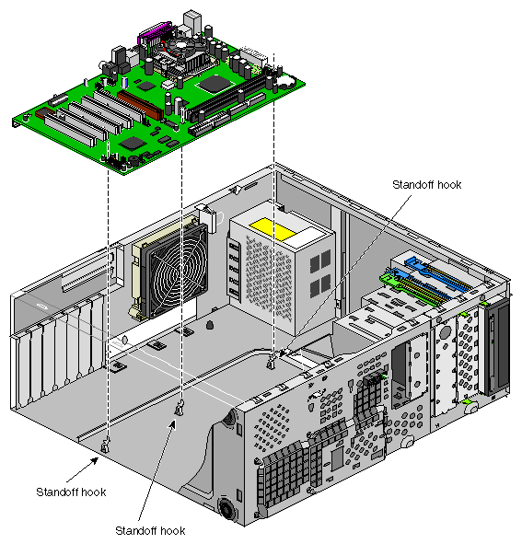

Key Term Quiz:
Use the following vocabulary terms to complete the following sentences.
AT
ATX
Chipset
Motherboard manual
P1 Power Connector
P8/P9 power connector

- The power supplies for modern ATX motherboards connect using the ________________

- To check the technical specifications of a motherboard, consult its ________________

- PS/2 connectors are found on ___________ motherboards

D) DIN (not mini) are found on _________ motherboards

On your power supply, locate the watts rating. What is the wattage rating of your power supply?

Use the following table to calculate the overall wattage needed for your system. Add the numbers for each component and determine the wattage requirement. Go to www.tigerdirect.com and locate an appropriate power supply for this system.

Component | Wattage Requirement
AGP Video Card | 50W
PCI Card | 10W
10/100 NIC | 4W
SCSI Controller PCI | 20W
Floppy Drive | 5W
7200 RPM IDE hard drive | 20W
10,000 rpm SCSI drive | 40W
CD\DVD media drive | 25W
Case/CPU fans | 3W each
Motherboard(without CPU or RAM) | 40W
RAM | 10W per 128MB
Pentium 4 Processor | 70W

Describe the following types of power conditions and the damage they can cause

Power Spike

Brownout

Blackout

Describe the following types of power protection equipment

Surge Suppressor
UPS

Standby UPS

Lab Analysis Test:
Athena lives in an area where the power is often interrupted. She bought a good surge protector strip, but that doesn’t seem to help. What does she need to prevent her system from shutting down unexpectedly?

Key Term Quiz:
Use the following vocabulary terms to complete the following sentences.
12V
5V
Molex Connector
P1
P4
P8/P9
Power Spikes
Power Supply
UPS

1) The AT form factor power supply plugs into the motherboard using the ____________ connectors

2) PC devices with motors, such as hard drives, usually require ________ of power

3) Hard drives and CD-ROMs connect to the power supply with a ____________

4) A surge protector prevents damage from ____________ in the voltage

5) Pentium 4 motherboards have both _________ and __________ power connectors.

Open up Device Manager and view the Input/Output (I/O) settings on your computer.

What is the address for the keyboard?

What is the address of the printer port (LPT1)?

What is the address of the system speaker?

What is the address of the communications port 1 (COM1)?

What is the address for the system timer?

Look up the IRQ settings on your computer

What device is using IRQ 6, if any?

