Research Questions #2 MP3:
1) The System, Mouse and Display applets are found in _________
A) Disk Management B) Control Panel C) FAT D) Device Manager

2) The Start button and System Tray are parts of the Windows ___________
A) Taskbar B) Toolbar C) Quick Launch D) Start Menu

3) If your hard drive is running out of space, you should use the ______ utility
A) Windows Update B) Scandisk C) Scanreg D) Defrag E) Disk Cleanup

4) To create a FAT or NTFS file structure, you must ________ the hard drive
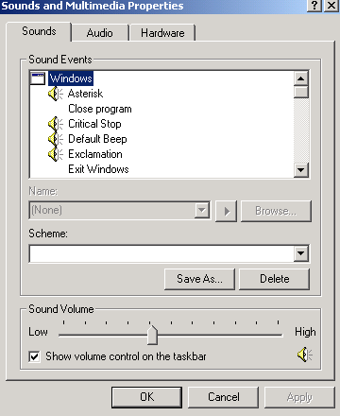
A) Format B) Partition C) Defrag D) Multiboot

5) The ________ tool enables you to partition and format drives in Windows 2000.
A) FDISK B) Disk Management C) System Information
D) Device Manager

6) Which Control applet is shown at right?
A) Speech applet B) Keyboard properties
C) Sounds and Multimedia Properties D) Accessibility Options

7) What file on the Windows 2000 CD allows you to make the 4 boot disks?
A) MAKEBOOT.EXE B) MAKEBT32.EXE
C) BOOTFLOP.EXE D) BOOTDISK.EXE

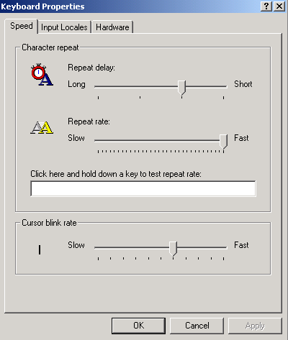
8) Where is the following window located?
A) Control Panel B) Device Manager
C) Accessibility Options D) System Information

9) The various tools in the MMC are known as ___________
A) applets B) devices C) files D) snap-ins

10) You’ve installed a new network card and sound card. Every time you boot, the system locks up, and you must boot into safe mode to get a GUI. What tool can you use to assist you in locating the source of the problem?
A) Defrag B) Add/Remove Programs applet
C) Accessibility Options D) Device Manager

11) Go to Start, Run. Type WINMSD.EXE. What utility does this show?
A) Device Manager B) System Information
C) Event Viewer D) Network Connections

12) How do you get to the screen below?
A) Press F8 when Windows is starting
B) Press CTRL-ALT-DEL from the Desktop Screen
C) Press F-5 from the command line prompt
D) Type SAFEMODE.EXE from the run dialog box

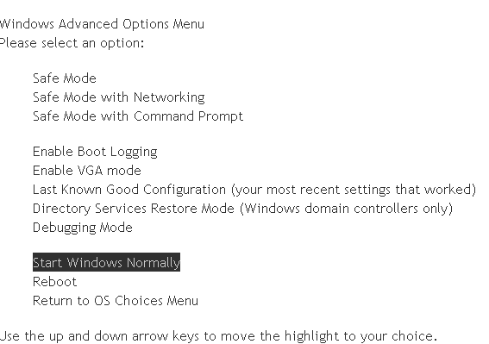

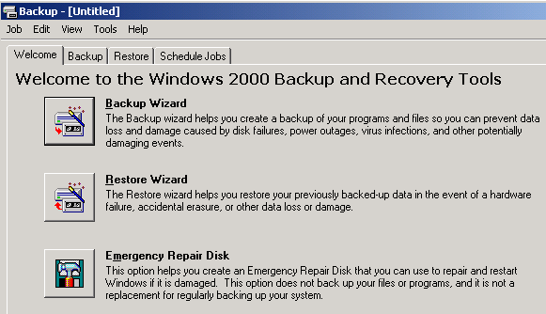

13) How do you get to the Windows below at right?
A) Type BACKUP.EXE from the run dialog box
B) Go to My Computer and on the hard drive, right-click properties and choose backup
C) Go to Start, Programs, Accessories, System Tools, then Backup.
D) Go to System Information, then Backup

14) Windows 2000 offers a power-saving mode that saves everything in memory to disk, turns off the monitor and hard disk, then turns off the computer. When the computer is restarted, the desktop is restored exactly as it was left. A power failure while the computer is in this mode will not cause data loss. What is this mode called?
A) Sleep B) Snooze C) Standby D) Hibernate

15) What is the version of NTFS that comes with Windows 2000?
A) NTFS v.1 B) NTFS v.3 C) NTFS v.4 D) NTFS v.5 E) NTFS v.2000

16) Which of the following computer systems will need to be upgraded before you can install Windows 2000 Professional on it?
- Computer 1 – Pentium 166 MHz, 96 MB RAM, 3.2 GB HD
- Computer 2 – Pentium II 433 MHz, 128 MB RAM, 500MB HD
- Computer 3 – Celeron 333 MHZ, 64MB RAM, 2 GB HD
- Computer 4 – AMDK6 266 MHz, 64 MB RAM, 6.4 GB HD

17) When should you try an upgrade?
A) Your computer is new and your hard drive is blank with no operating system installed on it.
B) Your present operating system has any type of problems that may be related to drivers and/or settings or has a substantial number of orphan files from program removals.
C) You have two partitions and would like to create a dual- boot configuration with a new operating system such as Windows XP and your current operating system, Windows 98.
D) There is an emergent need to retain your existing settings and file preferences such as for special applications and you have the necessary patches etcetera to insure compatibility

18) What does NTFS stand for?
A) New Technology File System B) New Transfer File Software
C) NeWton File System C) Norton Transfer File Software

19) What is a mount point?
A) A point on the hard drive that separates the partition table from the actual data stored on the hard drive
B) A drive that functions like a folder mounted into another drive.
C) The location on the hard drive that separates the primary partition from the extended partition
D) The place in the case where you mount the hard drive.

20) What is a spanned volume?
A) A primary partition with more than one operating system on it
B) An extended partition
C) One volume on more than one hard disk.
D) One volume that consists of more than one drive letter.

21) What is the swap file in Windows XP called?
A) SWAPFILE.SYS B) XPSWAP.SYS C)WIN386.SWP D) PAGEFILE.SYS

22) Sandra wants to install two drives in her new PC and install Windows XP as her OS. Mary suggests that she could install one as primary master and the other as the secondary master; both with primary partitions. Raleigh disagrees. He says that both master disks can’t be primary partitions, and that the secondary master drive must be set up as an extended partition with at least one logical drive. Who is right?
A) Only Mary is right. B) Only Raleigh is right
C) Both Mary and Raleigh are right
D) Neither Mary nor Raleigh are right. Sandra needs to make the secondary master a dynamic disk with a simple volume

23) Your boss has complained that he keeps getting error messages on his Windows XP Professional system about lack of disk space on his hard drive, which is a single basic disk. He’s deleted everything he can, but it hasn’t fixed the problem. He’s not a particularly experienced computer user, so he has come to you for a solution. Assuming his problem remains after you have performed all the standard disk maintenance on his drive, what is the best solution for his problem?
A) Install a second hard drive, and make it dynamic, and create a spanned volume
B) Install a second hard drive, and explain to your boss the while he can continue to run his programs from the old drive, he must store his data on the new drive
C) Install a second hard drive, and make it dynamic, and create a simple volume. Mount the volume to an empty folder on the C: drive
D) Replace his first drive with a bigger drive; reinstall XP and his applications.

24) Which of the following tech utilities is available in Windows XP, but not in Windows 98?
A) Files and Settings Transfer wizard B) System Tools
C) Control Panel D) Command Line

25) What should be done before installing an OS?
A) Make sure your hardware and the software you will put the computer can work with the OS. By going to Windows Marketplace (formerly known as Hardware Compatibility List, HCS) at www.windowsmarketplace.com.
B) Do a Windows update to make sure you have the latest patches.
C) Upgrade your drivers before installing the OS so your devices work properly after the install
D) Why do anything if everything is going to be wiped out anyway.

26) You want to multiboot with Windows 98 and Windows XP. Which do you install first?
A) You can’t multiboot because Windows 98 is only FAT 32 and Windows XP is NTFS
B) You can multiboot, but you need third party (other than Microsoft) software and either can go first.
C) Windows XP
D) Windows 98
27) If for some reason your CD drive is not auto-running and you want to upgrade to Windows 2000 or Windows XP. What file can you run on the Windows 2000 or Windows XP CD to start the upgrade?
A) Setup B) Install C) Run D) WINNT32.EXE

28) What should you do after installing Windows?
A) Determine how you want to partition you drive
B) Determine your computer’s network role
C) Update the OS with patches and service packs
D) Increase RAM

29) What are the minimum requirements to install Windows XP?
A) 166 MHz CPU 32MB RAM 1 GB Hard Drive
B) 233 MHz CPU 64MB RAM 1.5 GB Hard Drive
C) 500 MHz CPU 256MB RAM 20 GB Hard Drive
D) 1GHz CPU 512 MB RAM 40 GB Hard Drive

30) We used a volume license version of Microsoft XP that didn’t have any serial numbers and didn’t require activation. But single users require that you activate Microsoft Windows XP. If you do not complete the registration process for Windows XP, what will happen to your computer?
A) Nothing. Activation is optional
B) The computer will work fine for 30 days and then Windows XP will be disabled.
C) Microsoft will not know how to contact you to provide upgrade information.
D) You will have to use a floppy disk set to boot to windows XP

31) Which of the following is an advantage of running Windows 2000 on NTFS as opposed to FAT32?
A) Security B) Support for DOS applications C) Long Filenames D) Network Support

32) I downloaded Microsoft’s Setup Manager to create a text file to do an unattended install (like we did since we didn’t have to enter any information). After the installing 30 PCs with my unattended version of Windows XP, what do I have to do?
A) Change the computer name on the all the computers since the computers all have the same name
B) Enter the CD key
C) Enter the product key
D) Enter the CD serial number

33) Phil tried to install a printer on his Windows XP Professional machine, but found he didn’t have permission. What could be the problem?
A) Phil is logged on with a Limited Account B) Phil is logged on as a local user
C) Phil is logged on as a Local Administrator D) Phil didn’t load the printer drivers

34) If you are experiencing problems with Windows Me and wish to install Windows XP, what type of installation is preferred?
A) Clean install B) Upgrade Install C) Network Install D) Image Install

35) Which utility is helpful in troubleshooting hardware?
A) System Properties B) Device Manager C) Disk Management D) Security Center

36) Which of the following should be done first before installing a new OS on a computer?
A) Partition the drive B) Format the drive
C) Erase the old partition
D) Check the hardware requirements of the OS to make sure you computer meets the hardware requirements of the OS

37) What would be a reason to do a clean install over an upgrade?
A) Eliminate any corrupt files B) Retain all your old programs
C) Not have to reinstall applications D) To eliminate having to reinstall drivers

38) What is a DISADVANTAGE of doing a clean install on a system that already has an earlier version of the operating system?
A) You have to reinstall your CD-ROM B) You have to reinstall the hard drive
C) You have to reinstall the RAM D) You have to reinstall applications

39) If you have an existing computer and are upgrading the OS or even doing a clean install, what should you do with your current valuable data?
A) Say goodbye to it. B) Back it up
C) Put it on the drive you want to partition, then partition the drive.
D) Put it on the drive you want to format

40) Which utility can speed up disk reads and writes?
A) ScanDisk B) CheckDisk C) FDISK D) Defrag

41) How can you get rid of some unnecessary files, such as temporary Internet files, and Recycle Bin files in one shot?
A) Disk Defragmenter B) Backup C) Disk Cleanup D) System Restore

42) How do you get to the AutoPlay properties in Windows XP?
A) Right-click on the optical drive and click properties then auto play
B) Double-click on the optical drive and click properties then AutoPlay
C) Double-click on My Computer, then Tools, then Folder Options then Auto Play
D) Right-click on My Computer, then Properties, then Optical Drive, then Auto Play

43) You have decided to do away with a few applications and their respective data that you haven't used in a while to free up some free space on your hard disk on your Win 2000 system. After completing this task, it is advisable to execute which of the following programs before you begin to use the HDD to store data further?
A) Antivirus B) Registry Scanner C) Defragmenter D) ScanDisk

44) Which of these files does the NTLDR read to present the OS Selection screen along with defaults, during boot up?
A) BOOT.INI B) NTSYS.INI C) BOOTSECT.INI D) NTSYS.INI

45) What is the minimum microprocessor required to install Windows 2000?
A) 486 B) Pentium C) Pentium II D) Pentium III

Part II:

1) In FAT32, what does the 32 represent?
A) The maximum size hard drive that FAT32 can address, namely 32 GB.
B) The maximum size hard drive that FAT32 can address, namely 32 TB.
C) The number of sectors per cluster used in FAT32 D) The number of clusters per partition.
E) The number of bits used to represent the total number of clusters on the partition

2) What do we call a group of sectors that work as one file storage unit?
A) cylinder B) cluster C) FAT D) track E) Partition

3) The DOS and Windows 9x _____ program sets up a partition table at the beginning of the hard drive.
A) CHKDSK B) DEFRAG C) SCANDISK D) FDISK E) PDISK

4) A fragmented hard drive is one in which the files (clusters) are _____?
A) cross-linked B) missing C) lost D) not contiguous E) Bad

5) The _______ partition is the partition on the hard drive that is used to boot to the OS.
A) default B) boot C) active D) loaded E) extended

6) What is another name for clusters?
A) sectors B) tracks C) cylinders D) allocation units E) hard drives

7) Which application reorganizes the clusters on a disk pertaining to a file to optimize disk drive performance?
A) SCANDISK B) DEFRAG C) OPTIMIZE D) FDISK E) CLUSTORG

8) Which of the following is NOT a valid file attribute?
A) Protected B) Hidden C) System D) Archive

9) What does MBR stand for?
A) Master Boot Record B) Master BIOS Record C) Microsoft BIOS record D) Microsoft Boot recovery disk

10) What is the correct syntax for the following format command?
A) FORMAT B) FORMAT A: C) FORMAT A; D) FORMAT A;//

11) The most recent information taken from the hard drive is stored in a ______ so that the hard drive platters don’t have to spin again and locate the same information again, resulting in faster data retrieval.
A) Primary Cache B) L1 Cache C) L2 Cache D) Disk Cache

12) All information on a hard drive is managed in groups called _____, which have to be periodically organized with a defragmentation utility. Defragmentation makes sure groups of similar information are stored next to each other so they can all be grabbed in one chunk quickly.
A) cylinders B) packets C) clusters D) tracks

13) What does a high-level format do?
A) Creates the drive letters B) Breaks up the drive into tracks, sectors, and cylinders
C) Creates an extended partition D) Creates a FAT and a root directory

14) What is the greatest advantage of using FAT32 over FAT16?
A) Ability to use bigger hard drives B) Ability to use Antivirus software
C) Ability to install two hard drives D) Ability to have multiple operating systems

15) How do you recover files after they’ve been deleted from the Recycle Bin?
A) You can’t recover those files B) Use the Restore option from the Recycle Bin
C) Use the Undelete Option from the Recycle Bin
D) By using certain utilities such as Norton’s UnErase or WinUndelete
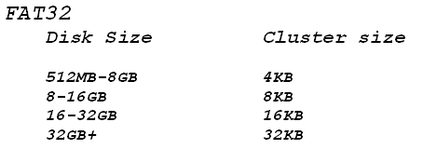
16) Using the table at right, how many sectors are in one cluster for a 1.5GB partition using FAT32?
A) 4 B) 8 C) 12 D) 16 E 32

17) What is the very first sector of the physical hard disk called?
A) Master Sector B) Active Sector C) Boot Sector D) Partition Sector

18) With a Windows 9x system, only 1MB of hard drive space is left on the boot drive and the operating system crashes. Which file may have run out of space?
A) SYSTEM.INI B) WIN386.SWP C) PAGEFILE.SYS D) SWAPFILE.TMP

19) A Windows 98 computer has a 14GB hard drive installed with FAT32. How many partitions must be created to fully utilize this drive’s capacity (assuming your BIOS provides no limiting problem)?
A) 1 B) 2 C) 4 D) 7

20) What is the outcome of running disk defragmentation?
A) File sectors large B) File sectors small C) Faster data transfer D) Slower access speed
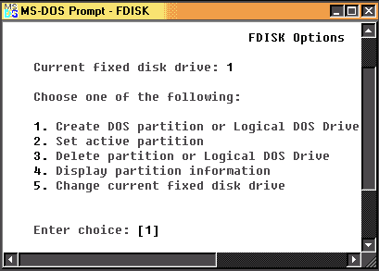
21) When would you have this 5th option in FDISK?
A) When you have two primary partitions
B) When you have more than one physical hard drive
C) When you have a CD-ROM drive and a hard drive
D) The fifth option is always there.

22) Which is NOT a reason to partition a hard drive?
A) Ability to use larger physical drives by creating multiple logical drives
B) To have multiple operating systems
C) Personal way of organizing data
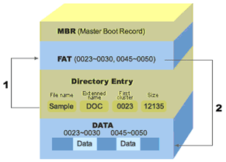
D) Increase overall hard drive size

23) What does the master boot record read to determine which partition is active?
A) The File Allocation Table (FAT)
B) The Volume Boot Label
C) The MBR
D) The partition table

24) The file Sample.DOC is spread over several clusters on the hard drive. Which is NOT reason why clusters for 0031-0044 were skipped for this file?
A) Those clusters contain bad sectors
B) The clusters were open for use
C) Those clusters contain other files
D) None of the other choices

25) When a user deletes a file, empties the Recycle Bin, what happens to the file?
A) Clusters are flushed
B) The file is move to C:\Windows\Temp
C) Sectors of the hard drive are blanked/erased
D) Clusters associated with that file are marked as open for use

26) A Windows 95 user has a 2GB hard drive partitioned for FAT16 that is almost full. What is the quickest way to increase hard drive space for the user
A) Run Scandisk B) Run Device Manager
C) Convert the Drive to FAT32. D) Replace the Drive

27) Which of the following is the best definition for virtual memory?
A) RAM used as hard drive space B) Memory that is not physically present in the computer
C) Memory that is located on a PC card that is accessed as if it were RAM.
D) Hard Drive space used as RAM

28) In Windows 9x, how do you activate the Task Manager Window?
A) By clicking on Start, Shut Down, and Choosing Task Manager option
B) By pressing the CTRL key while clicking on the task bar
C) By pressing CTRL-ALT-DEL
D) By right-clicking on My Computer icon.

29) Your Windows 9x computer locks up and you are unable to close the program. How can you terminate the program without shutting down the system?
A) Press CTRL-ALT-DEL twice B) Use software release utility UNLOCKIT.EXE
C) Select the Close Program option in Control Panel.
D) Press CTRL-ALT-DEL. Select the program not responding and click the End Task button

30) When you double-click on a shortcut that appears on the Windows desktop, why does the application not run?
A) Desktop shortcuts can’t be used in this way B) The shortcut has a different icon from the default
C) The shortcut file is corrupt and needs to be replaced
D) The program file for that shortcut is corrupt, deleted, or inaccessible

31) When a customer calls in and says, “My system will not boot. It was fine in the morning, but now it says it can’t find the operating system.” What question should you ask?
A) Are you using the same keyboard
B) Are you using a different computer
C) Are any floppy disks in the floppy drive
D) Do you have a USB port

32) In the picture at right, what does the A under status indicate?
A) That partition 1 is the A partition, out of letters B, C, and D
B) That partition 1 is the boot- partition
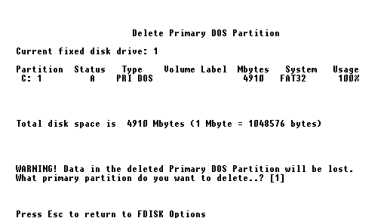
C) That partition 1 is currently inactive
D) That partition 1 is protected
E) That there partition 1 is empty

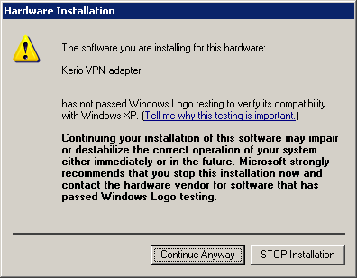
Part III:

1) What does the screen at right indicate?
A) You are using a DOS program
B) Microsoft has not tested your software to work with Windows XP.
C) There is a security risk with your software
D) Microsoft and the Vendor do not have a software agreement

2) Ricardo’s Windows XP installation has failed. What file should he check to see what files failed to copy?
A) INSTALL.LOG B) SETUP.LOG
C) SETUP.TXT D) SETUPLOG.TXT

3) You can upgrade directly to Windows 2000 from which of these operating systems?
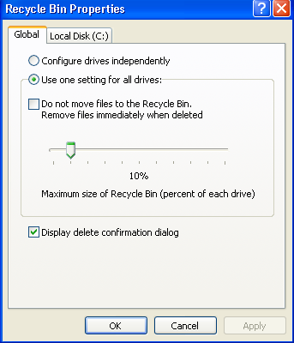
A) Windows 3.11 B) Windows 95 C) Windows Me
D) All of the above

4) How do you get the window at right?
A) In the Control Panel B) In the Device Manager Properties
C) Right-clicking on the Recycle Bin Icon and going to Properties
D) In the Programs folder

We used an unattended disk to install Windows XP. To setup and unattended setup go to http://www.microsoft.com/downloads/details.aspx?FamilyID=3e90dc91-ac56-4665-949b-beda3080e0f6&DisplayLang=en and download this software (Setup Manager and SysPrep) which lets you create an unattended setup.

Go here to learn how to make a boot CD http://www.netbootdisk.com/bootcd.htm

5) Which of the following is an advantage of running Windows 2000 on NTFS as opposed to FAT32?
A) Security B) Support for DOS applications
C) Long Filenames D) Network Support

6) Which of the following best describes the operating system’s user interface?
A) It enables the system to communicate with peripheral devices
B) It provides a display of the programs and data on a system to the user
C) It provides a display of the system hardware to the user
D) It provides error handling or notification displays when communicating with hardware

7) If you do not complete the activation process for Windows XP, what will happen to your computer?
A) Nothing. Activation is optional
B) The computer will work fine for 30 days and then Windows XP will be disabled
C) Microsoft will not know how to contact you to provide upgrade information
D) You will have to use a floppy disk set to boot to XP

8) Which term describes a combination of many updates and fixes?
A) Hot fix B) Hot pack C) Service Pack D) Service Release

9) If you are experiencing problems with Windows Me and wish to install Windows XP, what type of installation is preferred?
A) Clean install B) Upgrade install C) Network Install D) Image Install

Try out these common Hot Keys and Function Keys when you don’t want to or can’t use the mouse:

F1 = Help
F5 = Refresh the current windows
F10 = Activate Menu bar items.

CTRL-ESC – Open Start Menu
ALT-TAB – Switch between open programs
ALT-F4 – Quit Program
CTRL-A Select all items in the current window
ALT-SPACE – Display the main window’s system menu
Shift-DEL – Delete item permanently
Shift – Bypass the automatic-run feature for optical media while inserting optical media
CTRL-C – Copy
CTRL X – Cut
CTRL V – Paste
Windows key – Start Menu
Windows Key-C – Open the Control Panel
Windows Key-D – Show desktop
Windows Key-F – Search Menu

Windows 2000/XP files that start the operating system:

These files are called system files (you would think that they would be called boot files)

NTLDR, BOOT.INI, and NTDETECT.COM. If you are using a SCSI hard drive, then there is a fourth file called NTBOOTDD.SYS.

After the booting to the OS, the core Operating system files take effect. The main core file is NTOSKRNL.EXE

When the computer boots up, the master boot record or Master File Table on the hard drive starts the NTLDR program and then launches Windows 2000/XP or some other OS. To find the available OSs, the NTLDR program must read the BOOT.INI file

The BOOT.INI file is a text file that lists the OS available to NTLDR and tells NTLDR where to find the boot partition (the partition with the (OS core files. Weird; the files that boot up the computer are called system files and the core OS files are called the boot files. Question about this later)

You can edit the BOOT.INI file with any editor program, or you can access a GUI version by doing the following:
Start, Control Panel, System applet, Advanced Tab then the click Startup and Recovery. The BOOT.INI options show at the top. Here you could change will OS will boot by default

Windows 2000 versions:
Server and Professional

Windows XP versions:
Professional – Offers a complete computing solution
Home – Designed for the home and small office user. Doesn’t include
- Ability to log on to a Windows domain
- Encrypted File System
- Support for Multiple processors
- Support for Remote Desktop
- Support for NTFS Access Control
Media Center – Of course geared towards multimedia

Other Windows versions:
Windows Vista and its variations (although not part of the current CompTIA exam)
Windows Mobile designed for PDSs and phones
Windows XP Tablet

Sample Test Questions:
10) Which folder permission allows for file creation and editing, but not deleting?
A) Full Control B) Full Access C) Modify D) Read & Execute

11) Which type of files are NTLDR, BOOT.INI and NTDECTECT.COM? (Tricky question)
A) Boot files B) System Files C) Starter Files D) NTFS Files

12) What folder is a central storage location for user files?
A) Program Files B) My Documents C) My Files D) My Network Places

13) Which utility is helpful in troubleshooting hardware?
A) System Properties B) Device Manager C) Disk Management D) Security Center

14) Which Windows XP utility backs up critical files and settings and enables you to roll back to a previous state?
A) Registry B) System Restore C) System Information D) Microsoft Management Console

15) Many tools are grouped together in which location?
A) Start | All Programs | Tools
B) Start | All Programs | Tools | System Tools
C) Start | All Programs | System Tools | Accessories
D) Start | All Programs | Accessories | System Tools

16) What is displayed in the My Computer window?
A) All the drives on your system
B) All the Control Panel applets
C) Installed Programs
D) Other computers on the network

Let’s practice some command line commands:
Go to start Run, then type CMD and press Enter

1) Type DIR. What does this do?

- Try different switches with DIR like DIR /O, DIR /P, DIR /W, DIR /O/P

2) Type Exit. What does this do?

OK, get back in

Try using the HELP command.
The CD command is used to change the directory. For example type CD\Windows to get into the Windows folder (if it exists!)

To return to the root directory, type CD\

You can make a directory using the MD command

Type MD (or MKDIR) MROD

Now go into the MROD folder. Check through your GUI to see if you see the MROD folder

You can hold down the F5 or F8 key during boot up to access the Windows 2000 or Windows XP advanced Options menu. This has an option to boot to Safe Mode with Command Prompt. This loads the GUI into Safe Mode and then overlays that with a command line interface for rapid access to a prompt. This saves you the step of going to Start Run CMD. Of course this is if you want the command line when turning on the computer.

To remove a directory, use the DEL command to remove files then exit the directory and use the RD command to remove the directory.

To remove files and directory all at once do

RD C:\MROD /S

Rename a file with the REN command

A file can attributes such as hidden, read-only, System and Archive, denoted by the letters H, R, S and A. Type ATTRIB at the command prompt. What is displayed?

To add and attribute to a file, do the following, ATTRIB +R FILE.DOC which makes the FILE.DOC file read only.

To take off an attribute from a file, do something like ATTRIB –H FILE.DOC which takes off the hidden attribute from a file.

Use the * wildcard to find all files with a TXT ending. For example type

DIR *.TXT. Very helpful. I do this if I want to find all my WAV files, or MP3 files. Etc.

Type EDIT and press <Enter> to access the OLD DOS notepad.

Type
MD\MROD
CD\MROD
VER

Save this file as TODO.BAT. BAT is the extension for a BAT file

At the command prompt, type TODO.

What is a batch file?

What does the VER command do?

Sample Test Question:
1) What is the command to quit the command line interface?
A) EXIT B) BYE C) QUIT D) STOP

2) What command do you type at the RUN dialog box to access the command line interface in Windows XP?
A) CMD B) COMMAND C) MSDOS D) PROMPT

Assignment:
Do a Windows update by going to Start, All Programs and at the top should be a Windows Update section

