Research Questions:

1) What hard drive installation/preparation step sets up the file allocation table?
A) CMOS configuration B) Partitioning C) Low Level Formatting D) High-Level Formatting

2) What hard drive installation/preparation step assigns a drive letter?
A) CMOS configuration B) Partitioning C) Low Level Formatting D) High-Level Formatting

3) In Windows 2000 Professional, what command is used to convert a FAT partition into an NTFS partition?
A) FDISK B) SETUP C) CONVERT D) RDISK

4) Which of the following is NOT a Windows 2000 boot file?
A) NTLDR B) NTDETECT.COM C) BOOT.INI D) NTOSKRNL.EXE

5) Which of the following will get you to a screen where you can add the Device Manager snap-in in to a blank MMC you have opened in Windows 2000?
A) Console, Add/Remove Snap-in, Add button B) File, Add/Remove Snap-in, Add Button
C) Console, Add Standalone Snap-in, Add Button D) File, Add Standalone Snap-in, Add Button

6) What is the Windows 2000 term for a collection of accounts that share the same access capabilities?
A) Domain B) Group C) Power Users D) Administrators

7) What is the configuration database in Windows that contains settings for the hardware and software in the PC it is installed in and can be edited directly, but that is usually only done for very technical enhancements or as a last resort. Routine access is done via the Control Panels in My Computer or any Properties menu.
A) Disk Management B) The Master Boot Record C) Group Policies D) The Registry

- Which of the following can the Add/Remove hardware applet (in Control Panel) perform in Windows 2000?
A) Configure the registry B) Uninstall the device driver
C) Reconfigure a multiple display layout D) Disable a PC Card drive before it is removed

9) You have configured a dual boot system consisting of Windows 98 in a FAT32 partition and Windows 2000 in an NTFS partition. You checked your Windows 2000 installation and it looks good. However, when you boot to Windows 98, you can’t see the files in the Windows 2000 partition. What might be the source of the problem?
A) The partition has not been made active B) Windows 98 file sharing hasn’t been turned on
C) Windows 98 is not compatible with NTFS D) NTLDR does not start when loading Windows 98

10) In Windows 2000 explorer, opening the C:\WINNT folder shows no files. What is the cause?
A) Virus infection B) System files have been deleted. C) System files all have the system attribute set
D) Windows explorer automatically hides system files from view

11) What applet should you use to add Windows components distributed on the Windows 2000 professional CD?
A) System Settings B) Regional settings C) Add/Remove Programs D) Windows 2000 Professional Resource Kit

12) What tool ensures that a newly installed device on Windows 2000 Professional is functioning properly?
A) System B) DOS Prompt C) Device Manager D) Add/Remove Hardware

13) How can a Windows 2000 shortcut be created for opening specific application?
A) Open the application, go to File and choose Create shortcut
B) Right-click on the application file within Windows Explorer, and choose create shortcut
C) In Control Panel, My Documents, right-click on the application file, and choose Create Shortcut
D) Right-click on the application files from the Documents options of the Start menu and select Create shortcut

14) Which is NOT a way to display the Task Manager in Windows 2000?
A) Press CTRL-ALT B) Press CTRL-SHIFT-ESC
C) Right-click on the taskbar and choose Task Manager D) Press CTRL-ALT-DEL then click Task manager

15) Where can users of Windows 2000 systems be prevented from installing unsigned device drivers?
A) Local Users and Groups, Drivers B) Hardware profiles, Device Drivers
C) Device Manager, Computer Name D) System Properties, Hardware, signing

16) 1) What must be done to start the upgrade procedure from Windows 98 to Windows 2000 Professional?
A) Boot from the Windows 2000 CD-ROM
B) Boot from the Windows 2000 floppy disk
C) Copy the Windows 2000 CD-ROM to the hard drive and reboot
D) Start the Windows 2000 Setup program from within the operating system.

17) What is the purpose of a driver?
A) Tells the operating system how to interact with the device
B) Improves performance of installed devices by optimizing access patterns
C) Provides more useful memory by moving device control data to extended memory
D) Modifies application programs to work correctly with devices attached to a system

18) A user starts Windows 2000 Professional and logs in successfully but doesn’t appear to have a taskbar, otherwise the system starts normally and all the user’s icons appear on the desktop. How can you locate the start menu?
A) Reveal the secret Start m=Menu by pressing F1 + N
B) Display a hidden Start Menu by pressing CTRL+ESC
C) Create the duplicate Start Menu by pressing the Desktop and pressing ALT+TAB
D) Erase the damaged Start Menu by clicking My Computer and pressing ALT+ENTER
19) A client calls you and says that the files have been deleted from the removable drive and the customer wants to recover them. However, the files are not in the Recycle Bin. What can be the cause of this problem?
A) Removable hard drive data is corrupt B) Removable hard drive is in sleep mode
C) Removable hard drive is a compressed drive D) Files on removable devices are not stored in the recycle bin

20) From where can you start Device Manager in Windows 2000?
A) Computer Manager B) System Applet in Control Panel C) Services Tool in the Administrative Tools
D) The Event Viewer on the Administrative Tools Menu

21) A Windows 98 computer is upgraded to Windows 2000. After restarting the computer for the first time, one of the applications is no longer working. What should be done?
A) Run SCANREG B) Run MSCONFIG C) Run REGEDIT32 D) Re-install the application

22) When working from a Windows 2000 command prompt, what Windows 2000 Professional command is used to edit the registry?
A) REGEDT B) REGEDIT32 C) REGEDT32 D) SCANREG

23) Which of the following describes how to encrypt a Windows 2000 Professional file?
A) Programs, System Tools, Management Control Console, File Management, Encryption Button
B) Control Panel, File Management, select file from list, File menu option, Encryption option
C) Right-click file icon, Properties, General tab, Advanced button, Encrypt Contents to Secure Data option
D) A file can’t be encrypted in Windows 2000; only a folder can.

24) What happens when you double-click on a document icon and the application that created the document is not registered with Windows?
A) An error message appears.
B) A dialog box appears, requesting which application is to be used to open the document.
C) The program that created the document starts with the document active in a window
D) The document opens, but the application that created it is not active

25) How would you set up Windows to automatically use Microsoft Word for all documents that end in CAS?
A) In My Computer or Explorer, click on the Tools menu, Folder Options, File Types, then New
B) In Word, click Options, and click on the Associations tab.
C) In Explorer, click on the View menu, click on Associations, click on the New Association button
D) It can’t be done.

26) What Windows 2000 Professional feature has the ability to add and remove snap-ins for operating system administration?
A) CDC B) MMC C) SAM D) WIN

27) Which of the following describes the steps to make a Windows 2000 Emergency Repair Disk?
A) Programs, Accessories, System Tools, Backup
B) Settings, Control Panel, Add/Remove Software, Startup Disk Tab, Create Disk
C) Programs, System Tools, System Disk Maker
D) Settings, Control Panel, System Control Panel, System Disk Tab, Create Disk

28) What Windows 2000 program protects system files?
A) MSCONFIG B) SYSINFO C) SMP D) WFP

29) Which of the following is used to add additional components to the Windows 2000 Professional environment?
A) Add/Remove Programs from Control Panel B) Programs Control Panel
C) Management Installation Console D) Setup Program

30) Which of the following steps describes how to adjust the virtual memory settings for Windows 2000 Professional?
A) Windows 2000 does not allow virtual memory settings to be changed
B) Hard Drive Control Panel icon, Advanced button, Performance button, Virtual Memory tab
C) System Control Panel icon, Advanced tab, Performance Options, Change button
D) Start button, Programs, System Tools, Configuration Manager

31) Which of the following file systems does Windows 2000 NOT support?
A) FAT16 B) FAT32 C) HPFS D) NTFS

32) Which Windows 2000 snap-in is used to manage storage devices?
A) Boot Manager B) Device Manager Pro C) Disk Management D) Hard Disk Tool

33) Where can you easily view hardware driver information and settings in Windows 2000?
A) Add Hardware Control Panel icon B) The Registry
C) SYSTEM.DAT D) Device Manager

34) Which Windows 2000 feature is in effect when the message “Files required for Windows to run properly have been replaced by unrecognized versions”?
A) WIG (Windows Integrated Guard) B) WFP (Windows File Protection)
C) SCANREG D) WSFP (Windows System File Protection)
35) What operating system has a Last Known Good Configuration menu option when incompatible hardware errors occur?
A) DOS B) Windows 95
C) Windows 98 D) Windows 2000

36) On a Windows 2000 computer, when does the OS save the configuration information used for the Last Known Good Configuration?
A) When the “Loading OS screen appears B) When the Microsoft Login appears
C) When the network Login begins D) Before the computer shuts down

37) Which does NOT show information on resources used by a device in Windows 2000?
A) WINMSD.EXE B) Device Manager C) MSCONFIG.EXE D) System Information

38) Which file system supports encryption in Windows 2000?
A) NTFS B) CDFS C) FAT16 D) FAT32

39) What does virtual memory do?
A) Use hard disk space for extra memory
B) Uses shared parallel processor memory
C) Borrows memory from other systems on the network
D) Uses video and NIC address space and shares available memory with other systems on the network

40) What type of memory stores data on a swap file in a hard drive?
A) High memory B) Virtual Memory C) Extended memory D) RAM

41) Where are the boot options stored for Windows 2000?
A) SYS.CFG B) BOOT.INI C) STAR.INI D) BOOT.CFG

42) How do you access Disk Management in Windows XP?
A) Start | Run | type DM and press the Enter key
B) Start | Program Files | System Tools | Disk Management
C) Start | Control Panel | Administrative Tools | Computer Management | Disk Management
D) Start | System | Disk Management

43) What command brings up a Windows 2000 command prompt?
A) CMD.EXE B) CMD.COM C) CMMD.PIF D) COMMAND.COM

44) Which Windows 2000 utility should you use right after installing a new hard drive to make it usable?
A) FDISK B) FORMAT C) DISKEDT32 D) DISK MANAGEMENT

45) Where is Disk Management in Windows 2000?
A) Control Panel B) Device Manager C) Administrative Tools D) Computer Management

46) Which type of disk(s) does Windows 2000 support?
A) Primary B) Standard C) Extended D) Basic and Dynamic

47) What must an IDE hard drive have in order for a PC to boot to that hard drive?
A) Active partition B) Passive partition C) Dynamic partition D) Extended partition

48) Which of the following represents a GUI (Graphical User Interface) utility that can be used to edit the BOOT.INI file?
A) WINMSD B) MSCONFIG C) OSK D) BOOTCFG

49) The Registry contains all the configuration data and can be accessed directly using_________
A) Control Panel B) Device Manager C) System Information D) Registry Editor

50) When you delete files from the hard drive using the GUI, you actually move them to the __________
A) FAT B) NTFS C) Recycle Bin D) flash drive

51) The System, Mouse and Display applets are found in _________
A) Disk Management B) Control Panel C) FAT D) Device Manager

52) The Start button and System Tray are parts of the Windows ___________
A) Taskbar B) Toolbar C) Quick Launch D) Start Menu

53) If your hard drive is running out of space, you should use the ______ utility
A) Windows Update B) Scandisk C) Scanreg D) Defrag E) Disk Cleanup

54) To create a FAT or NTFS file structure, you must ________ the hard drive
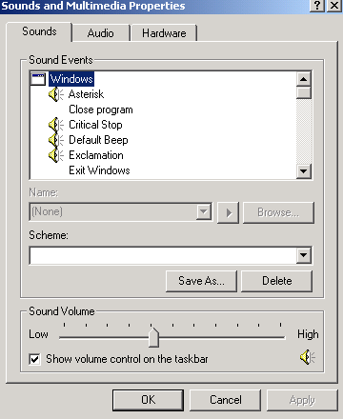
A) Format B) Partition C) Defrag D) Multiboot

55) The ________ tool enables you to partition and format drives in Windows 2000.
A) FDISK B) Disk Management C) System Information
D) Device Manager

56) Which Control applet is shown at right?
A) Speech applet B) Keyboard properties
C) Sounds and Multimedia Properties D) Accessibility Options

57) What file on the Windows 2000 CD allows you to make the 4 boot disks?
A) MAKEBOOT.EXE B) MAKEBT32.EXE
C) BOOTFLOP.EXE D) BOOTDISK.EXE

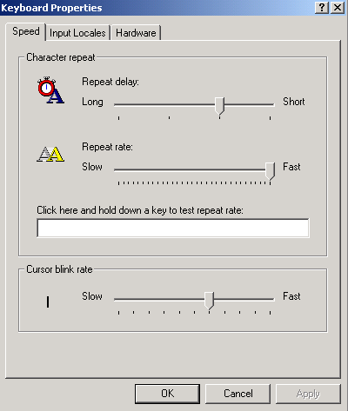
58) Where is the following window located?
A) Control Panel B) Device Manager
C) Accessibility Options D) System Information

59) The various tools in the MMC are known as ___________
A) applets B) devices C) files D) snap-ins

60) You’ve installed a new network card and sound card. Every time you boot, the system locks up, and you must boot into safe mode to get a GUI. What tool can you use to assist you in locating the source of the problem?
A) Defrag B) Add/Remove Programs applet
C) Accessibility Options D) Device Manager

61) Go to Start, Run. Type WINMSD.EXE. What utility does this show?
A) Device Manager B) System Information
C) Event Viewer D) Network Connections

62) How do you get to the screen below?
A) Press F8 when Windows is starting
B) Press CTRL-ALT-DEL from the Desktop Screen
C) Press F-5 from the command line prompt
D) Type SAFEMODE.EXE from the run dialog box

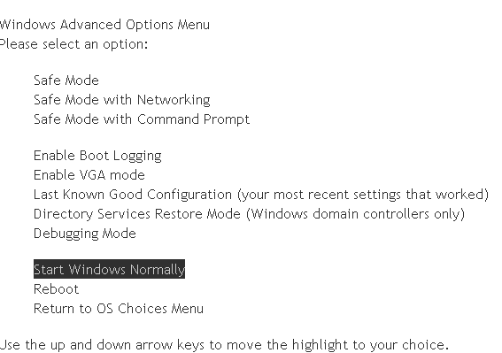

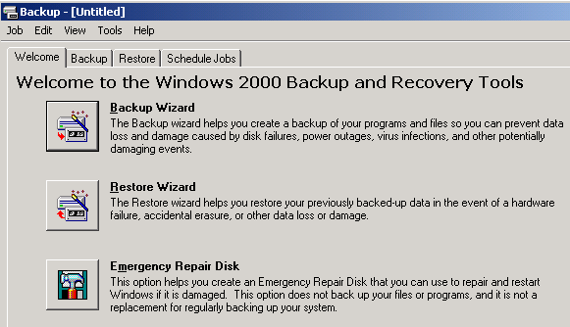

63) How do you get to the Windows below at right?
A) Type BACKUP.EXE from the run dialog box
B) Go to My Computer and on the hard drive, right-click properties and choose backup
C) Go to Start, Programs, Accessories, System Tools, then Backup.
D) Go to System Information, then Backup

64) Windows 2000 offers a power-saving mode that saves everything in memory to disk, turns off the monitor and hard disk, then turns off the computer. When the computer is restarted, the desktop is restored exactly as it was left. A power failure while the computer is in this mode will not cause data loss. What is this mode called?
A) Sleep B) Snooze C) Standby D) Hibernate

65) What is the version of NTFS that comes with Windows 2000?
A) NTFS v.1 B) NTFS v.3 C) NTFS v.4 D) NTFS v.5 E) NTFS v.2000

66) Which of the following computer systems will need to be upgraded before you can install Windows 2000 Professional on it?
- Computer 1 – Pentium 166 MHz, 96 MB RAM, 3.2 GB HD
- Computer 2 – Pentium II 433 MHz, 128 MB RAM, 500MB HD
- Computer 3 – Celeron 333 MHZ, 64MB RAM, 2 GB HD
- Computer 4 – AMDK6 266 MHz, 64 MB RAM, 6.4 GB HD

67) When should you try an upgrade?
A) Your computer is new and your hard drive is blank with no operating system installed on it.
B) Your present operating system has any type of problems that may be related to drivers and/or settings or has a substantial number of orphan files from program removals.
C) You have two partitions and would like to create a dual- boot configuration with a new operating system such as Windows XP and your current operating system, Windows 98.
D) There is an emergent need to retain your existing settings and file preferences such as for special applications and you have the necessary patches etcetera to insure compatibility
68) What does NTFS stand for?
A) New Technology File System B) New Transfer File Software
C) NeWton File System C) Norton Transfer File Software

69) What is a mount point?
A) A point on the hard drive that separates the partition table from the actual data stored on the hard drive
B) A drive that functions like a folder mounted into another drive.
C) The location on the hard drive that separates the primary partition from the extended partition
D) The place in the case where you mount the hard drive.

70) What is a spanned volume?
A) A primary partition with more than one operating system on it
B) An extended partition
C) One volume on more than one hard disk.
D) One volume that consists of more than one drive letter.

71) What is the swap file in Windows XP called?
A) SWAPFILE.SYS B) XPSWAP.SYS C)WIN386.SWP D) PAGEFILE.SYS

72) Sandra wants to install two drives in her new PC and install Windows XP as her OS. Mary suggests that she could install one as primary master and the other as the secondary master; both with primary partitions. Raleigh disagrees. He says that both master disks can’t be primary partitions, and that the secondary master drive must be set up as an extended partition with at least one logical drive. Who is right?
A) Only Mary is right. B) Only Raleigh is right
C) Both Mary and Raleigh are right
D) Neither Mary nor Raleigh are right. Sandra needs to make the secondary master a dynamic disk with a simple volume

73) Your boss has complained that he keeps getting error messages on his Windows XP Professional system about lack of disk space on his hard drive, which is a single basic disk. He’s deleted everything he can, but it hasn’t fixed the problem. He’s not a particularly experienced computer user, so he has come to you for a solution. Assuming his problem remains after you have performed all the standard disk maintenance on his drive, what is the best solution for his problem?
A) Install a second hard drive, and make it dynamic, and create a spanned volume
B) Install a second hard drive, and explain to your boss the while he can continue to run his programs from the old drive, he must store his data on the new drive
C) Install a second hard drive, and make it dynamic, and create a simple volume. Mount the volume to an empty folder on the C: drive
D) Replace his first drive with a bigger drive; reinstall XP and his applications.

74) Which of the following tech utilities is available in Windows XP, but not in Windows 98?
A) Files and Settings Transfer wizard B) System Tools
C) Control Panel D) Command Line

75) What should be done before installing an OS?
A) Make sure your hardware and the software you will put the computer can work with the OS. By going to Windows Marketplace (formerly known as Hardware Compatibility List, HCS) at www.windowsmarketplace.com.
B) Do a Windows update to make sure you have the latest patches.
C) Upgrade your drivers before installing the OS so your devices work properly after the install
D) Why do anything if everything is going to be wiped out anyway.

76) You want to multiboot with Windows 98 and Windows XP. Which do you install first?
A) You can’t multiboot because Windows 98 is only FAT 32 and Windows XP is NTFS
B) You can multiboot, but you need third party (other than Microsoft) software and either can go first.
C) Windows XP
D) Windows 98

77) If for some reason your CD drive is not auto-running and you want to upgrade to Windows 2000 or Windows XP. What file can you run on the Windows 2000 or Windows XP CD to start the upgrade?
A) Setup B) Install C) Run D) WINNT32.EXE

78) What should you do after installing Windows?
A) Determine how you want to partition you drive
B) Determine your computer’s network role
C) Update the OS with patches and service packs
D) Increase RAM

79) What are the minimum requirements to install Windows XP?
A) 166 MHz CPU 32MB RAM 1 GB Hard Drive
B) 233 MHz CPU 64MB RAM 1.5 GB Hard Drive
C) 500 MHz CPU 256MB RAM 20 GB Hard Drive
D) 1GHz CPU 512 MB RAM 40 GB Hard Drive

80) We used a volume license version of Microsoft XP that didn’t have any serial numbers and didn’t require activation. But single users require that you activate Microsoft Windows XP. If you do not complete the registration process for Windows XP, what will happen to your computer?
A) Nothing. Activation is optional
B) The computer will work fine for 30 days and then Windows XP will be disabled.
C) Microsoft will not know how to contact you to provide upgrade information.
D) You will have to use a floppy disk set to boot to windows XP
81) Which of the following is an advantage of running Windows 2000 on NTFS as opposed to FAT32?
A) Security B) Support for DOS applications C) Long Filenames D) Network Support

82) I downloaded Microsoft’s Setup Manager to create a text file to do an unattended install (like we did since we didn’t have to enter any information). After the installing 30 PCs with my unattended version of Windows XP, what do I have to do?
A) Change the computer name on the all the computers since the computers all have the same name
B) Enter the CD key
C) Enter the product key
D) Enter the CD serial number

83) Phil tried to install a printer on his Windows XP Professional machine, but found he didn’t have permission. What could be the problem?
A) Phil is logged on with a Limited Account B) Phil is logged on as a local user
C) Phil is logged on as a Local Administrator D) Phil didn’t load the printer drivers

84) If you are experiencing problems with Windows Me and wish to install Windows XP, what type of installation is preferred?
A) Clean install B) Upgrade Install C) Network Install D) Image Install

85) Which utility is helpful in troubleshooting hardware?
A) System Properties B) Device Manager C) Disk Management D) Security Center

86) Which of the following should be done first before installing a new OS on a computer?
A) Partition the drive B) Format the drive
C) Erase the old partition
D) Check the hardware requirements of the OS to make sure you computer meets the hardware requirements of the OS

87) What would be a reason to do a clean install over an upgrade?
A) Eliminate any corrupt files B) Retain all your old programs
C) Not have to reinstall applications D) To eliminate having to reinstall drivers

88) What is a DISADVANTAGE of doing a clean install on a system that already has an earlier version of the operating system?
A) You have to reinstall your CD-ROM B) You have to reinstall the hard drive
C) You have to reinstall the RAM D) You have to reinstall applications

89) If you have an existing computer and are upgrading the OS or even doing a clean install, what should you do with your current valuable data?
A) Say goodbye to it. B) Back it up
C) Put it on the drive you want to partition, then partition the drive.
D) Put it on the drive you want to format

90) Which utility can speed up disk reads and writes?
A) ScanDisk B) CheckDisk C) FDISK D) Defrag

91) How can you get rid of some unnecessary files, such as temporary Internet files, and Recycle Bin files in one shot?
A) Disk Defragmenter B) Backup C) Disk Cleanup D) System Restore

92) How do you get to the AutoPlay properties in Windows XP?
A) Right-click on the optical drive and click properties then auto play
B) Double-click on the optical drive and click properties then AutoPlay
C) Double-click on My Computer, then Tools, then Folder Options then Auto Play
D) Right-click on My Computer, then Properties, then Optical Drive, then Auto Play

93) You have decided to do away with a few applications and their respective data that you haven't used in a while to free up some free space on your hard disk on your Win 2000 system. After completing this task, it is advisable to execute which of the following programs before you begin to use the HDD to store data further?
A) Antivirus B) Registry Scanner C) Defragmenter D) ScanDisk

94) Which of these files does the NTLDR read to present the OS Selection screen along with defaults, during boot up?
A) BOOT.INI B) NTSYS.INI C) BOOTSECT.INI D) NTSYS.INI

95) What is the minimum microprocessor required to install Windows 2000?
A) 486 B) Pentium C) Pentium II D) Pentium III

