Brooklyn Technical High School Per. ________________ Name ___________________________
Computer Repair, Upgrade, Management & Maintenance Marking Period 2 Review 2 11/24/09
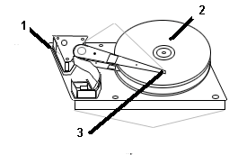
1) Calculate the approximate size of the hard drive with following geometry: 64 cylinders, 2 heads, and 63 sectors per track
A) 540 MB B) 32 MB C) 126 MB
D) 256 MB E) 4MB

2) Which number shows the platters of the hard drive?
A) 1 B) 2 C) 3 D) None of the other choices

3) Typically, if a hard drive has 2 platters, most likely how many heads does it have?
A) 0 B) 1 C) 2 D) 4
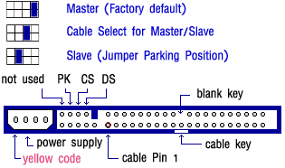
4) Looking at the back of the hard drive at right, on which jumper
would you put the shunt to use this hard drive as a slave drive?
A) not used B) PK C) CS D) DS

5) What is the difference between disk mirroring and disk
duplexing?
A) Disk mirroring requires 4 hard drives and disk duplexing requires only 2 hard drives
B) Disk mirroring requires 3 hard drives while disk duplexing requires 2 hard drives
C) Disk mirroring requires 1 controller card and disk duplexing requires 2 controller cards
D) Disk mirroring requires PATA drives while disk duplexing requires SATA drives

6) Below are the specifications of a hard drive:
Specifications
Capacity (GB) Learn More
Interface
Spindle Speed (RPM)
Buffer Memory
Average Latency (msec)
Average Seek (msec) Learn More
Track-to-Track Seek Time (typical read, ms)
Maximum External Transfer Rate (Mbits/sec)

What is buffer memory?
A) The minimum amount of RAM needed to use this hard drive in a computer.
B) Memory (cache) on the hard drive that stores recently accessed data to speed up disk access
C) Memory that holds programs instead of data
D) An extra baby hard drive on the outside of the regular hard drive

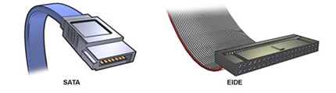
7) At right is a picture showing the difference between a Parallel ATA cable and a Serial ATA cable.
Which is NOT a benefit of using a serial ATA cable over parallel ATA cable
A) Ability to reach ATA devices that are far away from the controller
B) Better airflow through the PC
C) Greater storage capability
D) Better Cable control

8) How many pins are on the SATA data connector?
A) 40 B) 80 C) 7 D) 1

9) What values are held in CMOS for the hard drive?
A) Drive Bay location B) Access Speed to data
C) Size (Heads, Cylinders, Sectors) D) Physical dimension of the drive (Height, Width, Depth, Weight)
10) How many physical hard disks are being recognized by CMOS in the computer that has this setup screen?
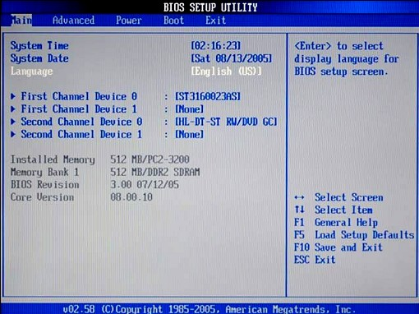
A) 0 B) 1 C) 2 D) 3 E) 4

11) In the computer represented by the CMOS screen at right, you have installed a second hard drive on “First Channel Device 1”. What do you do to have the CMOS recognize this second hard drive?
A) Reboot the computer
B) Change [None] to [Auto] on “First Channel Device 1”
C) Move over to the “Advanced” section of CMOS and find the feature that says, “Please add a second hard drive for me”
D) You can’t add a second hard drive on “First Channel Device 1” because it says [None].

12) Looking at the BIOS setup utility screen above, assuming you don’t have a cable select hard drive and BIOS, what should the jumper setting be on the “Second Channel Device 0” device?
A) Cable Select B) Master C) Slave D) Open

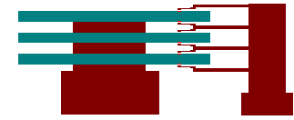
13) In the hard drive shown at right, how many platters are shown?
A) 1 B) 2 C) 3 D) 4 E) 6

14) In the hard drive shown at right how many heads are shown?
A) 1 B) 2 C) 3 D) 4 E) 6

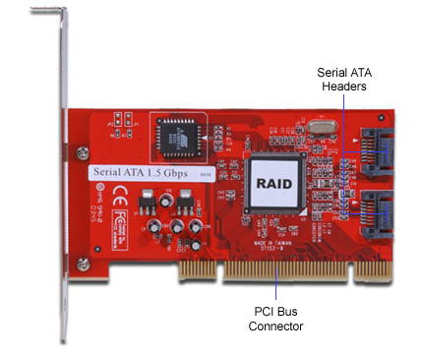
15) In a computer with 2 IDE controllers on the motherboard and no SATA controllers and 1 Parallel ATA hard drive and one ATA CD-ROM drive, where should you connect an ATA CD-ROM drive?
- On the floppy bus B) On the primary IDE
- On the secondary IDE D) On the SCSI bus
- None of the above

16) What can this adapter card used for?
A) To implement a UPS
B) To implement drive partitioning
C) To implement a SCSI chain
D) To implement disk mirroring

17) You are installing an IDE hard drive that will be your boot drive.
Which is the correct order of steps that need to be followed?
A) jumper properly, auto-detect (or configure manually) in cmos, low level format, high level format, partition
B) jumper properly, auto-detect(or configure manually) in CMOS, partition, high level format with /s switch
C) jumper properly, partition, auto-detect (or configure manually in CMOS, high level format with /s switch
D) jumper properly, auto-detect in CMOS, regular format
E) jumper properly, partition, low level format, high level format

18) Which is NOT a reason to partition a hard drive?
A) Ability to use larger physical drives by creating multiple logical drives
B) To have multiple operating systems
C) Personal way of organizing data
D) Increase overall hard drive size
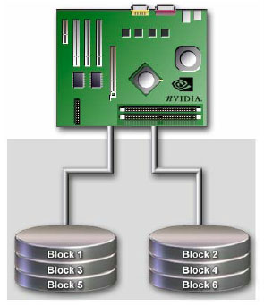
19) The picture at right represents
A) Mirroring B) Duplexing C) Striping
D) SATA E) PATA

20) Which of the following is part of the ATA-7 standard?
A) Red controller connections on the motherboard
B) SATA
C) ATA/100
D) 1 meter maximum cable length

21) What is the maximum number of SATA drives you can have on a system
A) One master, one slave
B) Two, with no master/slave distinction
C) Eight
D) There is no maximum other than the limitations of your motherboard.

22) When Windows first reads a floppy drive, it keeps a copy of the directory in ______?
A) ROM B) HDD C) Floppy Drive D) RAM
23) The ____ option is used to inform the PC NOT to check the floppy disk during the POST
A) Boot Up Floppy Seek B) Swap Floppy Device C) Boot Sequence CMOS D) First Boot Device

24) The ____ option enables a user to manage the booting devices and their order.
A) Boot Up Floppy Seek B) Swap Floppy Device C) Boot Sequence CMOS D) First Boot Device

25) What needs to be checked first when a floppy drive stops working?
A) Cable B) CMOS settings C) Floppy Drive controller D) Floppy disk E) Floppy Disk Drive

26) Which wire on the floppy drive cable is called the Drive Change Signal?
A) 24 B) 36 C) 26 D) 34

- What connects to the 34-pin motherboard connector?
A) Hard Drive B) CD-ROM C) Power Supply D) Floppy Drive

- Rico complains that every floppy he inserts in the floppy disk drive reports the same contents; even though he knows for sure that each disk has different contents. What could be the problem?
A) Pin 1 on the ribbon cable is broken B) Pin 34 on the ribbon cable is broken C) The floppy disk is bad
D) Rico is crazy. All the disks must have the same contents if that’s the way they appear

- What is the purpose of the seven-wire twist in the floppy cable?
A) To increase the flexibility in the cable
B) The system doesn’t use those wires, but it makes a floppy cable easier to identify.
C) To differentiate between drive A: and drive B:
D) There is no twist in a floppy ribbon cable

- The ____ setting enables a user to change the A: and B: drives, without moving the cables.
A) Boot Up Floppy Seek B) Swap Floppy Device C) Boot Sequence CMOS D) First Boot Device Ans. ____

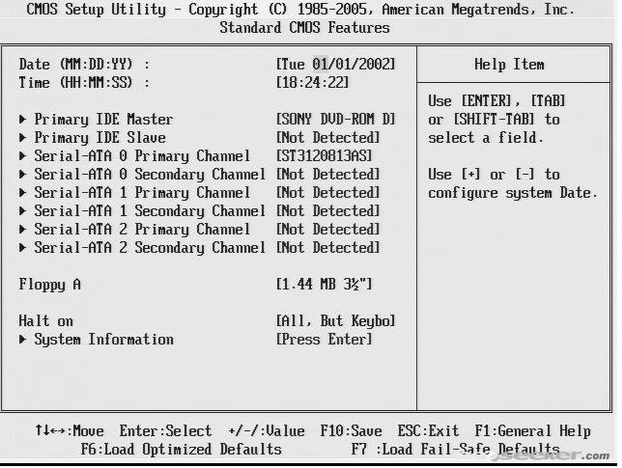
- How many parallel ATA hard drives are detected in this computer by looking at its CMOS?
A) 0 B) 1 C) 2 D) 3 E) 4

- What type of RAID does the picture below show?
A) 0 B) 1 C) 3 D) 5 E) 10

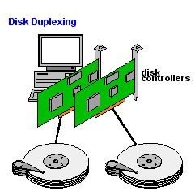

33) On a flat data cable, a red or blue stripe means:
A) ground B) high voltage C) null connection D) pin 1 E) that it's an IDE or SCSI cable

34) With IDE drives, ______ formatting is done at the factory
A) low-level B) high-level C) operating system D) maintenance

35) What do we call a group of sectors that work as one file storage unit?
A) cylinder B) cluster C) FAT D) track

36) What is the very first sector of the physical hard disk called?
A) Master Sector B) Active Sector C) Boot Sector D) Partition Sector

37) IDE data cables have how many pins?
A) 25 B) 40 C) 60 D) 100

38) What is another name for clusters?
A) sectors B) tracks C) cylinders D) allocation units

39) What is the maximum size hard drive that the BIOS routines for an original AT command set enabled?
A) 504 MB B) 504 million bytes C) 528 MB D) There was no limit

40) What does MBR stand for?
A) Master Boot Record B) Master BIOS Record C) Microsoft BIOS record D) Microsoft Boot recovery disk

41) What is the maximum cable length of a serial ATA cable?
A) Two meters B) Eighteen inches C) Twelve inches D) One meter

42) John’s system is running INT 13 extensions. What is the maximum size hard drive it can support?
A) 504MB B) 137GB C) 10GB D) 8.4GB

43) How many primary partitions can a Basic Disk have?
A) 0 B) 1 C) 2 D) 3 E) 4

44) How many extended partitions can you have on one Basic Disk have?
A) 0 B) 1 C) 2 D) 3 E) 4

45) A drive has an extended partition. How many primary partitions can this drive have?
A) 0 B) 1 C) 2 D) 3 E) 4

46) The maximum length for an parallel IDE cable is _________ inches
A) 6 B) 18 C) 24 D) 30

47) You’ve just made a floppy boot disk and want to test it. You put the floppy disk in the floppy disk drive and reboot the computer. Instead of booting to the floppy, it boots to the hard drive and starts Windows 9x. Why?
A) The floppy disk is set to write protect B) The BIOS is set to boot to the hard drive first
C) You did not se the boot sector of the disk to active D) You left your Windows 9x CD in the CD-ROM drive

48) What program is used to edit a text file when a PC starts at the command prompt only?
A) Edit B) Write C) Notepad D) Wordpad

49) What does the ATAPI specification allow that traditional IDE standard did not support?
A) Shared IRQs B) Steered IRQs C) CD-ROM support D) USB support

50) A user often gets “Out of Disk Space” error? Which is NOT a solution?
A) Add more RAM B) Add a larger hard drive C) Remove unneeded files D) Add a second hard drive

51) Your newly appointed trainee wants to know what RAID level provides added performance as well as fault tolerance?
A) RAID 0 B) RAID 1 C) RAID 2 D) RAID 5

52) Your trainee wants to know how to differentiate an ATA/33 IDE cable from an ATA/66 IDE cable?
A) Cable color B) Cable pin-out C) Twist in the cable D) Number of wires

53) Mike has physically installed his brand new hard drives and they are recognized by CMOS. What is the first thing that he must do to prepare the hard drive for the operating system?
A) Partition the drives B) Format the drives C) Nothing, he just needs to install the operating system
D) Reboot

54) Walter is upgrading his computer. He is adding a second IDE hard drive that needs to be configured. He put the second hard drive on the same data cable as the first, and made sure that a power cable was connected to both drives. When he powered the system up, it didn’t recognize either drive. What does Walter need to know to correct the situation?
A) Each drive needs its own interface card to access the bus
B) The second hard drive will need to have CAM-ATA (Common Access Method) software drivers loaded in order to be recognized by the primary drive.
C) Each drive must have a different designation (unless it’s a cable select drive with a cable select BIOS), one as master and the other as slave. Changing jumpers on the drive usually fixes this problem and prevents having two competing drive controllers.
D) The Delayed Start command needs to be activated for the new drive. This allows the original drive to spin up first5 and minimizes the load on the power supply

55) You have just installed a second hard disk drive into a system by adding it as the second drive on the existing IDE cable. When you restart and enter the BIOS configuration program, it can detect neither drive, even though you can hear both drives spinning. What is the most likely problem?
A) The IDE cable is defective. B) You didn’t connect the power cable to the new drive
C) You need to set one drive as master and one as slave D) The new drive is defective.

56) __________ geometry is the head, track, and sector information that the hard drive controller BIOS presents to system BIOS and the OS, not the actual geometry inside the hard drive.
A) Default B) Logical C) System D) Physical

57) After installing a new ATA-100 80GB hard drive, you boot up the system and watch as POST displays information about the system on your monitor. You notice the 80GB hard drive is identified correctly as 80GB, but is listed as using UDMA/33. How should you interpret this?
A) You hard drive cable is not 40-pin B) Your hard drive ribbon cable is not installed correctly
C) ATA-100 is actually UDMA/33 and this is normal
D) Your hard drive ribbon cable is not an 80-conductor cable

58) You have installed two new 80GB hard drives in a Pentium II system that originally only had a 6.4GB hard drive. When you run FDISK to set up the drives, each is listed as having only 8.4GB capacity. What is the most likely problem?
A) You incorrectly formatted the drive B) you need to enable LBA mode in the BIOS setup program.
C) You set the master/slave jumpers on the drives incorrectly
D) Pentium II computers do not support multiple hard drives
E) Your BIOS does not support drives larger than 8.4GB

59) Assuming that both primary and secondary IDE controllers are enabled what is the maximum combined total number of devices that can be connected to both IDE controllers?
A) 3 B) 4 C) 5 D) 6

60) You have an older PC with only one IDE interface. There is already one IDE hard drive and one IDE CD-ROM drive installed in the PC. How would you add a second IDE hard drive?
A) Use and IDE cable that has extra connections on it
B) Install an IDE interface card
C) Use the existing free connector on the floppy drive cable
D) Install a SCSI card

61) Two hard drives are installed in a system. The first hard drive (one IDE 0) has a primary partition, an extended partition, and one logical drive within the extended partition. The second drive (on IDE 1) has one primary partition, one extended partition, and three logical drives within the extended partition. What is the drive letter assigned to the second logical drive within the extended partition on the second hard drive?
A) C: B) D: C) E D) F E) G

62) The most recent information taken from the hard drive is stored in a ______ so that the hard drive platters don’t have to spin again and locate the same information again, resulting in faster data retrieval.
A) Primary Cache B) L1 Cache C) L2 Cache D) Disk Cache

63) John has an ATA/66 capable hard drive for his ATA/66 capable system. However, he notices that he forgot to install the special 80-wire cable. If he installs the ATA/66 drive with a 40-wire EIDE cable, what will happen?
A) The drive will work, but not run at the ATA/66 speed B) He might damage the motherboard.
C) He won’t be able to install the drive D) He will not be able to run his ATA mode

64) What method is commonly used to set an IDE device to master or slave?
A) Use a cable with a twist B) Use the IDE device’s configuration software
C) Set the correct option in the Setup program D) Set a jumper on the EIDE drive

65) What do you do if the motherboard’s IDE controllers fail?
A) Replace the motherboard BIOS B) Disable the controller in the BIOS and add a PCI IDE controller
C) Replace the hard drive D) Flash the BIOS and configure the new primary controller as Master Controller

66) What could cause a larger capacity drive’s capacity to be read as a lower capacity when you install it in an existing system?
A) The BIOS can’t handle the larger capacity drive and formats at the highest recognizable capacity
B) The disk repository C) The new drive is not Y2K compatible
D) The RAM does not support the larger capacity drives

67) A customer just installed a new CD-RW drive. The system was working fine before the installation, but the CD-RW drive doesn’t work. What do you suggest the customer do?
A) Flash or upgrade the BIOS B) Check the CONFIG.SYS setup
C) Add the CD-RW drive in the device manager D) Check the jumper settings on the CD-RW drive

68) Two hard drives are installed in a system. The first hard drive (on IDE 0) has a primary partition, an extended partition, and one logical drive within the extended partition. The second drive (on IDE 1) has one primary partition, one extended partition, and two logical drives within the extended partition. What is the drive letter assigned to the primary partition on the second hard drive?
A) C: B) D: C) E D) F E) G

69) On a system with one Parallel ATA hard drive and one CD-ROM drive, what is the typical placement of the CD-ROM drive?
A) slave drive on the primary IDE channel B) Master drive on the primary IDE channel
C) slave drive on the secondary IDE channel D) Master drive on the secondary IDE channel

70) You just installed a new Parallel ATA hard drive, but your system BIOS will not recognize the new drive. What should you check first?
A) Cable sequence B) Jumpers on the hard drive
C) Drivers that need to be loaded D) Hard drive manufacturer website information

71) Which steps must you complete when installing a second IDE device on the same controller as the existing IDE device?
A) Set the drive identification to match B) Terminate the second drive properly
C) Set one drive as master and the other as slave D) Place the boot drive at the end of the IDE cable

72) You install a 1.2GB IDE drive. It only reports a drive of 540MB. What went wrong?
A) The drive is set to slave B) No active partition is set C) The ribbon cable is on backwards
D) There is no power to the hard drive E) BIOS was not updated

73) What does the master boot record read to determine which partition is active?
A) The File Allocation Table (FAT)
B) The Volume Boot Label
C) The MBR
D) The partition table

74) Which is NOT a reason to partition a hard drive?
A) Ability to use larger physical drives by creating multiple logical drives
B) To have multiple operating systems
C) Personal way of organizing data
D) Increase overall hard drive size

75) What must an IDE hard drive have in order for a PC to boot to that hard drive?
A) Active partition B) Passive partition C) Dynamic partition D) Extended partition

76) What is the purpose of the Master Boot Record on a hard drive?
A) To set up the File Allocation Table B) To keep track of the number of clusters per file
C) To find a valid OS to pass control to D) To keep a log of viruses

77) Name the program that is needed to locate the OS on a drive.
A) Master Boot Record B) File Allocation Table C) NTFS D) FAT32

78) A partition must be marked as ________ in order for the partition to be bootable.
A) Active B) Bootable C) Archived D) System

79) The smallest amount of storage space for a file is called a
A) FAT B) Cluster C) Byte D) Fragment

80) What power supply connector most commonly attaches to a 3.5-inch floppy drive?
A) Molex B) Submini C) Mini D) P1

81) Floppy Drives use DMA channel ______
A) 2 B) 3 C) 4 D) 5

82) The standard IRQ for a floppy drive is _____
A) 4 B) 6 C) 3 D) 2

83) What do we call a group of sectors that work as one file storage unit?
A) cylinder B) cluster C) FAT D) track E) Partition

84) What is another name for clusters?
A) sectors B) tracks C) cylinders D) allocation units E) hard drives

85) The following hard drive is advertisement boasts “Seagate Xtreme Black 1.5TB 3.5" Hard Drive - 7200, USB 2.0, FireWire-400, eSATA” What is eSATA?
A) provides transfer speeds of up to 400MB/sec B) An external version of SATA drives
C) An internet Hard Drive storage system that uses SATA drives in the storage servers
D) An enhanced version of SATA drives providing greater storage

86) I would like to implement RAID 0. Which is not an option?
A) Saving every file to two different hard drives B) Use a motherboard with built-in RAID 0 support
C) Buy an expansion card with RAID 0 support D) Use software for RAID 0

87) Which is a hard drive technology that reports its own degradation enabling the operating system to warn the user of potential failure?
A) SMART Drive B) Flash Drive C) SATA Drive D) PATA drive E) IDE drive

88) You have a hard drive with 4 primary partitions. Which partition boots up?
A) Primary B) Extended C) Master Boot Record D) Active

89) Logical Block Addressing was first designed to let hard drives break the
A) 504 MB limit B) 32MB limit C) 137GB limit D) 2GB limit

90) What could cause a larger capacity drive’s capacity to be read as a lower capacity when you install it in an existing system?
A) The BIOS can’t handle the larger capacity drive and formats at the highest recognizable capacity
B) The disk repository C) The new drive is not Y2K compatible
D) The RAM does not support the larger capacity drives

91) What is the capacity of currently used floppy disk?
A) 720KB B) 2.88MB C) 1.44GB D) 1.44MB E) 360KB

92) What connections have to be made when installing a floppy drive? (Select the best answer)
A) Mini-Molex (Berg) connector B) 34-pin data ribbon connector C) 40-pin parallel IDE connector
D) 34-pin data ribbon connector and Mini-Molex (Berge) connector
E) 40-pin data ribbon connector and Mini-Molex (Berg) connector

93) If you insist on having a floppy drive to work with your old floppy disks and your motherboard doesn’t come with a floppy drive controller connector, which is the best option?
A) Get a new computer with a floppy drive controller connector
B) Get a new motherboard with a floppy drive controller connector
C) Buy an old computer with a floppy drive
D) Get a USB floppy drive or a PCE expansion card with a floppy drive connector on it.

94) Which technology based on flash memory and is intended to eventually replace conventional hard disks drives that have moving discs and other mechanisms?
A) Thumb drives B) Memory cards C) Solid-state drives D) Optical drives

95) After SATA was introduced, what was the retroactive term used for the original ATA specification?
A) EIDE B) IDE C) PATA D) SCSI

