Student Version L E S S O N P L A N #39 Per. Name:

CLASS: Computer Repair, Maintenance, Upgrade and Management DATE: Wednesday January 7th, 2008

TOPIC: Optimizing Windows XP Professional AIM: How do we optimize Windows XP professional?

NOTE: At the end of the period, leave the computers on the home page, put the keyboards on the top of the monitors, push in your chairs, and take your items, including any garbage with you.

H.W. # 39
1) When a CD is inserted into the optical drive, nothing happens. I want to check the AutoPlay settings. How is this done?

DO NOW:
One of the students in the class mentioned U3. Look up U3 at www.techweb.com/encyclopedia. What is U3?

Sample Test Question:
1) Sandra wants to install two drives in her new PC and install Windows XP as her OS. Mary suggests that she could install one as primary master and the other as the secondary master; both with primary partitions. Raleigh disagrees. He says that both master disks can’t be primary partitions, and that the secondary master drive must be set up as an extended partition with at least one logical drive. Who is right?
A) Only Mary is right. B) Only Raleigh is right
C) Both Mary and Raleigh are right
D) Neither Mary nor Raleigh are right. Sandra needs to make the secondary master a dynamic disk with a simple volume

2) Your boss has complained that he keeps getting error messages on his Windows XP Professional system about lack of disk space on his hard drive, which is a single basic disk. He’s deleted everything he can, but it hasn’t fixed the problem. He’s not a particularly experienced computer user, so he has come to you for a solution. Assuming his problem remains after you have performed all the standard disk maintenance on his drive, what is the best solution for his problem?
A) Install a second hard drive, and make it dynamic, and create a spanned volume
B) Install a second hard drive, and explain to your boss the while he can continue to run his programs from the old drive, he must store his data on the new drive
C) Install a second hard drive, and make it dynamic, and create a simple volume. Mount the volume to an empty folder on the C: drive
D) Replace his first drive with a bigger drive; reinstall XP and his applications.

3) How do you access Disk Management in Windows XP?
A) Start | Run | type DM and press the Enter key
B) Start | Program Files | System Tools | Disk Management
C) Start | Control Panel | Administrative Tools | Computer Management | Disk Management
D) Start | System | Disk Management
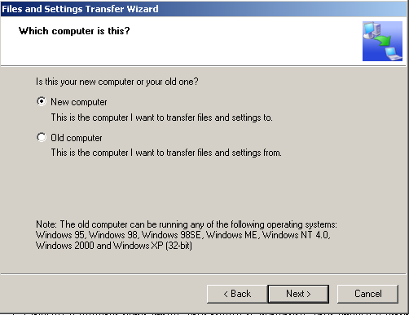
PROCEDURE:
Write the AIM and DO NOW.
Get students working!
Take attendance.
Go Over HW
Collect HW
Go over the Do Now

Assignment #1:
In Windows XP, Microsoft introduced the Files and Settings Transfer Wizard. You can use this wizard if you get a new system, but you want to transfer all your files and settings. Here is how you do it. Run the Files And Settings Transfer wizard (You may need to do this from the Windows XP CD. After you put the CD in and it autoloads, it is under the Additional Tasks Link. If you already have it, it should be under Start, Programs, Accessories, System Tools. The wizard prepares your old drive to transfer its settings. Then you install Windows XP on the new hardware and run the File and Settings Transfer Wizard on the new computer.

Sample Test Question:
1) Which of the following tech utilities is available in Windows XP, but not in Windows 98?
A) Files and Settings Transfer wizard B) System Tools
C) Control Panel D) Command Line

2) After upgrading a system from Windows 98 to Windows XP Professional, you notice that the modem no longer works, even after you manually attempt to reinstall the driver. What is the first thing that you should check before making a call to technical support?
A) Check the Windows XP Hardware Compatibility List (HCL)
B) Check the Windows XP Approved Vendors List (AVL)
C) Remove the modem and check the jumpers to make sure it is configured for Plug and Play detection
D) Check the modem manufacturer’s web site for an updated driver

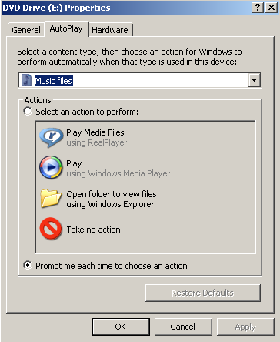
Assignment #2:
Windows XP includes an AutoPlay feature that’s set by default to spring into action when you insert a removable storage item such as a CD, a DVD, a removable disk. AutoPlay is designed to take different actions for different types of content. Explore the AutoPlay properties.

Assignment #3:
Display your onscreen keyboard by going to Start, All Programs, Accessories, Accessibility, On-Screen Keyboard. Play around with the Settings.

Sample Test Question:
1) What should be done before installing an OS?
A) Make sure your hardware and the software you will put the computer can work with the OS. By going to Windows Marketplace (formerly known as Hardware Compatibility List, HCS) at www.windowsmarketplace.com.
B) Do a Windows update to make sure you have the latest patches.
C) Upgrade your drivers before installing the OS so your devices work properly after the install
D) Why do anything if everything is going to be wiped out anyway.

- You want to multiboot with Windows 98 and Windows XP. Which do you install first?
A) You can’t multiboot because Windows 98 is only FAT 32 and Windows XP is NTFS
B) You can multiboot, but you need third party (other than Microsoft) software and either can go first.
C) Windows XP
D) Windows 98

- If for some reason your CD drive is not auto-running and you want to upgrade to Windows 2000 or Windows XP. What file can you run on the Windows 2000 or Windows XP CD to start the upgrade?
A) Setup B) Install C) Run D) WINNT32.EXE

- What should you do after installing Windows?
A) Determine how you want to partition you drive
B) Determine your computer’s network role
C) Update the OS with patches and service packs
D) Increase RAM

- What are the minimum requirements to install Windows XP?
A) 166 MHz CPU 32MB RAM 1 GB Hard Drive
B) 233 MHz CPU 64MB RAM 1.5 GB Hard Drive
C) 500 MHz CPU 256MB RAM 20 GB Hard Drive
D) 1GHz CPU 512 MB RAM 40 GB Hard Drive

- We used a volume license version of Microsoft XP that didn’t have any serial numbers and didn’t require activation. But single users require that you activate Microsoft Windows XP. If you do not complete the registration process for Windows XP, what will happen to your computer?
A) Nothing. Activation is optional
B) The computer will work fine for 30 days and then Windows XP will be disabled.
C) Microsoft will not know how to contact you to provide upgrade information.
D) You will have to use a floppy disk set to boot to windows XP

- Which of the following is an advantage of running Windows 2000 on NTFS as opposed to FAT32?
A) Security B) Support for DOS applications C) Long Filenames D) Network Support

- I downloaded Microsoft’s Setup Manager to create a text file to do an unattended install (like we did since we didn’t have to enter any information). After the installing 30 PCs with my unattended version of Windows XP, what do I have to do?
- Change the computer name on the all the computers since the computers all have the same name
- Enter the CD key
- Enter the product key
- Enter the CD serial number

Assignment #4:
In Windows XP, Microsoft introduced the Files and Settings Transfer Wizard. You can use this wizard if you get a new system, but you want to transfer all your files and settings. Here is how you do it. Run the Files And Settings Transfer wizard (You may need to do this from the Windows XP CD. After you put the CD in and it autoloads, it is under the Additional Tasks Link. If you already have it, it should be under Start, Programs, Accessories, System Tools. The wizard prepares your old drive to transfer its settings. Then you install Windows XP on the new hardware and run the File and Settings Transfer Wizard on the new computer.

Sample Test Question:
1) Which of the following tech utilities is available in Windows XP, but not in Windows 98?
A) Files and Settings Transfer wizard B) System Tools
C) Control Panel D) Command Line

2) After upgrading a system from Windows 98 to Windows XP Professional, you notice that the modem no longer works, even after you manually attempt to reinstall the driver. What is the first thing that you should check before making a call to technical support?
A) Check the Windows XP Hardware Compatibility List (HCL)
B) Check the Windows XP Approved Vendors List (AVL)
C) Remove the modem and check the jumpers to make sure it is configured for Plug and Play detection
D) Check the modem manufacturer’s web site for an updated driver

Assignment #5:
Windows XP includes an AutoPlay feature that’s set by default to spring into action when you insert a removable storage item such as a CD, a DVD, a removable disk. AutoPlay is designed to take different actions for different types of content. Explore the AutoPlay properties.

Assignment #6:
Display your onscreen keyboard by going to Start, All Programs, Accessories, Accessibility, On-Screen Keyboard. Play around with the Settings.

Assignment #7: You can download a free utility that will tell you the manufacturer of your PCs motherboard. Get it at www.majorgeeks.com/download181.html

Sample Test Questions:
1) You’ve successfully completed an upgrade to Windows 2000 Professional. Several days later, you add your old printer, using the driver that originally came with it. Now the printer, which has never had a problem, won’t print. What do you need to fix the problem?
A) Older printers are often not compatible with Windows 2000. You may need to replace the printer
B) Your printer driver is out-of-date. Contact the vendor or visit its website for an updated driver
C) Uninstall, and then reinstall the printer using the original driver.
D) None of the above

2) You place a Windows 2000 installation CD in the CD-ROM drive and turn on your computer. If the “Press Any Key to boot from CD” message CD does not appear, what could be the problem?
A) You PC is not configured to boot from CD-ROM B) You need to clean the CD
C) You need to clean the CD-ROM drive D) You forgot to press a key

True or False:
- Windows XP does not support FAT32.

Short Answer:
- What Windows feature is a paging file associated with?

2) What needs to be done to a hard disk prior to formatting?

