Student Version L E S S O N P L A N #35 Per. Name:

CLASS: Computer Repair, Maintenance, Upgrade and Management DATE: Wednesday December 09th, 2009

TOPIC: Maintaining, Optimizing, and Troubleshooting Windows 2000.

AIM: How do we maintain, optimize, and troubleshoot Windows 2000?

H.W. # 35
List the steps, in detail, to create a dynamic disk with 2 volumes as shown below.
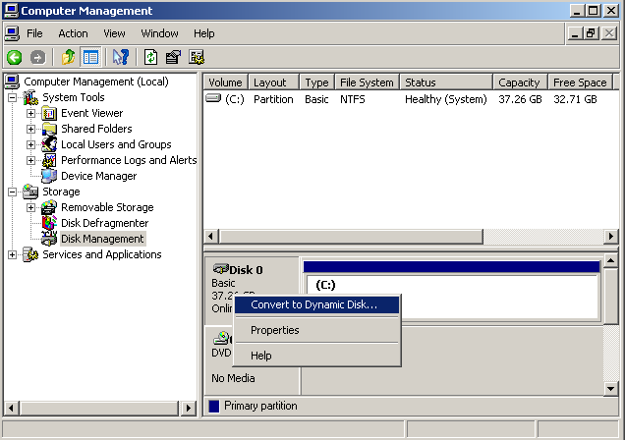
DO NOW:
- What is a service pack?

- What is a patch?

Go to http://www.smartcomputing.com/Editorial/daily/dailycontent.asp?guid=&did=2900451 for a more complete reading on the differences between service packs, updates, patches.

If you haven’t already done so, install service pack 4 for Windows 2000.

2) If you haven’t already done so, add a second hard drive to your Windows 2000 computer. After installing your 2nd drive, open up Computer Management and convert your 2nd hard drive from basic disk to a dynamic disk
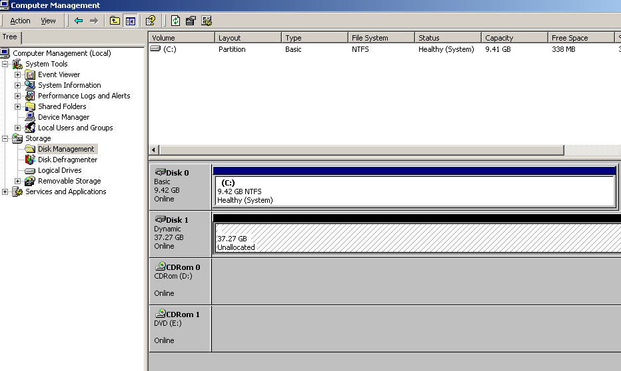

After doing this create a volume in this second drive using half the space.
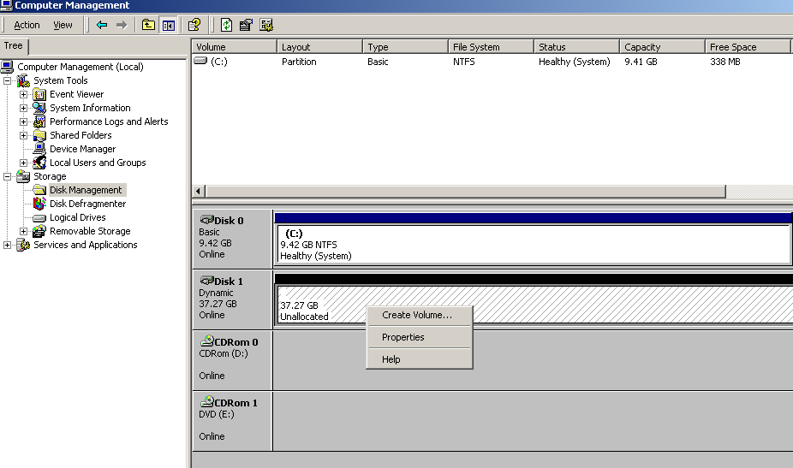

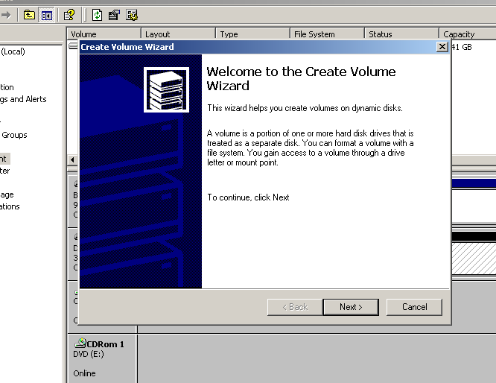

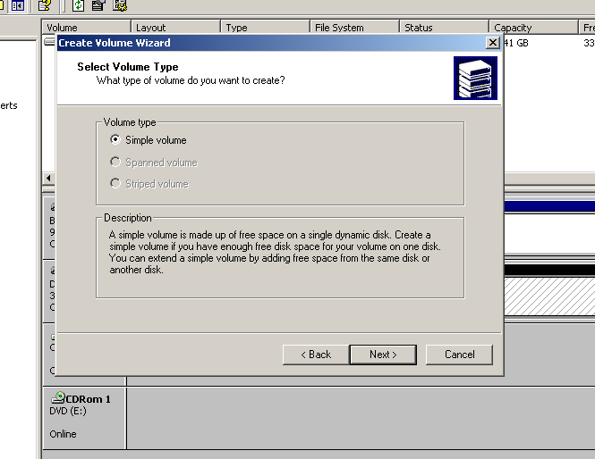

Create another volume so that your drive situation looks like below

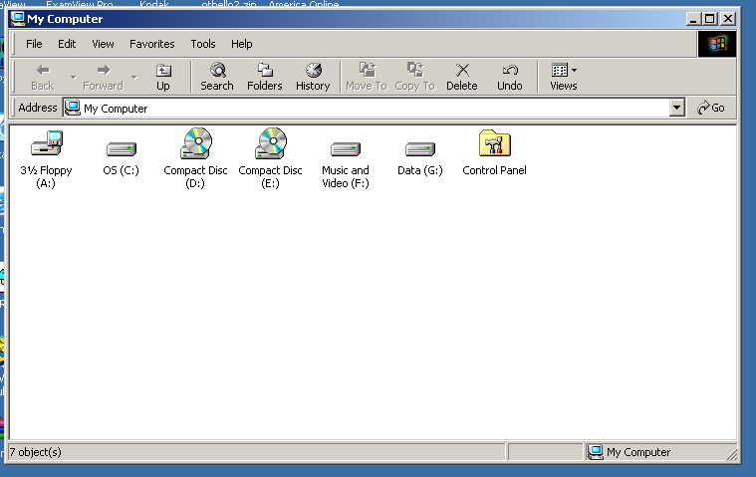

PROCEDURE:
Write the AIM and DO NOW.
Get students working!
Take attendance.
Go Over HW
Collect HW
Go over the Do Now

Microsoft included a new registry editor in Windows 2000 called REGEDT32.EXE, but it also includes the old registry editor REGEDIT.EXE. REGEDT32.EXE is a more powerful registry editor than REGEDIT.EXE, but it doesn’t include a good search feature. Typically, searches in the registry in Windows 2000 are done with REGEDIT.EXE, but changes are made using REGEDT32.EXE.

Assignment #1:
Use the registry to check your double click speed.

Assignment #2:
What is the purpose of a swap file?

The swap file, or page file as it is called in Windows 2000, is PAGEFILE.SYS. Do a search for this file and state its path (location on the computer).

Assignment #3:
If you have a second hard drive, you can get a nice performance boost by moving your page file from the C: drive to the second hard drive. To move your page file, go to the Control Panel then System applet and select the advanced tab. In the Performance section, click the Settings button to open the Performance options dialog box. Select the Advanced tab, and click the Change button in the Virtual Memory section. Select a drive from the list and give it a size or range, and you’re ready to go. Make your Virtual Memory size 3 times the actual RAM in your machine, if possible.

Assignment #4:
In Windows 2000, go to My Network Places (which differs from Windows 98’s Network Neighborhood) and look up the “Computers Near Me”. Which are the computers near you? ________________________________________________________

Assignment #5:
In Control Panel, go to Users and Passwords and create an account for a user. Create a folder on your Windows 2000 computer and set permissions on this folder for the user you created.

Assignment #6:
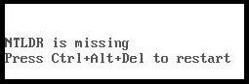
In Windows 2000, there are files that start the PC or boot, and then there are the rest of the operating system files. The boot files consist of NTLDR (pronounced NT Loader), BOOT.INI, NTDETECT, and NTBOOTDD.SYS. Of these four, NTLDR begins the process. The area the boot files occupy is called the system partition. The Windows 2000 OS kernel is NTOSKRNL.EXE. The area that OS system files occupy is called the boot partition (Notice the names are reversed).

Question:
In Windows 2000, what is the name of the area that the boot files occupy? System partition

In Windows 2000, what is the name of the area that the system files occupy? Boot partition.

Go to http://en.wikipedia.org/wiki/NTLDR and read about what NTLDR does and what BOOT.INI does?

Question:
What does BOOT.INI do?

What does NTDETECT do?

Question: I've installed 2000 with 98 for dual boot. Was working fine for about 2 weeks then all of a sudden when it boots up and I tell it to load 98 it gives me error non system disk and won't boot to 98 but will boot to 2000. What could be the problem?

Go to http://support.microsoft.com/?kbid=263201. Scroll down to Winlogon.exe. What is this file responsible for?

Question:
What is the version of NTFS that comes with Windows 2000?

Question:
Which of the following is not a Windows 2000 boot file?
A) NTLDR B) NTDETECT.COM C) BOOT.INI D) NTOSKRNL.EXE

Assignment #7:
Instead of going to a myriad of places to run the various utilities (defrag, device manager, etc,) available to us in Windows 2000, you can create 1 location to run all of your utilities. The Microsoft Management Console is simply a shell program in Windows 2000 (and XP) that holds individual utilities called snap-ins. You can get to the MMC by selecting Start, Run, and typing MMC, to get a blank MMC. To add a snap-in, go to File, Add-Remove Snap-in, and then click the Add button to open the Add Standalone Snap-in dialog box and see a list of available snap-ins. Add as many snap-ins as you want, then save this as Utilities on the Desktop. You can then access all your snap-ins in one shot by double-clicking this file on the desktop.

Assignment #8:
Examine the tools in the “Administrative Tools” Feature in Control Panel.

Assignment #9:
Find out where your Windows files are installed. To do this go to the command line by going to Start, Run, then typing CMD. At the command line, type cd %systemroot%, short for change directory to the one where the Windows system files are installed. What directory (path) does it take you to?
(Although we have left Windows 98, the same command in Windows 98 is cd %windir%)

Systemroot is the tech name given to the folder (in Windows 2000/XP) in which Windows has been installed.

The registry files (called hives) for 2000/XP are in the \%systemroot%\System32\config folder. .

Assignment #10:
Do a Windows update on your Windows 2000 computer. You can go to Start, Windows Update.

Assignment #11:
To get into the Windows 2000 / XP Safe mode, as the computer is booting press and hold your "F8 Key" which should bring up the "Windows Advanced Options Menu" as shown below.

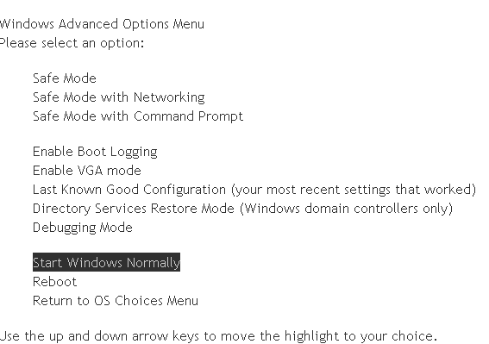

Assignment #12:
Research the Windows 2000 utility called SysPrep. What is this utility used for?

Sample Test Questions:
1) Which of the following will get you to a screen where you can add the Device Manager snap-in in to a blank MMC you have opened in Windows 2000?
A) Console, Add/Remove Snap-in, Add button
B) File, Add/Remove Snap-in, Add Button
C) Console, Add Standalone Snap-in, Add Button
D) File, Add Standalone Snap-in, Add Button

2) What is the Windows 2000 term for a collection of accounts that share the same access capabilities?
A) Domain B) Group C) Power Users D) Administrators

3) Which of the following is NOT a Windows 2000 boot file?
A) NTLDR B) NTDETECT.COM C) BOOT.INI D) NTOSKRNL.EXE

- Which of the following can the Add/Remove hardware applet (in Control Panel) perform in Windows 2000?
A) Configure the registry B) Uninstall the device driver
C) Reconfigure a multiple display layout D) Disable a PC Card drive before it is removed

5) You have configured a dual boot system consisting of Windows 98 in a FAT32 partition and Windows 2000 in an NTFS partition. You checked your Windows 2000 installation and it looks good. However, when you boot to Windows 98, you can’t see the files in the Windows 2000 partition. What might be the source of the problem?
A) The partition has not been made active B) Windows 98 file sharing hasn’t been turned on
C) Windows 98 is not compatible with NTFS D) NTLDR does not start when loading Windows 98

- In Windows 2000 explorer, opening the C:\WINNT folder shows no files. What is the cause?
A) Virus infection B) System files have been deleted. C) System files all have the system attribute set
D) Windows explorer automatically hides system files from view

- What applet should you use to add Windows components distributed on the Windows 2000 professional CD?
A) System Settings B) Regional settings C) Add/Remove Programs D) Windows 2000 Professional Resource Kit

- What tool ensures that a newly installed device on Windows 2000 Professional is functioning properly?
A) System B) DOS Prompt C) Device Manager D) Add/Remove Hardware

- How can a Windows 2000 shortcut be created for opening specific application?
A) Open the application, go to File and choose Create shortcut
B) Right-click on the application file within Windows Explorer, and choose create shortcut
C) In Control Panel, My Documents, right-click on the application file, and choose Create Shortcut
D) Right-click on the application files from the Documents options of the Start menu and select Create shortcut

- Which is NOT a way to display the Task Manager in Windows 2000?
A) Press CTRL-ALT B) Press CTRL-SHIFT-ESC
C) Right-click on the taskbar and choose Task Manager D) Press CTRL-ALT-DEL then click Task manager

- The screensaver can be changed in the ______________ dialog box
A) Display Properties B) Taskbar C) Menu Bar D) Shortcut Menu

- The Taskbar can be increased in size by _________________
A) Right-clicking the mouse and dragging the Taskbar to make it bigger
B) Left-clicking the mouse and double-clicking the Taskbar
C) Moving the mouse pointer to the top of the Taskbar, pausing until the pointer turns into a double-headed arrow, and then clicking and dragging.
D) Highlighting the Taskbar and double-clicking in the center.

- Which of the following file attributes are available to files on a FAT32 partitions?
A) Hidden, Read Only, Archive, System B) Compression, Hidden, Archive, Encryption, Read Only
C) Read Only, Hidden, System, Encryption D) Indexing, Read Only, Hidden, System, Compression

- If a program doesn’t have a shortcut on the Desktop or in the Programs submenu, you can start it by ______________
A) Using the Shut Down command B) Typing cmd I the Start Run box
C) Using the Run command and typing in the name of the program
D) Typing cmd in the Start box followed by the program name

- In Windows, a deleted file can be retrieved using which of the following?
A) My Computer icon B) Recycle Bin C) Control Panel D) Settings Panel

