Student Version L E S S O N P L A N #31 Per. Name:

CLASS: Computer Repair, Maintenance, Upgrade and Management DATE: Thursday December 3rd, 2009

TOPIC: Distinguishing characteristics of Windows 98/Me

AIM: What are the distinguishing characteristics of Windows 98/Me?

NOTE: We are going to the OS part of A+ for a while then we’ll go back and forth some more between OSs and hardware.

H.W. # 31:
1) Why would you need to back up your registry?
2) How do you configure your swap file size on your computer?
3) When might you have to boot into safe mode?
4) Why might you need to reduce your software disk cache memory size?

DO NOW: Yesterday we spoke about the registry. If anything goes wrong with your computer, it would be good to have a good copy of the registry saved as a backup so you can restore the working registry when the current one goes bad. Go to Start, Run, then type command (or CMD in Windows 2000/XP). Type ScanReg /?

How can you back up the registry?

How can you restore the registry?

How can you fix the registry?

These work when you boot into MS-DOS mode. To back up the registry from Windows 98 do the following:

To Backup Your Registry In Windows 98:
- Click Start/Run, type SCANREGW and click OK.
- This will launch Windows' Registry scanner and backup utility. Once complete you will see a Registry Scan Results dialog box informing you of the results of the scan (it will tell you whether there were errors or not) and asking if you'd like to create a backup.
- Click the Yes button and Scanreg will replace your oldest backup with a current copy of the Registry.
- That's it. It's that easy.

Windows 98 automatically backs up the registry every time you reboot!

PROCEDURE:
Write the AIM and DO NOW.
Get students working!
Take attendance.
Go Over HW
Collect HW
Go over the Do Now

Question:
What is virtual memory?

Question:
What is a swap file?

Question:
When is the swap file needed or used?

Question:
What effect does swapping have on the speed of the computer’s operations?

Why?

Question:
If swapping slows down the computer, why should swapping be done?

Windows 9x/Me is really two products: a DOS protected mode interface (DPMI) and a protected-mode GUI. DMPI is composed of three main files: IO.SYS, MSDOS.SYS, and COMMAND.COM. COMMAND.COM provides the user interface that an OS is supposed to have, but at the command line level. Go to Start, Run, then type COMMAND. At the command prompt, type ver. What does this show you?

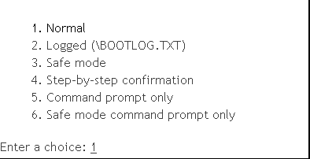
For troubleshooting purposes, you many need to boot Windows 98 in a manner other than a normal startup. In that case, you would like to have a menu with a variety of boot options or a boot menu. To access the Windows 98 boot menu, pres F8 as the computer is booting up.

Assignment #1:
Go to http://www.smartcomputing.com/editorial/article.asp?article=articles/2005/s1602/08s02/08s02.asp&guid= and

and briefly describe the 6 menu options:

Normal

Logged

Safe Mode

Step-by-Step confirmation

Command prompt only

Safe mode command prompt only

A quick adjustment to the Windows System Configuration Utility (also known as msconfig) will force your computer to display the Startup Menu each time it boots. Go to Start and Run and type msconfig in the Open field. Select the Advanced button on the General tab and place a check mark in the Enable Startup Menu box

Assignment #4:
MSDOS.SYS is the file that controls the Windows 98 Startup Menu, and also other things. You may need to edit the contents of MSDOS.SYS To learn how to do so, go to http://www.computerhope.com/msdossys.htm. Instead of using msconfig as stated above, how else can you make the boot menu appear automatically at startup?

Questions:
1) Maria has deleted a set of pictures. She thought she had backups but now she can’t locate them. Where should she check first if she wants to recover the deleted pictures?

2) Which is a safer place for trained technicians to make changes or modifications: the Control Panel or the Registry? Explain your choice?

The A+ exam includes questions about user accessibility for those computer users who have impairments. Know where and what settings you can change to accommodate the hearing and visually impaired.

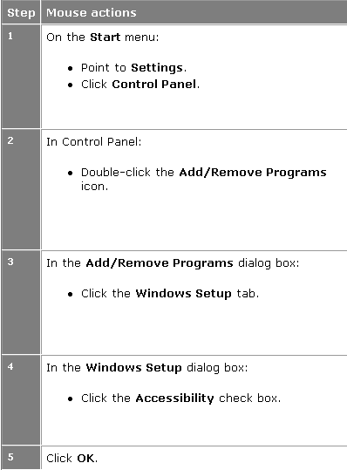
From control panel you can manage other accessibility options using the Accessibility Options dialog box shown below
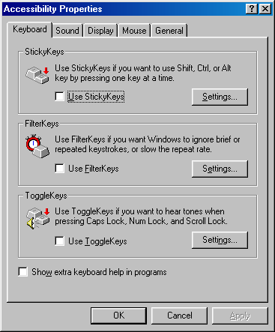

Scroll through the tabs in the Accessibility properties to see what each one does.

To diagnose your system you can use some DOS utilities (you may have to copy some of these from the A+ Stuff folder to your C drive, then run it from your C: Drive

Assignment #5:
Run the Microsoft Diagnostics Utility (MSD.EXE) to examine your system

Assignment #6:
Run the MEM utility to examine your system’s memory

A disk cache is a mechanism for improving the time it takes to read from or write to a hard disk. Today, the disk cache is usually included as part of the hard disk. This is hardware cache or sometimes called buffer memory in advertisements. A disk cache can also be a specified portion of random access memory (RAM). This is called software cache. The disk cache holds data that has recently been read and, in some cases, adjacent data areas that are likely to be accessed next.
Before Disk caching came along, DOS used buffers to speed disk access. A buffer is an area in main memory (e.g. DIMMs) where data waiting be read or written is temporarily stored. Buffers are implemented by putting the
BUFFERS = [NUMBER] command in config.sys.

With Windows 3.1, it used a program called SMARTDrive, a software caching utility.

With Windows 9x/Me, it used a program called VCACHE.

With Windows NT/2000/XP, software caching is built directly into the OS.

To view your Disk cache size:
1.Start System Monitor (select Start > Programs > Accessories > System Tools > System Monitor)
2.To add an item to be displayed, select View > Add Item
3.The entries for the Disk Cache size are found under the Memory Manager category (Disk cache size, Maximum disk cache size, Mid disk cache size, Minimum disk cache size)
What is the size of your memory cache?

What percent is this of your total memory?

Sample Test Questions:
1) A customer uses a Windows 98 machine with a 20GB hard drive formatted with FAT32 and tries to install an old DOS program, but gets an error message that there is not enough space on the hard drive. According to the drive properties, more than 12GB free space is remaining on the drive. What is wrong?
A) Windows 98 is not reporting free space properly B) The DOS program does not recognize a FAT32 partition
C) Windows 98 does not support any D) The partitions on the primary hard drive are not set to active
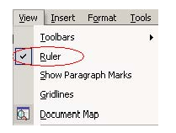
2) What does a check mark next to an item on a Windows menu indicate concerning a command?
A) Active B) Inactive C) Available D) Unavailable

3) During boot up, which function key allows you to boot directly to Safe Mode in Windows 9x?
A) <F4> B) <F5> C) <F6> D) <F7>

4) What is the outcome of running disk defragmentation?
A) File sectors large B) File sectors small C) Faster data transfer D) Slower access speed

5) When a user deletes a file, empties the Recycle Bin, what happens to the file?
A) Clusters are flushed B) The file is move to C:\Windows\Temp
C) Sectors of the hard drive are blanked/erased D) Associated entries in the FAT are removed

6) You are troubleshooting a system with a problematic registry. You want to replace the current copy of the registry with an older copy. You open a command prompt window. What command should you issue to accomplish this?
A) SCANREG /REVISE B) SCANREG /RESTORE
C) SCANREG /REPLACE D) SCANREG /REVERSE

7) Which registry files in Windows 9x are stored in the Windows directory?
A) SYSTEM.IDX and USER.IDX B) SYSTEM.DAT and USER.DAT
C) SYSTEM.EXE and USER.EXE D) SYSTEM.ADM and USER.ADM

8) Which tool can be used to fix cross-linked files in Windows 9x?
A) CHKDSK B) DEFRAG C) SCANDISK D) DRIVESPACE

