Student Version L E S S O N P L A N #26 Per. Name:

CLASS: Computer Repair, Maintenance, Upgrade and Management DATE: Wednesday November 17th, 2009

TOPIC: RAID Hard Drives

AIM: How do we set up a RAID system?

NOTE:
Do not change any settings on the computer. Keep your computer area clean. Don’t write on the computers. Don’t throw your garbage underneath your desks.

H.W. # 26:
1) Explain Disk Mirroring
2) Explain Disk Striping
3) What is RAID 1?
4) How can you set up RAID in your PC?

DO NOW:
What is the most expensive part of a PC?

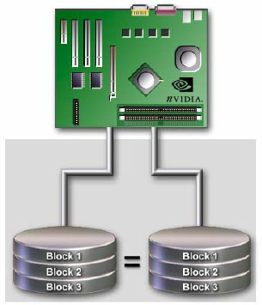
PROCEDURE:
Write the AIM and DO NOW.
Get students working!
Take attendance.
Go Over HW
Collect HW
Go over the Do Now

If you got the correct answer, then you know data is the most expensive part of the PC. How could you replace data that was lost (and wasn’t backed up)? You can’t unless you implement some backup method. So let’s take a look at a couple of ways you could back up your data.
One way is to install a hard drive controller that reads and writes to two hard drives simultaneously. The data on each drive would always be identical. One drive would be the primary drive and the other drive, called the “mirror”, would not be the primary unless the primary drive failed. The process of reading and writing data at the same time to two drives is called disk mirroring.
Original Data
Mirrored Data
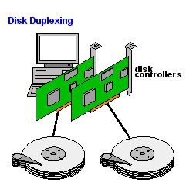
If you really want to make data safer, you can use two separate controllers, one for each drive. With two drives, each on a separate controller, the system will continue to operate, even if the primary controller’s drive stops working. This drive mirroring technique is called drive duplexing. Drive duplexing is much faster than drive mirroring since one controller does not write each piece of data twice.

The many different techniques using multiple drives for data protection have been standardized under the term RAID. RAID stands for Redundant Array of Independent Disks. There are various types of RAID. The one we have described here is known as RAID 1 (mirroring or duplexing).
There are other versions of RAID, not necessarily for data protection, but for speed of writing data to disks. Instead of writing data on one disk, you can write data to multiple disks. Theoretically this makes data storage and retrieval much faster. This type of RAID that writes data across multiple disks is known as RAID 0.
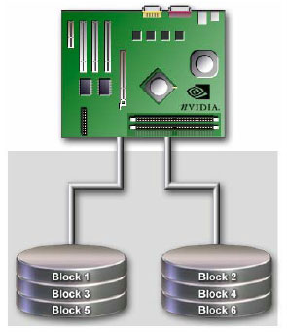
Here is summary of RAID 0 and RAID 1.

RAID 0 Striping:
The data is written across multiple drives to improve access performance. There is no data redundancy. For example, a 4 MB file would be written across 4 drives in 1 MB pieces. Note that the failure of one drive will render the data inaccessible. The advantage is much higher throughput.

RAID 1 Mirroring
Provides 100% redundancy providing an exact copy or mirror of the primary drive. Should one drive fail, the data will be completely accessible on the other drive. There is no performance improvement unless simultaneous reads are allowed. Note that twice as many drives must be purchased. One controller can provide mirroring across one bus or two controllers can be used to provide controller redundancy as well as drive redundancy.

There are types of RAID. The A+ exam is interested in your understanding of RAID levels 0, 1, and 5. Research RAID 5 at www.techweb.com/encyclopedia. Read the introduction to RAID and then read RAID level 5

What is RAID 5?

For many years, implementing RAID fell in the domain of SCSI which is a method that allows you to daisy chain several devices together. This was good because you could daisy chain several hard drives together and implement RAID. But with specialized RAID ATA controllers, you can do without SCSI to implement RAID. Also, serial ATA allows you to implement RAID easily.

Activity #3: Go to www.tigerdirect.com and look up a motherboard that supports RAID via its serial ATA ports. Try this one http://www.tigerdirect.com/applications/SearchTools/item-details.asp?EdpNo=3523225&Sku=E145-2034. Read the specs on this hard drive. If you have ear phones connect them to the sound output port on the back and look at the bottom video describing the motherboard.

Activity #4: If you don’t have a motherboard with built in RAID support using serial ATA drives, you can add an adapter card for this. Go to http://www.tigerdirect.com/applications/searchtools/item-Details.asp?EdpNo=1281807&sku=M501-1086&srkey=Sabrent%20Silicon%20Image%20Serial%20ATA%202-port%20SATA%20RAID%20PCI%20Controller%20Host%20Card%20Adapter.

What are the features of this card?

Research Items:
- At www.techweb.com when you look under hard drives, one of the specifications is buffer. What is this?

- Another specification for hard drives is seek time. What is this?

- Most modern hard drives use a function called SMART. What is this?

- As technology gets better, drives become faster. Faster drives generate a lot of heat, possibly causing the computer to overheat. This is especially true in tight cases such as mini-towers, or cases containing too many components. One solution to this is by adding a drive bay fan. Look on of these up at www.tigerdirect.com and list its specifications.

- Look at an advertisement for a hard drive on www.tigerdirect.com. What are some other specifications for hard drives?

