Student Version L E S S O N P L A N #25 Per. Name:

CLASS: Computer Repair, Maintenance, Upgrade and Management DATE: Monday November 16th, 2009

TOPIC: SATA Hard Drives

AIM: How are SATA drives different than PATA drives?

NOTE:
Do not change any settings on the computer. Keep your computer area clean. Don’t write on the computers. Don’t throw your garbage underneath your desks.

H.W. # 25:
1) What are the benefits of SATA over PATA?
2) How do you connect a serial ATA drive?
3) How can you attach your PATA drive to your SATA port?
4) How many SATA drives can you have per SATA controller?

DO NOW:
- Go to www.techweb.com/encyclopedia. Look up the term Cable Select. What is cable select? How is it different from jumpering Master/Slave drives? What are the requirements to use a Cable Select drive?

2) What are some drawbacks of the parallel ATA drives that are currently in existence? To help you answer this question look up SATA at www.techweb.com/encyclopedia. Answer the following questions
A) What is the maximum distance of PATA cables?

B) What is the maximum distance of a SATA cable?

C) Why is it good to have a cable that is longer?

D) How does the physical width of a SATA cable compare to the width of a PATA cable?

E) How is this beneficial in a PC case?

F) What are the transfer rates for serial ATA?
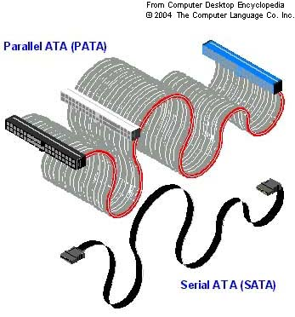

G) Refer to lesson plan 26. How do the SATA rates compare to the PATA rates?

PROCEDURE:
Write the AIM and DO NOW.
Get students working!
Take attendance.
Go Over HW
Collect HW
Go over the Do Now
Serial ATA addresses the limitations of Parallel ATA drives. The serial interface needs 7 wires instead of the 80 wires required on the newer PATA drives. This results in much thinner cabling, enabling better cable control and better airflow throughout the PC, resulting in better cooling.
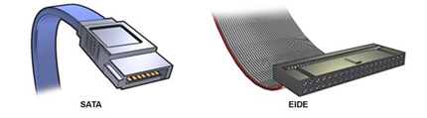
The maximum SATA cable length is more than twice that of the PATA cable (39.4 inches as compared to 18 inches). This comes in handy when you have a full tower with an IDE device at the top and the IDE controller connector at the bottom and you have to weave around other cables and devices. The extra length of SATA cables allow you to make those connections.

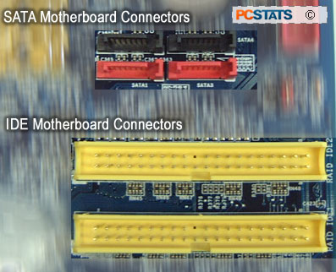
SATA devices are also hot swappable, meaning they can be plugged into or removed from the PC without having to shutdown. Although SATA speeds are about 150MBps to 300MBps, they are expected to go up to 600MBps.

Activity #1:
Go to http://www.tigerdirect.com/applications/SearchTools/item-details.asp?EdpNo=2795126&CatId=139. List the features of this drive.

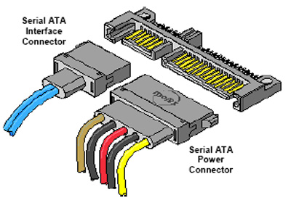
Installing SATA drives is even easier than installing IDE devices due to the fact that there are NO master, slave, or cable select configurations to mess with. SATA only supports a single device per controller channel. Simply plug the power and plug the controller cable in. The OS automatically detects the drive and it’s ready to go.

SATA drives are backwards compatible with current PATA standards, and you can install a PATA devices, including hard drives and CD-media drives, among others, to a SATA controller using a device called a SATA bridge. So if you have a PATA drive and wish to connect it to your SATA controller you can do so.

Activity #2
Go to http://www.granitedigital.com/catalog/pg52_satabridgeboards.htm and examine a SATA bridge.

Sample Test Question:
What is the maximum cable length of an internal serial ATA device?

The previous question leads us to the next thing. SATA defines only internal drives, but eSATA (External SATA) enables them to reside in their own housing outside the computer and be plugged in as required. Providing an external, hot swappable drive solution similar to USB, SATA offers much higher speeds than the USB bus.
Cables up to two meters long attach eSATA drives to the computer either via an eSATA PCI card or directly to the internal SATA socket on the motherboard. A short cable extends the motherboard socket to the back of the computer. Designed for thousands of insertions, eSATA plugs and sockets are more rugged than internal SATA connectors.
Sample Test Question: (To help answer this question, go to www.techweb.com/encyclopedia and look up IDE, then scroll to the bottom where you see ATA standards)
Which of the following is part of the ATA-7 standard?
A) Red controller connections on the motherboard
B) SATA
C) ATA/100
D) 1 meter maximum cable length

Sample Test Question:
What is the maximum number of SATA drives you can have on a system?
A) One master, one slave
B) Two, with no master/slave distinction
C) Eight
D) There is no maximum other than the limitations of your motherboard.

Sample Test Question:
Simon wants to connect his old PATA hard drive to the SATA controller in his new computer. What doe he need to do this?
A) A SATA bridge to plug into the connector on the PATA drive
B) A PATA converter to plug into the SATA bridge on the controller
C) Nothing at all; he can just connect the PATA drive directly to the SATA controller
D) He can’t do it; the SATA controller is not backward compatible with PATA drives.

Activity #3:
Go to http://www.tigerdirect.com/applications/SearchTools/item-details.asp?EdpNo=1281812&CatId=1455. What is this device used for?

