Student Version L E S S O N P L A N #23 Per. Name:

CLASS: Computer Repair, Maintenance, Upgrade and Management DATE: Thursday November 6th, 2009

TOPIC: Floppy Drives AIM: What are the different components of a floppy drive?

NOTE:
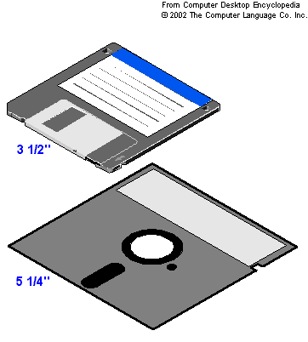
Do not change any settings on the computer. Keep your computer area clean. Don’t write on the computers. Don’t break the computers and peripherals like the mice and keyboards. Don’t throw your garbage underneath your desks. Don’t throw your garbage behind the computer. Throw the garbage in the trash can.

H.W. # 23:
- Before floppies can be used to store data, they must be formatted. How can we format a floppy disk in a PC?
- What are the drive letters that can be assigned to floppy disk drives?
- How many wires are in the floppy disk drive cable?
- If a floppy disk drive cable has a twist in it, which side goes to the floppy drive?
- Why don’t all floppy disk drive cables come with a twist?
- If you are connecting a floppy disk drive to a floppy disk drive ribbon and the ribbon has a twist, how can you determine the drive letter that the floppy disk drive will get?
- What are some other media that can be used effectively instead of using a floppy disk?
- What is the PC component that fails most often?
- What is a good preventative maintenance technique performed on floppy drives?

DO NOW:
Does your computer (in front of you) have a floppy drive? If yes, why would you still have a floppy drive if the capacity of the floppy disk is only 1.44 MB? If not, why

PROCEDURE:
Write the AIM and DO NOW.
Get students working!
Take attendance.
Go Over HW
Collect HW
Go over the Do Now

Story of room 4E14
In 1997, there were 34 IBM 8086 PCs. These machines did not have a hard drive. Their form of permanent storage was a floppy disk. At that time, the size of the floppy disk that went into the floppy disk drive was 5.25 inches wide. Gradually all those computers were switched first to x286’s then x386s then to 486s then to Pentium Is, and finally to Pentium IIs. Although these are still old, but they are more modern than those from 10 years ago.
Floppy Disk Geometry
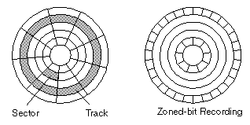
We are going to focus on the prevalent 3.5-inch floppy disks and briefly the older 5.25-inch floppy disks. The first thing we want to know is what is this floppy disk made of. Go to www.techweb.com/encyclopedia and look up magnetic disk.
How is the magnetic disk divided so it can store information?

What is the typical byte size of a sector on a floppy disk?

How is the floppy disk divided into sectors and tracks? To help us answer this question let’s go to www.webopedia.com and look up the term format. What happens when you format a disk?

Activity #1:
Take a floppy disk and insert it into the floppy disk drive. Go to Start, Programs, MS-DOS prompt. At the prompt type format a: Write down your observations of what happens when you format the floppy disk.

Look up the term cluster at www.techweb.com/encyclopedia. What is a cluster?

Go to http://www.pcguide.com/ref/fdd/media.htm and click on media density. What does TPI (Tracks per inch) mean?

What does BPI (Bits per inch) mean?

Density Characteristic | 360 KB 5.25" | 1.2 MB 5.25" | 720 KB 3.5" | 1.44 MB 3.5" | 2.88 MB 3.5"
Track Density (TPI) | 48 | 96 | 135 | 135 | 135
Bit Density (BPI) | 5,876 | 9,869 | 8,717 | 17,434 | 34,868
Density Name | Double Density (DD) | High Density (HD) | Double Density (DD) | High Density (HD) | Extra-High Density (ED)
Look at the tables below that contain formatting information about floppy disks and answer the questions that follow:

Geometry Specification | 360 KB 5.25" | 1.2 MB 5.25" | 720 KB 3.5" | 1.44 MB 3.5" | 2.88 MB 3.5"
Tracks (Cylinders) | 40 | 80 | 80 | 80 | 80
Sectors Per Track/Cylinder | 9 | 15 | 9 | 18 | 36
Total Sectors Per Disk | 720 | 2,400 | 1,440 | 2,880 | 5,760

The 3.5 inch floppy has 80 tracks x 18 sectors per track x 512 bytes per sector x 2 sides. How many bytes does this equal?

File System Parameter | 360 KB 5.25" | 1.2 MB 5.25" | 720 KB 3.5" | 1.44 MB 3.5" | 2.88 MB 3.5"
Cluster Size | 2 sectors | 1 sector | 2 sectors | 1 sector | 2 sectors
Maximum Number of Root Directory Entries | 112 | 224 | 112 | 224 | 448

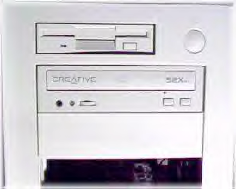
Installing Floppy Drives
To install your floppy drive you have to physically insert it in the drive bay. Usually it will be a 3.5-inch floppy drive so you will insert it in the 3.5-inch drive bay.
As you insert the floppy drive, you will have to make two connections in the back of the floppy drive. The first one is for the power. Usually, you will use the mini-power connector or Berg from the power supply.
The next connection you have to make is the connection from the floppy drive to the motherboard via the 34-pin floppy disk drive ribbon cable.
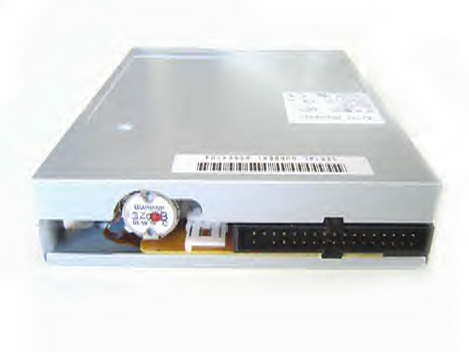
If the cable supports two floppy drives, it will have a seven-wire twist used to differentiate electronically between the A and B drives. If the floppy drive is installed on the end connector, it becomes the A drive. If the drive is installed on the middle connector, it is the B drive.
If you want to change this, floppy drives sometimes come with jumpers. Depending on where you place the jumpers, that floppy drive will become the A: drive or B drive.
Another way to change the letter designation of the drives is via CMOS. In CMOS there is a “Swap Floppy Device” option that allows you to change the drive letter designations without moving the cables or moving jumpers. While you are in CMOS, check the “Boot Sequence”. Here you can decide if you want to boot off of the floppy first or not.
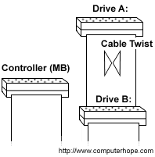
Not many users have two floppy disk drives, so many manufacturers are making floppy disk ribbon cables for only one drive, thereby eliminating the need for the twist and extra floppy drive connector.
When connecting the ribbon to the motherboard, make sure the red wire goes to pin 1 labeled on the motherboard. Usually you won’t have trouble inserting floppy drive ribbon cables because they usually have a notch and can only go in one way.
After installing your floppy drive, go into CMOS to make sure that your CMOS has the correct information for your floppy drive.
In CMOS, besides the “Swap Floppy Device” option, you may also see the “Boot Up Floppy Seek” option. This option, if enabled, tells the PC not to check for the floppy drive during POST. All this really does is speed up the boot process. It doesn’t disable the floppy drive. It just means that POST doesn’t check to see if it is working.

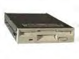
Troubleshooting Floppy Drives: When a floppy drive stops working, follow these steps to resolve the problem:
- Check for a bad floppy disk. How? Try different floppy disks in the same drive.
- Check for data errors on the disk. How? Put in a floppy disk into the disk drive. Go to My-Computer. Right-Click on the A: drive. Go to Properties then Tools. Go to Check Now
- Check the CMOS settings. How? Get in and make sure the floppy drive is enabled
- Check the cable. How? Check for any breaks in the cable.
- Check the floppy drive controller. How? Check to make sure no pins are broken on the floppy drive controller on the motherboard. If you have a bad floppy drive controller and you need to use a floppy drive, you have two options. Get an external USB floppy drive or get an expansion card (like a PCI card) that has a floppy connection on it.
- Replace the floppy drive. How? Disconnect cables. Unscrew it or release it from its position. Put in a new floppy drive and connect it again.

There are times when, even if you replace a floppy disk, the computer still reads the same data on the disk even though you have changed the disk. The reason this happens is that when Windows first reads a floppy disk, it keeps a copy of the directory in RAM and will not update that information unless the floppy drive detects a disk removal and activates a drive change signal. The 34th wire on the floppy drive cable is the drive change signal. If that pin is bad or broken, there is no way to detect a drive change and Windows still thinks you have the same disk in the floppy drive. So if this happens to you, check the 34th wire. Something may be wrong with it.

Protecting floppy disks and drives:
Whenever you access a floppy disk in its floppy drive, a read/write LED on the outside of the drive will flash on. You should not try to remove the floppy disk from the drive when the light is lit. That light means that the read/write heads are accessing the floppy disk, and pulling the disk out while the light is on can damage the floppy disk. When the light is off, you can push in the small release button on the front of the drive to eject the floppy disk.

Sample Test Questions:
- The storage capacity of the present-day 3-½ inch floppy disk is ____.
A) 60KB B) 1.44MB C) 160KB D) 1.66 MB

- Which of the following floppy drives has a data capacity of 2.88 MB?
A) Double Sided, Double Density 5$\frac{1}{4}$ B) Double Sided, Extra High Density 5$\frac{1}{4}$
C) Double Sided, High Density 3-½ D) Double Sided, Extra High Density 3-½

3) The smallest data storage area on a disk is called _____.
A) Track B) Sector C) read/write LED D) Metallic Film

4) The magnetic mapping of floppy drives to provide a structure for storing data is called ____
A) booting B) sectoring C) formatting D) installation

5) Which of the following floppy disks is still used in PCs?
A) Single-sided, low density B) Double-sided, double density
C) Double-sided, extra high density D) Double-sided, high density

6) What floppy drive format is used most commonly today?
A) 3 ¼ inch floppy drive B) 5 ¼ inch floppy drive
C) 3 ½ inch floppy drive D) 5 ½ inch floppy drive

7) What is the data storage capacity of a double-sided, double density 3½ inch floppy disk?
A) 360 KB B) 720 KB C) 1.2 MB D) 1.44 MB

8) Each floppy drive sector can store up to ____ bytes of data.
A) 412 B) 612 C) 512 D) 712

- The device that is used to read a floppy disk is called ____.
A) Floppy Drive B) Zip Drive C) CD-ROM Drive D) DVD-ROM Drive

- If the floppy drive is installed on the middle connector, then it is assigned the ____ drive.
A. A: B. C:
C. B: D. F:

- A few floppy drives come with a special set of jumpers that enable the user to change the floppy ____.
A. format B. storage capacity
C. drive letter D. sectors

12) The ____ setting enables a user to change the A: and B: drives, without moving the cables.
A. Boot Up Floppy Seek C. Swap Floppy Device
B. Boot Sequence D. Boot Up Floppy Drive

13) If your PC is set to boot from a floppy disk and the floppy disk has no OS, and you boot your PC with that floppy, what error message do you get? “non-system disk”

14) After installing the floppy drive, the next step is to configure the ____ settings.
A. CONFIG B. BIOS
C. CMOS D. REGISTRY

15) The ____ option is used to inform the PC NOT to check the floppy disk during the POST.
A. Boot Up Floppy Seek B. Swap Floppy Device
C. Boot Sequence D. First Boot Device

16) The ____ option enables a user to manage the booting devices and their order.
A. Boot Up Floppy Seek B. Swap Floppy Device
C. Boot Sequence CMOS D. First Boot Device

17) What option can be used as a powerful security tool?
A. Boot Up Floppy Seek B. Swap Floppy Device
C. Boot Sequence D. Boot Up Floppy Drive

18) What needs to be checked first when data is not being read from a floppy disk?
A. Cable B. CMOS settings
C. Floppy drive controller D. Floppy Disk

19) How fast does the floppy disk spin the floppy drive?
A) 500rpm B) 3600rpm C) 7200rpm D) 360rpm

Lab Assignment:
Shut down your computer. Open up the case. Take out the floppy drive. Clean it up a bit. Put it back in. Make all the appropriate connections. Close the case. Turn on your computer. Make sure you can still write to and read from floppy disks in the floppy disk drive. You can also try this Lab Assignment externally with spare power supplies and their mini-molex (or Berg) connectors, data ribbon connectors, floppy drives and floppy disks, motherboard floppy disk driver controller (connectors).

