Student Version L E S S O N P L A N #22 Per. Name:

CLASS: Computer Repair, Maintenance, Upgrade and Management DATE: Tuesday Oct 27th, 2009

TOPIC: Surge Suppressors and Uninterruptible Power Supply

AIM: What can we use to prevent damage due to spikes, sags, brownouts and blackouts?

NOTE:
Do not change any settings on the computer. Keep your computer area clean. Don’t write on the computers. Don’t throw your garbage underneath your desks.

H.W. # 22:
- What is the purpose of a surge suppressor?
- What features would a good surge suppressor contain?
- What is the purpose of an Uninterruptible Power Supply?
- What is the difference between an Online UPS and Standby UPS?
- Describe the 3 classes of fire extinguishers?

DO NOW:
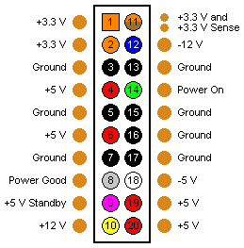
The first ATX power supplies and motherboards used a single power connector called a P1 connector that includes, in addition to the voltages provided by AT, a 3.3-volt circuit for a low voltage CPU. How many pins does this first ATX power connector have? _________
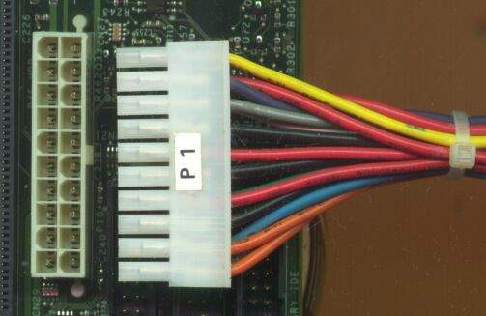

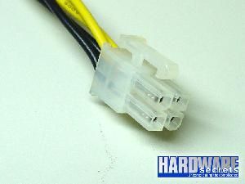
The electrical requirements for motherboards change over time as new technologies make additional demands for power. When processors began to require more power, the ATX Version 2.1 specifications added a 4-pin auxiliary connector (unofficially called the P4) near the processor socket to provide an additional 12V of power. A power supply that provides this additional 4-pin 12-volt power cord is called an ATX12 V power supply.
Assignment #1:
You work for a computer repair company. A customer brings in a computer with a dead power supply. You need to replace the power supply. In inspecting the dead power supply you note that the power supply has a 20 pin connector and a 4-pin auxiliary connector, both connected to the motherboard. The customer asks you to purchase and install a new power supply. You ask your intern to search on www.tigerdirect.com for a compatible power supply. Your intern returns with this URL for a power supply for the customer. http://www.tigerdirect.com/applications/SearchTools/item-details.asp?EdpNo=2974582&CatId=2533
So you read the advertisement at this URL (So you, the student in Mr. Rodriguez’ class, actually go there and read it now) checking out the specifications, connectors, features; actually the entire advertisement since you want to make an informed decision so your company keeps getting business. Will this power supply work with your customer’s motherboard? Why or why not?

Later, when PCI express slots were added to motherboards, more power was required and a new ATX specification (ATX version 2.2) allowed for a 24-pin P1 connector. The extra 4 pins on the P1 connector provide 12V, 5V, and 3.3V pins and with this new connector, the 4-pin auxiliary connector is no longer needed. Motherboards that support PCI Express and have the 24-pin P1 connector are sometimes called enhanced ATX boards.

Assignment #2: Go to http://www.interloper.com/products/product-details.php?productid=55600031&cat=55. Read the specs on this motherboard. Would this motherboard be considered an enhanced ATX motherboard? Why or Why Not?

PROCEDURE:
Write the AIM and DO NOW.
Get students working!
Take attendance.
Go Over HW
Collect HW
Go over the Do Now

Assignment #1:
1) Look up Power Management at www.webopedia.com. What is Power Management?

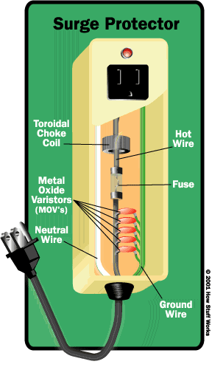
2) Go to http://computer.howstuffworks.com/surge-protector.htm.
What is a spike?

What is a surge?

3) Go to http://www.cowlitzpud.org/surge_protection.html

What are some causes of spikes and surges?

What do spikes and surges cause in your computer systems?

4) http://www.pcguide.com/ref/power/ext/probs.htm
What is line noise?

What is a brownout or sag?

What is a blackout?

Activity #2: Go to http://computer.howstuffworks.com/surge-protector1.htm. After reading, answer the following questions:
A) If the voltage from the outlet surges or spikes -- rises above the accepted level, where is the extra electricity diverted through?

B) What is the device that diverts the extra voltage called?

Activity #3: Go to http://computer.howstuffworks.com/surge-protector7.htm. To pick the right Surge suppressor/protector, you should make sure it meets a certain standard. What is the standard and what organization is responsible for that standard?

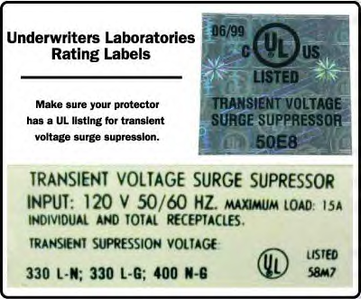
What are three ratings you should look for in a surge suppressor and what are acceptable values for those three ratings?

Activity #4: Go to http://catalog.belkin.com/IWCatProductPage.process?Product_Id=329365.

What are the features of this surge suppressor that you find appealing?

Activity #5: Go to http://www.pcguide.com/ref/power/ext/prot.htm. Click on Line Conditioner on the left frame. What is a line conditioner?

Click on Protecting the Modem and Other Peripherals. What power problems can your modem experience?

Activity #6: Although a surge suppressor can take care of spikes and surges, what will take care of your precious data if the power suddenly dips or is completely cut off? To help answer this question go to http://www.pcguide.com/ref/power/ext/ups/index.htm.

Go to http://www.pcguide.com/ref/power/ext/ups/types.htm.
- What is the idea behind a standby or offline UPS?

- What is an online or continuous UPS?

Go to http://www.tigerdirect.com/applications/Category/category_tlc.asp?CatId=20. Which UPS would you choose? Why? What are its features?

Activity #7: When it comes to electricity, you have to be aware that a fire can occur. You should have a fire extinguisher in a computer lab just in case a fire starts. But you have to have the right one. Go to http://www.pp.okstate.edu/ehs/modules/exting/index.htm.
1) What elements make up the fire triangle?

2) Look and list the different types of fuels that can cause fires. Which class of fuel is the one that is present in a computer lab?

3) Which of the fire extinguishers listed would you have in a computer room?

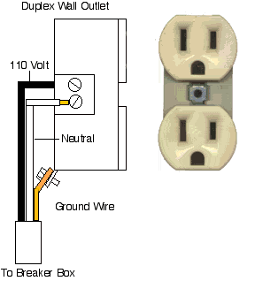
Sample Test Questions:
Neutral
Hot
Ground
- When testing an AC outlet in the United States, what voltage should the multimeter show
between the hot and ground wires?
A) 120 Volts B) 60 Volts C) 0 Volts D) -120 Volts

- What voltages does the ATX 12V P1 connector provide for the motherboard?
A) 3.3V, 5V B) 3.3V, 12V C) 5V, 12V D) 3.3V, 5V, 12V

- What sort of power connector does a floppy disk drive typically use?
A) Molex B) Mini C) Sub-mini D) Micro

- Joachim ordered a new power supply but was surprised when it arrived because it had an extra, 4-wire connector. What is that connector?
A) P2 connector for plugging in auxiliary components
B) P3 connector for plugging in case fans
C) P4 connector for plugging into Pentium 4 and later motherboards
D) Aux connector for plugging into a secondary power supply

- What should you keep in mind when testing DC connectors?
A) DC has polarity. The red lead should always touch the hot wire; the black lead should always touch the ground wire.
B) DC has polarity. The red lead should always touch the ground wire; the black lead should always touch the hot wire.
C) DC has no polarity, so you can touch the red lead to either hot or ground
D) DC has no polarity, so you can touch the black lead to either the hot or neutral, but not to ground.
6) What voltages should the two hot wires on a Molex connector read?
A) Red = 3.3 V; Yellow = 5V
B) Red = 5V; Yellow = 12V
C) Red = 12V; Yellow = 5V
D) Red = 5V; Yellow = 3.3V

7) Which of the following connectors would you not see on an AT-style power supply?
A) P1 B) P8 C) P9 D) Molex

8) A PCs power supply provides DC power in what standard configuration?
A) Two primary voltage rails, 12 Volts, and 5 Volts, and an auxiliary 3.3 volt connector
B) Three primary voltage rails, one each for 12-volt, 5-volt and 3.3 volt connector
C) One primary DC voltage rail for 12-volt, 5-volt, and 3.3-volt connectors
D) One voltage rail with a 12-volt connector for the motherboard, a second voltage rail with a 12-volt connector for the CPU, and a third voltage rail for the 5-volt and 3.3-volt connectors.

9) What feature of the ATX systems prevents a user from turning off a system before the operating system has been shut down?
A) Motherboard power connector B) CMOS setup C) Sleep mode D) soft power

10) Which of the following is least likely to cause a PC to overheat?
A) Missing slot covers B) Broken room air conditioner C) Dead power supply fan
D) Replacing a 250-watt power supply with a 300-watt power supply

11) What is an electrical spike?
A) unexpected reduction in power B) Steady, consistent increase in power
C) power alternating from AC to DC D) Short, unexpected, and sudden increase in power

- What rule should you follow when inserting P8 and P9 into a motherboard?
A) Orient the connectors so that the black wires go to the center.
B) Orient the connectors so that that black wires go to the outside
C) Remember to “face” them correctly.
D) Skip the center pin on the motherboard connection in order to provide proper grounding.

- ATX power supplies provide for all the voltages, except
A) 2.0 volts B) 3.3 volts C) 5.0 volts D) 12 volts

- Which of the following best describes soft power?
A) Soft power enables AT systems to handle power management
B) Soft power enables ATX systems to handle power management
C) Soft power enables power supplies to deliver smooth DC voltage to the PC
- Soft power enables techs to swap out components safely while the PC is on.

- The old AT power supplies use _______ to provide power to the motherboard
A) A P1 connector B) P8 and P9 connectors C) A Molex connector
D) A DIN connector

- The surge suppressor should be rated at a minimum of ____ joules.
A) 330 B) 800 C) 400 D) 1449

17) A standby UPS removes the battery from the AC circuit until the AC power drops below ____ V.
A) ~ 80-90 B) ~ 140-150 C)~ 110-120 D)~ 180-190

18)Power supplies can handle spikes of AC current of up to ____ V.
A) 600 B) 700 C) 1000 D) 1500

- The UL 497A rating of surge suppression is for the ____.
A) Keyboard B) Motherboard C) Modem D) Monitor

- A customer calls and says "my room air conditioner is broken and the temperature is 84 F inside my house so I took some slot covers off the computer so more air could get inside the case". You should tell him ___?
A) That’s a good idea. It will help cool it
B) Put them back on because it will cause the computer to overheat.
C) Its not going to help but it wont hurt the computer either
D) Put the refrigerator in the freezer to cool it down before using it

- The round prong on a standard AC receptacle is used for the __?
A) hot B) phase C) ground D) neutral

- If an electrical fire breaks out, you should use a(an) __ labeled fire extinguisher
A) A B) B C) C D) D

- The binary (base 2) number 0001001 is equivalent to a decimal (base 10) value of __

- A customer says his computer is experiencing numerous power blackouts and he is losing his data. He has nothing between the computer and AC outlet. What do you advice him to purchase?

- What can you buy that will help protect the computer against "sags"?

26) The fan in the power supply on the manager’s computer stopped working, but the computer is still running. What should be done?
A) Replace the fan B) Replace the transformer C) Lubricate the fan with oil D) Replace the power supply
E) No actions needs to be taken. There would still be a sufficient number of fans in the system

- There is a PC that is not protected with a UPS. What problem can occur if a power failure occurs and the power is restored?
A) ROM needs to be reprogrammed
B) There is danger from a power surge
C) The CMOS RAM has battery failure
D) The motherboard switch needs to be reset.

30) The size and shape of the circuit board, the position of the components, the position of the screw holes, and the technology incorporated, make up a motherboard's ____________ .
A) configuration
factory specs
form factor
OEM factor

