L E S S O N P L A N #21 Per. Name:

CLASS: Computer Repair, Maintenance, Upgrade and Management DATE: Monday October 26th, 2009

TOPIC: Power Supplies AIM: What does a power supply do?

NOTE:
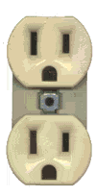
Do not change any settings on the computer. Keep your computer area clean. Don’t write on the computers. Don’t throw your garbage underneath your desks.
Neutral
Hot

H.W. # 21:
Ground
1) What does a power supply do?
2) How does a PC/XT/AT power supply differ from an AT power supply?
3) What are the different ways that the power supply fan can assist in cooling the system unit?
4) What are common voltages supplied by an ATX power supply?
5) What are the steps involved in removing a power supply?

DO NOW:
As a PC tech, you will sometimes need to test for electrical current. Check out this multimeter at http://www.radioshack.com/product/index.jsp?productId=2103174

PROCEDURE:
Write the AIM and DO NOW.
Get students working!
Take attendance.
Go Over HW
Collect HW
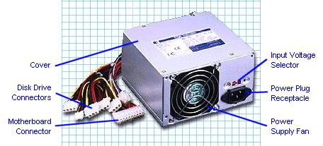
Go over the Do Now

Activity #-1:
- Go to http://science.howstuffworks.com/power9.htm. What is the amount of voltage that enters your house from the transformer outside your house?

- All standard electrical power in the United States is AC, approximately 115-120 volts and 60 Hz. But computer components need voltages in the range from about 2 volts to about 12 volts. What computer component does the job of converting the 115 volts and distributing it in lower voltage quantities? To help answer this question, look up the term power supply at www.techweb.com/encyclopedia. What does a power supply do?

What voltage is used for disk drives?

Activity #0:
- Let’s test the AC outlet to see if it is outputting 115-120 volts.
- Let’s test to make sure the ground works. (One lead in neutral the other in ground, voltage should be 0).

Activity #1:
Aside from obviously providing power to the PC, the power supply plays a bigger overall role in the functioning of the computer. Go to http://www.pcguide.com/ref/power/sup/ List 4 ways in which your power supply impacts the functioning of a PC.

A)

B)

C)

D)

Although a computer power supply may only take up 2% of the cost of a computer system, what percentage of problems may be attributed to the power supply?

Would you say that it is important to get a quality power supply?

Activity #2: Go to http://www.pcguide.com/ref/power/sup/func.htm and click on the Standard Output Voltages section. List the standard DC output voltages and what each is commonly used for?

- –12V

B) –5V

C) 0V

D) 3.3V

- 5V

- 12V
Activity #3: At the same site, in the left frame, click on Power Good Signal. What is a Power Good Signal?

Activity #4: At the same site, in the left from, click on Soft Power. What is soft power?

Activity #5: Go to http://www.pcguide.com/ref/power/sup/parts.htm. After reading the introduction, at the left, click on Power Cord And Power Pass Through. What is a pass-through connector on a power supply used for? Is it used on newer or older machines? Why?

Note: The power cord receptacle in the picture on the left is called an IEC-320. The power pass through connector is called an IEC 320-2-2.
Activity #6: At the same URL, click on Power Switch. How does the power switch on an older PC/XT/AT form factor differ from one on an ATX form factor?
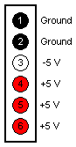
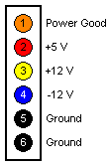

Activity #7: At the same URL, click on Motherboard Power Connectors. Look for the AT style power connectors. What are the names of the two power connectors for an AT motherboard?

How are you supposed to connect these two connectors (in other words, which two colors need to be together)?

P8
P9

P1
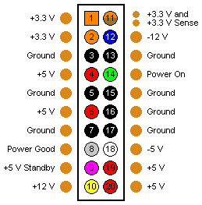
What are the available voltages on an AT motherboard connector?

What major difference exists between an AT motherboard connector and an ATX motherboard connector?

What is the ATX motherboard connector called?

What are the voltages available on an ATX motherboard connector?

What color codes are the power supply’s ground wires?
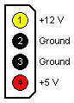
What is a major difference in voltages between the AT motherboard connector and the ATX mother board connector?

Molex Connector
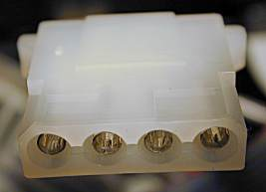

Activity #8: At the same URL, click on Drive Power Connectors. What voltages do the Molex and mini connectors supply to the components they connect to?

What is the mini-connector primarily used for?

Mini connector

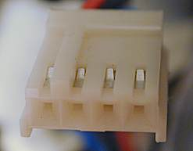
If your power supply doesn’t supply enough drive connectors, how can you solve this problem?

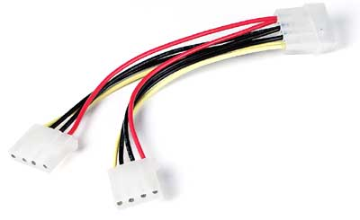

Activity #9: Go to http://www.pcguide.com/ref/power/sup/form.htm. What are some of the different power supply form factors?

Activity #10: Power supplies are rated in watts. How much wattage do you need in your power supply? Go to http://computer.howstuffworks.com/power-supply1.htm and see the wattage required by certain devices. Go to http://www.tigerdirect.com/applications/Category/category_tlc.asp?CatId=106. Which power supply would you select? Why

Assignment #11:
Go to http://www.pcguide.com/ref/power/sup/parts.htm and click on Motherboard Power Connectors in the left frame.
1) On the power supply connectors, what voltage is supplied by the
- Yellow wire __________
- Red wire ___________
- Blue wire ____________
- Orange wire ___________
- Black wire
- What is the gray wire used for? _______________
- What is the purple wire used for? ______________________
5) What is the white wire used for?
6) Go to http://www.google.com/url?sa=U&start=2&q=http://compreviews.about.com/library/weekly/aa-diy-powersupply.htm&e=747. Review the procedure to remove and install a power supply

Removing the Power Supply
- Make sure it's unplugged.
- All power connectors should be removed, including the connection to the motherboard and any auxiliary fans. Watch the little plastic tabs on ATX connectors (you'd rather not break them). AT power supplies have a two-piece power connector that may be labeled P-8 and P-9. Make note of the orientation. The black wires should be in the middle, black to black.
- Remove the connection to the remote power switch at the front of the case. Orientation of the colored wires at this switch is critical. If you remove them, make sure you document well, and during re-assembly plug the computer into a fused surge protector before turning it on (this could save your motherboard and components from melting if you've reconnected improperly). If you're putting the same power supply back, it's better to remove the entire switch and leave the connectors intact. The remote switch on an ATX form factor attaches to the motherboard.
- Remove the four screws at the back of the case and gently slide the power supply out of the case. While removing these screws, hold onto the power supply. You don't want it falling into the case

Assignment #12:
Using a power supply that was removed answer the following questions:

- The total wattage output -

- The different voltages output

- How many Molex connectors does it have?

- How many mini-connectors does it have?

- How many motherboard connectors does it have?

- How would you classify this power supply?

- Locate the fan on the power supply. Which location is the fan directing the air?

Installing the Power Supply

Once no power supply is installed into the computer place the new power supply into the computer and screw the screws into the back of the power supply. Most computer cases today also have a screw within the computer case, if present also screw a screw into this hole.

Connect cables

Once the power supply has been physically installed into the case and is being held in the case attach the power supply cable from the power supply to the motherboard. Next, connect each of the power connectors for the hard disk drive, cd drive, floppy drive and any other peripherals.

Assignment #13:
Go to www.techweb.com/encyclopedia and look up the term FRU. Is a power supply and FRU? Explain?

Sample Test Questions:
1. What is the unit of measuring voltage?

2. What is the unit of measuring current?

3. What unit is used to measure resistance?

- A PC uses ____ voltage. (AC/DC)

- What is a good conductor?

- Which of the three household outlet wires normally carries no voltage?

- Power supplies come with a standard ____ for the motherboard and interior devices.

- The P1 connector from the power supply is plugged into the ____ socket.

- The 3.5-inch floppy drive uses the ____ connector.

- Power supplies are rated in ____.

- Which motherboard power connectors must be plugged in with the black wires next to each other?

- How many volts of power do the P8 and P9 connectors provide to the PC?

- The ____ power supply never turns off.

- How many watts of power does a typical hard drive in a PC require?

15) Which of the following form factors dominates the PC industry?
A) AT B) ATX C) BTX D) CTX

16) Which of the following form factors offers the best cooling?
A) AT B) ATX C) BTX D) CTX

17) On Intel based motherboards, which chip enables the CPU to interact with RAM?
A) Memorybridge B) Northbridge C) Southbridge D) Super I/O

18) Brian bought a new motherboard that advertised support for eight USB ports. When he pulled the motherboard out of the box, however, he found that it only had four USB ports! What’s likely the issue here?
A) The extra four USB ports will connect to the front of the case or via a dongle to an expansion slot
B) The extra four USB require an add-on expansion card.
C) The Firewire port will have a splitter that makes it four USB ports
D) The motherboard chipset might support eight USB ports, but the manufacturer only included four ports

19) Martin bought a new motherboard to replace his older ATX motherboard. As he left the shop, the tech on duty called after him, “Check your standouts!” What could the tech have meant?
A) Standouts are the connectors on the motherboard for the front panel buttons. Like the on/off switch and reset button.
B) Standouts are the metal edges on some cases that aren’t rolled
C) Standouts are the metal connectors that attach to the motherboard case.
D) Standouts are the dongles that enable a motherboard to support more than 4 USB ports.

