Student Version L E S S O N P L A N #20

CLASS: Computer Repair, Maintenance, Upgrade and Management DATE: Thursday October 21st 2009

TOPIC: Motherboard Form Factors AIM: How can we tell the form factor of our motherboard?

NOTE:
Do not change any settings on the computer.

H.W. # 20:
1) What were some of the problems with earlier form factors that led to the new motherboard form factors?

DO NOW:
- After the POST is completed, the hardware settings it finds will be compared with those stored in _______. Any differences will be displayed as POST error codes on the display and/or beeps.
A) SYSTEM.INI B) CMOS C) CONFIG.SYS D) ROM

- A procedure that copies the Bios code from ROM into RAM when the computer boots is called __. This is done because the CPU can access RAM much quicker than sending the request over the bus to access the information in ROM?
A) Switching B) Mirroring C) Striping D) Shadowing
AT Motherboard form factor
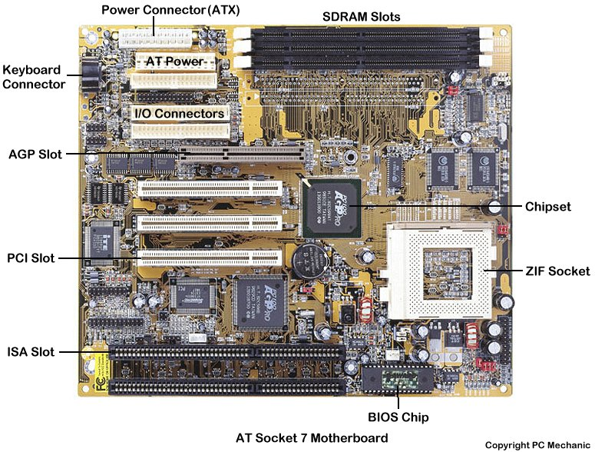
PROCEDURE:
Write the AIM and DO NOW.
Get students working!
Take attendance.
Go Over HW
Collect HW#
Go over the Do Now

Question:
When you look at a motherboard, how can you classify it?

Assignment #1:
Go to http://computer.howstuffworks.com/motherboard.htm. Read the pages on “How Motherboards Work”.

Question:
What are some characteristics that define modern motherboards?

Let’s examine the form factor characteristic. What is a form factor? To help us, let’s look at the website http://www.computerhope.com/jargon/f/formfact.htm.

The motherboard at right is an example of an AT form factor motherboard. What is an obvious feature of an AT motherboard?

The AT form factor was invented by IBM in the early 80’s. Its dimensions are 12" wide x 13.8" deep. As technology improved, the demand for a smaller (and less expensive to manufacture) AT motherboard increased. A smaller size was created. What was this type of motherboard. To learn more about this type look up baby AT at www.pcwebopedia.com.

What are the dimensions of the baby AT motherboard form factor? ________________

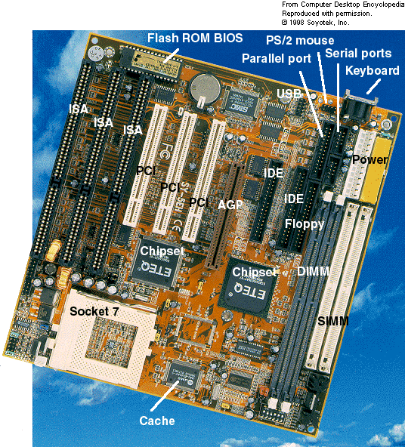

Examine the Baby AT motherboard at the right. What is the only dedicated connector for the back panel of this baby AT motherboard?

Notice the connectors on the motherboard for the IDE drives, floppy drives, PS/2 port, serial ports, USB port, Parallel port. If you connect all of these, what situation have you created?

Suppose you install full size expansion slot cards in ISA slots 2 and 3 and PCI slots 1 and 2. What could these cards get in the way of?

In summary, the problems with the baby AT and AT motherboard form factors were:
- Not enough back pane ports so we have an abundance of cables in the system unit creating a situation where it is difficult to locate remove and install items and decreased air flow within the system unit.
- Position of processor might prevent installation of peripheral boards.
- With all those cables in the way, it is difficult to install memory modules

To alleviate some of these problems, a new type of motherboard form factor was created. This was the LPX form factor. Look up the LPX (Low Profile eXtended) form factor at www.pcwebopedia.com. What were some characteristics of the LPX form factor?
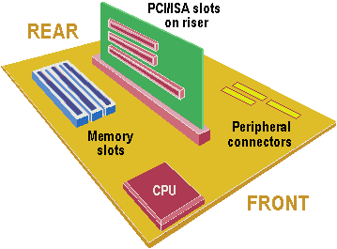

To improve upon some of the limitations of the LPX form factor, a new form factor was introduced, namely the NLX (New Low-profile eXtended) form factor. How did the NLX improve on the LPX? To help us answer this question look up NLX at www.pcwebopedia.com

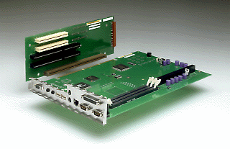

There were still improvements to be made. To see what further improvements could have been made to motherboard form factors, look up ATX at www.techweb.com/encyclopedia. What were some of the improvements that the ATX form factor made?

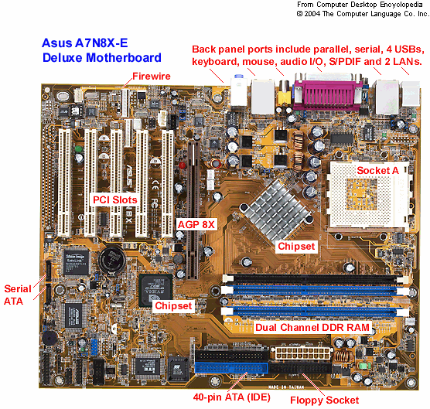

Go to http://www.motherboards.org/articles/tech-planations/17_1.html and read about chipsets. List the major chipset manufacturers.

Go to www.webopedia.com/DidYouKnow/Hardware_Software/2005/motherboard_form_factors.asp for a summary of motherboard form factors.

Examine the table the compares some of the different motherboard form factors?

Style | Width | Depth | Where Found | Match to Case and Power Supply
Full AT | 12" | 11-13" | Very Old PCs | Full AT, Full Tower
Baby AT | 8.5" | 10-13" | Older PCs | All but Slimline, ATX
ATX | 12" | 9.6" | Newer PCs | ATX
Mini ATX | 11.2" | 8.2" | Newer PCs | ATX
LPX | 9" | 11-13" | Older Retail PCs | Slimline
Mini LPX | 8-9" | 10-11" | Older Retail PCs | Slimline
NLX | 8-9" | 10-13.6" | Newer Retail PCs | Slimline

Now that we have become informed of the different motherboard form factors, let’s examine how we might choose components for our PC. Go to the URL http://www.build-your-own-computer-tips.com/choose-computer-parts.html. List some of the items to consider when choosing components for your PC.

Go to http://www.motherboards.org/articlesd/how-to-guides/35_1.html and read the article on how to install a motherboard. List the steps involved.

Question:
Which is the oldest motherboard form factor?

Sample Test Questions:
- Which of the following is not a common form factor?
A) AT B) ATI C) ATX D) Flex ATX

- Which motherboard design style is the most popular?
A) ATX B) AT C) Baby AT D) NLX ____________

- Which motherboard form factor places expansion slots on a special riser card and is used in low-profile PCs?
A) AT B) Baby AT C) ATX D) NLX

- You need to change the boot sequence of the computer. What would you use to change the order in which the computer searches for an operating system?
A) Boot disk B) DIP switches on the motherboard C) CMOS setup D) Jumpers on the hard drive

- __________ is the practice of increasing the clock multiplier to force the processor to run , thus increasing performance.

- Where do you go to disable a printer port that is built into the motherboard?
A) Windows 9x’s Add/Remove Software
- CMOS setup
- Dr. Watson
- Windows Diagnostics

- Which of the following are normally found on the motherboard (Select all that apply)
A) CPU B) Battery C) Expansion slots D) CMOS E) Chip Set

- What is the most common motherboard form factor used with today’s computers?
A) AT B) Baby AT C) NLX D) ATX

- Where is hard disk information stored?
A) BOOT.INI B) CMOS C) RAM D) SYSTEM.INI

- How many IDE controllers are typically built into an ATX motherboard?
A) 2 B) 4 C) 1 D) 8

- What is the first program to run during a system boot sequence?
A) Config.sys D) BIOS C) Autoexec.bat D) Command.com

- Which device contains its own BIOS?
A) Video Adapter B) DRAM C) Diskette Drive D) Hard Drive

- What is modified when changing the system start up boot sequence?
A) Autoexe.bat B) BIOS/CMOS C) Command.com D) config.sys

