L E S S O N P L A N #19

CLASS: Computer Repair, Maintenance, Upgrade and Management DATE: Thursday October 21st 2009

TOPIC: Expansion Slots AIM: How do we install an expansion card in an expansion slot?

NOTE: Please remember not to make any changes on the computers. Don’t download anything. Only do what the assignments ask you to do. Thank you.

H.W. # 19:
What are some steps you should take before and after installing an expansion card in an expansion slot?

DO NOW:
1) Go to http://www.kitchentablecomputers.com/assemble9.htm. and see how to install an expansion card.

PROCEDURE:
Write the AIM and DO NOW.
Get students working!
Take attendance.
Go Over HW
Collect HW
Go over the Do Now

Assignment #1:
- Go to www.tigerdirect.com and examine the specs on a PCIe x16 video card.

Go to www.tigerdirect.com and in the search box type Creative Sound Blaster X-Fi Extreme PCIe examine the specs on this card.

- Research: Which is faster, a PCI express x16 bus or the latest AGP bus?

- When examining a PCI expansion card, how can you tell the voltage(s) the card can use?

Assignment #2: Sample Test Questions:
1) What are the two data bus widths used by the conventional PCI bus?

2) What bus is expected to replace AGP to support the video card in a system?

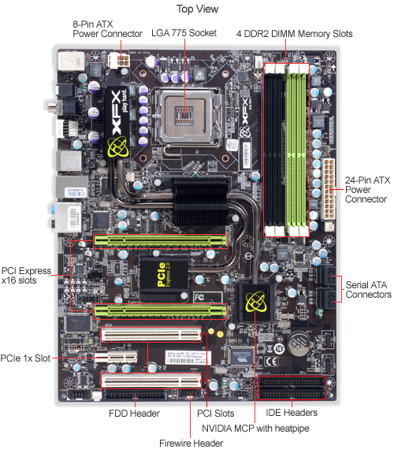
Assignment #3: List the different types of expansion slots on the motherboard below.

