Student Version L E S S O N P L A N #18

CLASS: Computer Repair, Maintenance, Upgrade and Management DATE: Wednesday October 21st 2009

TOPIC: PCI AIM: What are some of the more modern expansion bus slots?

NOTE:
Do not change any settings on the computer. Keep your computer area clean. Don’t write on the computers. Don’t throw your garbage underneath your desks.

H.W. # 18
1) Why don’t all buses on a motherboard operate at the same speed?
2) When you turn off a computer at night, it loses its date and you must reenter it each morning. What is the problem and how do you solve it?
3) What is one reason to flash BIOS?
4) What bus is expected to replace AGP to support the video card in a system.

DO NOW:
1) As the number of wires in the address bus increased, computer systems were able to allocate more than just the first 16 wires of the address bus to be used for I/O memory addresses. Today’s systems actually double the number of I/O address wires from 16 to 32. How many I/O addresses does this total?

2) What were the 3 expansion bus types that came after ISA, but couldn’t grab a stronghold of the expansion bus market?

3) Look up Plug and Play at www.techweb.com/encyclopedia. What are some items that are automatically configured when you install a PnP card in a PnP system?

4) Go to http://www.pcguide.com/ref/mbsys/res/pnpRequirements-c.html and list the requirements for plug and play to work.

Comment: Modern systems assign most IRQ’s automatically through a mechanism called Plug and Play and you can find many devices sharing the same IQ, but Interrupt controllers still exist. Systems may still use either of two interrupt controllers. Look up PIC at www.techweb.com/encyclopeida and look up the second definition for PIC. List the two interrupt controllers listed there.

PROCEDURE:
Write the AIM and DO NOW.
Get students working!
Take attendance.
Go Over HW
Collect HW#
Go over the Do Now
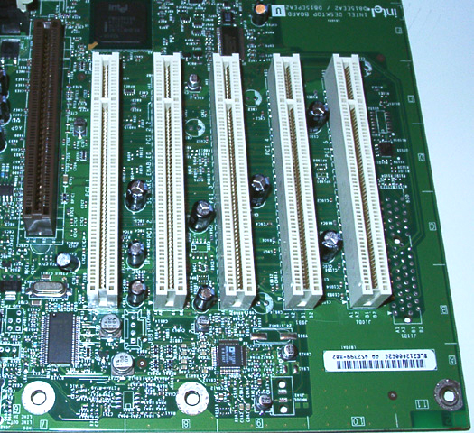
Despite various improved expansion bus types appearing after ISA, ISA remained a fixture on PCs. Each of the other expansion bus types had negative features that led to their demise, the last being the VESA VL Bus, which was strongly designed for the x486 systems, but couldn’t integrate properly when the Pentiums came out.
So it was time for another company to come out with another expansion bus type. This time it was Intel’s turn to come out with an expansion bus. Did Intel succeed or did Intel make mistakes like the other designers? Let’s see.
To find out more about this new expansion bus created by Intel, let’s go to http://www.pcguide.com/ref/mbsys/buses/types/pci.htm and answer the following questions:
- What was Intel’s new expansion bus type?

- When did the PCI standard come out?

- What is the bus width of the PCI standard?

4) List 3 PCI performance features.

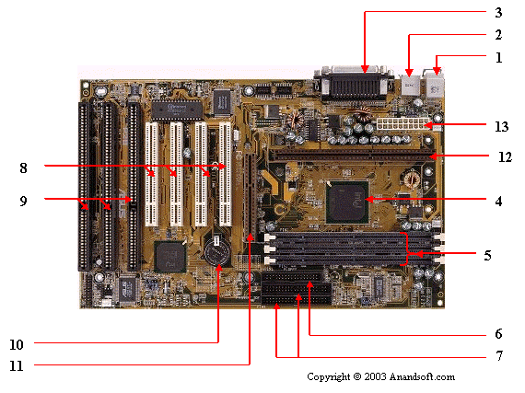
On the motherboard picture below, identify the ISA bus slots and the PCI expansion bus slots. Identify all the other numbered parts.

Answers:
- Mouse & keyboard 2) USB 3) Parallel port 4) CPU Chip 5) RAM slots
6) Floppy controller 7) IDE controller 8) PCI slot 9) ISA slot 10) CMOS Battery
- AGP slot 12) CPU slot 13) Power supply plug in

PCI turned out to be a good expansion slot. Even video cards were placed in PCI slots. But as time went on, the demands of video cards on the PCI bus became more intense. We needed to have a faster bus when it came to handling graphics and video.

Intel wanted to create a port specifically for video that could handle the high demands of video peripherals. To learn more about this expansion bus type, look up AGP at www.webopedia.com and answer the following questions:

- Who developed AGP?

- What are the system requirements for AGP?

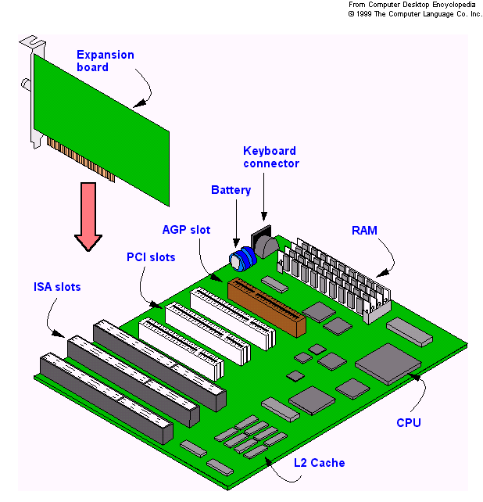
- How do you recognize the AGP slot on the motherboard?

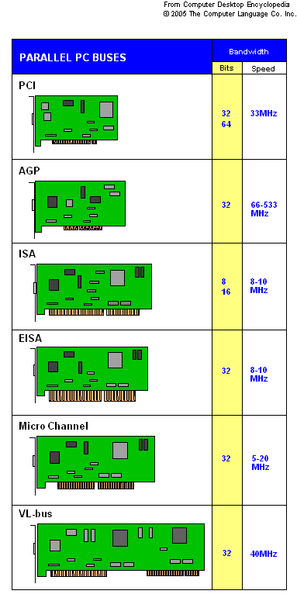

The newer expansion bus types that were coming out were faster and usually situated and routed through a faster location on the motherboard. The motherboard’s chipset is usually divided into 2 sections, one dealing with the slower components, the Southbridge, and one dealing with the faster components, the Northbridge.

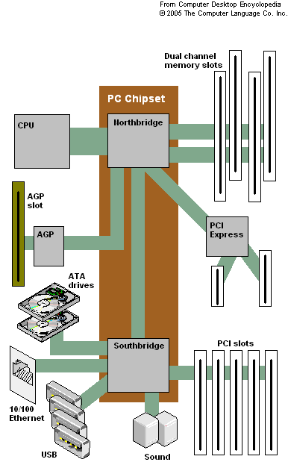
List the components connected to the SouthBridge

List the components connected to the Northbridge.

Go to http://www.intel.com/products/chipsets/P35/index.htm

List the features supported by this chipset?

There was a 64-bit version of the original PCI standard, but it was quite rare. Today there is a faster, 64-bit wide fully-backward compatible with original PCI version of PCI. This one is called PCI-X. Go to www.techweb.com/encyclopedia and look up PCI-X. Take a look at the PCI-X slots. How do the PCI-X and PCI slots compare, physically?

Still, trying to be faster, a different, non-compatible with the original PCI, version of PCI came out called PCI Express. The main difference is that previous versions of PCI worked in parallel mode. PCI Express sends out data in serial mode. This is one of the things that make it faster. PCI Express slots are usually abbreviated PCIe. The most common PCIe slot is the 16 lane PCIe x16. (A PCIe connection uses one wire for sending and one for receiving. Each of these pairs of wires between the PCIe controller and a device is called a lane. Each lane runs at 2.5Gbps).

Go to www.techweb.com/encyclopedia and look up PCI-Express. Look at the picture to note the physical differences between PCI, AGP, PCIe x16 and PCIe x1.

Go to http://www.techweb.com/encyclopedia/defineterm.jhtml?term=PCI%2DSIG for a comparison of all PCI technologies.

There are PCI cards designed for laptops. Look up Mini PCI at www.techweb.com/encyclopedia for a description of PCI cards designed for laptops.
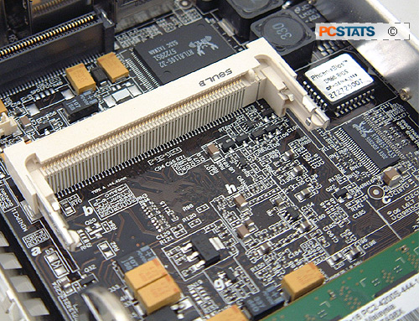

There were some other expansion card types created that dealt mainly with modems. To avoid having these Internet connection devices take up more than 1 slot, various components were put on one card. Go to www.techweb.com/encyclopedia and look up riser card. Scroll down and list the 3 cards mentioned and some features of each.

1)

2)

3)

Sample Test Questions:
1) Which of the following statements about the expansion bus is true?
A) The expansion bus runs at the speed of the system clock
B) The expansion bus crystal sets the speed of the expansion bus
C) The CPU communicates with RAM via the expansion bus
D) The Front Side Bus is another name for the expansion bus

- Which of the following statements best describes the hexadecimal numbering system?
A) It is a binary numbering system that uses only two digits, a 0 and a 1
B) It is another name for the decimal numbering system with ten digits, 0 through 9
C) It is an eight-digit numbering system using the letters A through H
D) It is a sixteen-digit numbering system that can express all of its values by using four wires

- AGP stands for
A) Accelerated Graphics Port, PCI
B) Alternative Graphics Port, PCI
C) Accelerated Graphics Port, ISA
D) Alternative Graphics Port, ISA

- Which one of the following devices is likely to still use DMA?
A) USB flash drive B) Floppy Drive C) Hard Drive D) CD-ROM Drive

- How does the CPU communicate with a device?
A) It uses the device’s I/O address over the address bus
B) It uses the device’s IRQ addresses over the data bus
C) It uses the device’s COM port over the address bus
D) It uses the device’s DMA over the data bus

- Which of the following does a device use to initiate communication with the CPU?
A) IO/MEM wire B) Bus mastering C) DMA D) IRQ

- Which variation of the PCI bus was specifically designed for laptops?
A) PCI-X B) PCIe C) Mini-PCI D) AGP

