Student Version L E S S O N P L A N #15

CLASS: Computer Repair, Maintenance, Upgrade and Management DATE: Monday October 9th 2009

TOPIC: Device Drivers AIM: How does your computer know of devices not listed in its ROM BIOS?
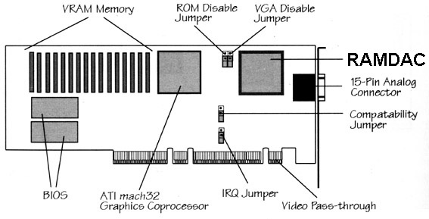
NOTE:
Do not view any websites that are not listed in the lesson plan

H.W. # 15:
- How does a computer know about the many devices not known by the System ROM?

2) What are some ways to activate
device drivers on a PC?

DO NOW:
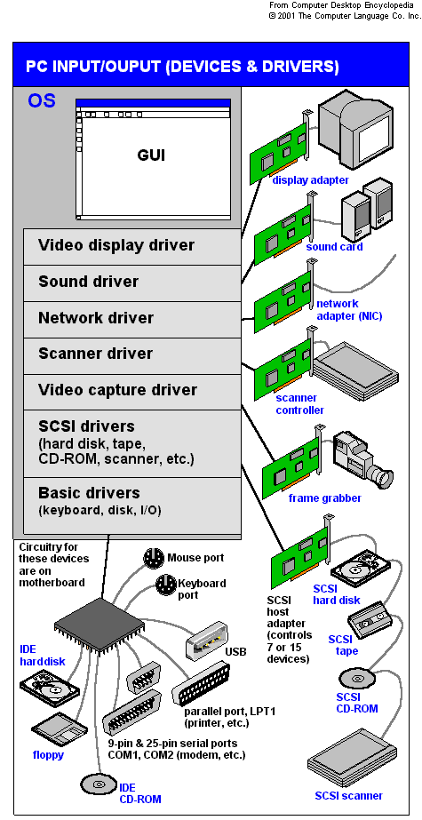
Look at the figure at the above right representing a video card. Why would the video card have BIOS chips if the motherboard already has a system BIOS on the system ROM?

Answer:
BIOS can’t know about all possible devices. As a result devices had to bring their own BIOSes. As you can see in the figure, this video card has its own BIOS on the video card.

PROCEDURE:
Write the AIM and DO NOW.
Get students working!
Take attendance.
Go Over HW
Collect HW#
Go over the Do Now

Most BIOSes that come on these Option ROMs advertise that they exist by displaying information about the device when you boot the system.

Now, BIOSes for devices come on external storage devices such as CD-ROMs. These are usually called installation disks. Instead of being called BIOS programs for the device, the programs that come on the installation disks are called device drivers.

The installation disks contain all BIOS commands necessary to talk to whatever device they were written to support. The files on the installation disks are then copied to the hard drive. When your computer boots up, the files are copied into RAM, thereby giving the CPU the capability to communicate with the hardware supported by the device driver

Sample Test Question:
Jill installs a new SCSI host adapter in a system. When she boots the system, a new text message appears and seems to cause the system to halt for a minute. Then the system continues, and Windows loads normally. The host adapter appears in her Device Manager and seems to be working. What could be the cause of the odd text message and slowdown at boot?
- The SCSI host adapter must have buggy drivers
- The SCSI host adapter must need drivers to load
- The SCSI host adapter has option ROM that loads BIOS for the card
- The SCSI host adapter has option RAM that has to search the hard drive for drivers before it can load

Let’s take a look at some other locations from which device drivers could be activated.

1) In the days of DOS, when the computer booted up, the computer executed a file called CONFIG.SYS.
Activity #1:
Go to http://www.pcmag.com/encyclopedia_term/0,2542,t=DOS+CONFIGSYS&i=41756,00.asp What is the purpose of CONFIG.SYS or what does it do?

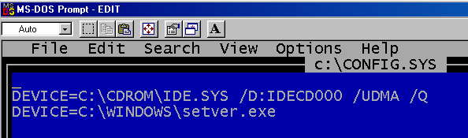

In the snapshot of the config.sys file a driver for what type of device is being loaded in the first line of the Config.sys file?
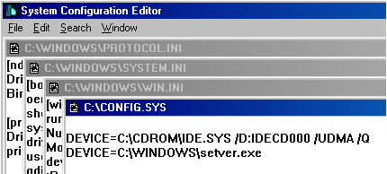

You can edit the config.sys file by opening the Edit program through DOS (as was done above) or by running the program SYSEDIT program from Windows.

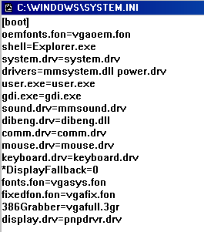
In DOS you only had 640K (the first 640K) of RAM available for programs (1MB including all other memory locations like ROM). When Windows first came out (Windows 3.1), programs were able to use more than 1MB of memory for programs. If you needed a device driver loaded, you would rather it take up space in the extended memory (memory above 1MB) and leave the first 640K for DOS programs. If we wanted device drivers to load into memory locations above 1MB, we couldn’t activate them through CONFIG.SYS because CONFIG.SYS worked through DOS and loaded device drivers into the first 640K of RAM.

To load device drivers in Windows, a file called SYSTEM.INI was used instead of CONFIG.SYS. Take a look at a small section of a sample SYSTEM.INI file at the right. You can see how, when this file is executed, device drivers (many of them with the .drv extension) are loaded into RAM.

Question:
What was the purpose of the SYSTEM.INI file when Windows first came out?

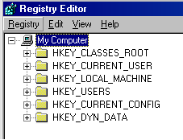
When Windows 95 came out, Microsoft was concerned about the ability to activate drivers from both the CONFIG.SYS and SYSTEM.INI file. So Microsoft decided to put the activation of device drivers in a file called the registry. You could access the registry with the program REGEDIT.

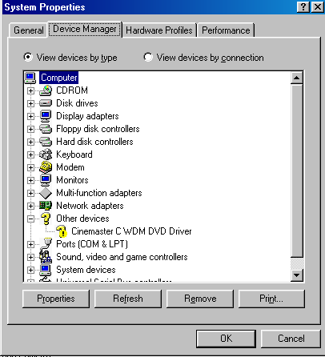
Although you could edit the registry with the REGEDIT program, a more user-friendly way of accessing information about device drivers is the Control Panel. Some of the Control Panel Icons are for devices and you could get information on device drivers. When you use the Control Panel, changes are effected in the Registry.
A second location that you could use to get information on device drivers is the Device Manager.

Sample Test Questions:
- While booting up, a client's computer shows an error message with a code 201. What is the likely cause?
A) The CMOS battery is bad B) The CPU is bad C) The Hard disk is bad D) The Memory test has failed
(Hint: Look at the information below)
The general errors and the corresponding failures are shown below:
100-199: System board failures
200-299: Memory failures
300-399: Keyboard failures
400-499: Monochrome video problems
500-599: Color video problems
600-699: Floppy disk errors
1700-1799: Hard disk problems.

- Over-clocking allows a microprocessor to run considerably faster than motherboard components. What type of memory structure was developed to minimize the delay of accessing RAM on the motherboard?
A) Processor resident pipeline B) L-2 cache C) CMOS memory D) Duplex memory

- Firmware is programming stored on _____________
A) CD-ROM B) A hard drive C) An operating system D) BIOS

- Taylor thinks his CMOS battery is dead. Which of the following would best verify this?
A) Reset the CMOS settings B) Clear CMOS and restore
C) Reboot and see if the CMOS data is still there D) Use a voltmeter to test the battery

- Which is not a common BIOS software brand?
A) American Megatrends B) Western Digital C) Phoenix Technologies
- Award Software

- Jill decided to go retro and added a second floppy disk drive to her computer. She thinks she got it physically installed correctly, but, it doesn’t show up in Windows. Which of the following options will most likely lead Jill where she needs to go to resolve the issue?
A) Reboot the computer and press the F key on the keyboard twice. This signals that the computer has two floppy disks.
B) Reboot the computer and watch for instructions to enter the CMOS setup utility (for example, a message may say to press the DELETE key). Do what it says and go into CMOS setup.
C) In Windows, press the DELETE key twice to enter the CMOS setup utility.
D) IN Windows, go to START | RUN | and type “floppy”. Click OK to open the Floppy Disk Drive Setup Wizard.

- Henry bought a new card for capturing television on his computer. When he finished going through the packaging, however, he found no driver disc, only an application disc for setting up the TV capture software. After installing the card and software, it all works flawlessly. What’s the most likely explanation?
A) The device doesn’t need BIOS, so there’s no need for a driver disc
B) The device has an option ROM that loads BIOS, so there’s no need for a driver disc
C) Windows supports TV capture cards out of the box, so there’s no need for a driver disc
D) The manufacturer made a mistake and didn’t include everything needed to set up the device.

- Davos finds that a disgruntled former employee decided to sabotage her computer when she left by putting a password in CMOS that stops the computer from booting. What can Davos do to solve the problem?
  - Davos should boot the computer holding the left SHIFT key. This will clear the CMOS configuration.
  - Davos should try various combinations of the former employee’s name. The vast majority of people use their name or initials for CMOS passwords.
  - Davos should find the CMOS clear jumper on the motherboard. Then he can boot the computer with a shunt on the jumper to clear the CMOS information.
  - Davos should find a replacement motherboard. Unless he knows the CMOS password, there’s nothing he can do.

- Richard, over in the Sales department, went wild in CMOS and made a bunch of changes that he thought would optimize his PC. Now most of his PC doesn’t work. He can boot, but only to CMOS, not into Windows. Which of the following tech call answers would most likely get him up and running again?
  - Reboot the computer about three times. That’ll clear the CMOS and get you up and running
  - Open up the computer and find the CMOS clear jumper. Remove a shunt from somewhere on the motherboard and put it on the CMOS clear jumper. Reboot and then put the shunt back where you got it. Reboot, and you should be up and running in no time.
  - Boot into CMOS setup program and then find the option to load a plug-and-play operating system. Make sure it’s set to ON. Save and exit CMOS; boot normally into Windows. You should be up and running in no time.
  - Boot into the CMOS setup program and find the option to load Optimized Default settings. Save and exit CMOS; boot normally into Windows. You should be up and running in no time.

- Where does Windows store device drivers?
A) My Computer B) My Hardware C) Registry D) Drivers and Settings.

11) Firmware is programming stored on _____________
A) CD-ROM B) A hard drive C) An operating system D) BIOS Ans. _____

12) Taylor thinks his CMOS battery is dead. Which of the following would best verify this?
A) Reset the CMOS settings B) Clear CMOS and restore
C) Reboot and see if the CMOS data is still there D) Use a voltmeter to test the battery Ans. _____

13) Which is not a common BIOS software brand?
A) American Megatrends B) Western Digital C) Phoenix Technologies D) Award Software
Ans. _____
14) Which of the following components is read-only?
A) DRAM B) RAM C) Hard disk D) ROM

Assignment #1: Read the article at
http://www.devhardware.com/c/a/Hardware-Guides/Why-and-How-to-Flash-Your-BIOS/

