Student Version L E S S O N P L A N #11 Name _____________________Per. __________

CLASS: Computer Repair, Maintenance, Upgrade and Management DATE: Wednesday September 30th 2009

TOPIC: RAM AIM: How can we determine the number of RAM sticks in a bank?

NOTE:

H.W. # 11:
1) What limitation did the 72-pin SIMMs overcome as compared to the 30-pin SIMMs?
2) What did the 168-pin DIMMs improve over the 72-pin SIMMs?
3) What is EDO DRAM?
4) What is ECC DRAM?
5) What improvement did SDRAM make over FPM DRAM?
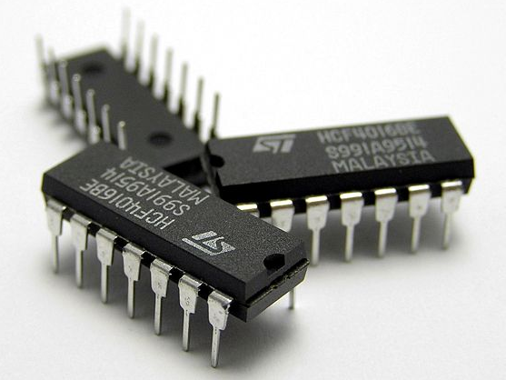
6) What improvement did DDR SDRAM make over SDR SDRAM?
7) How is RDRAM better than DDR SDRAM? How is it worse?

DO NOW:
When the 8086 came out, it had an 8 bit external data bus. RAM that was made at that time was 1 bit wide. So you had to have 8 chips of 1 bit wide RAM wired together to be able to talk to the CPU.

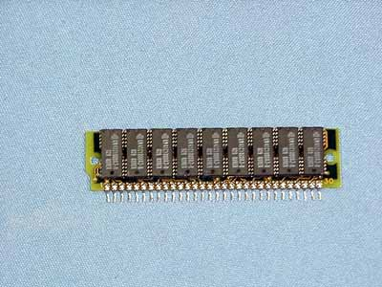
The first DRAM chips came in the form of DIPPs as you see pictured on the right. Initially you had to insert 1 DRAM chip at a time.

Eight (8) of these chips were wired together on a motherboard.

To make things easier, manufacturers started putting 8 DRAM chips on one circuit board so that you could replace an entire row of RAM at a time. These first packages were called SIPPs as pictured on the right. Notice you have the pins on the bottom.

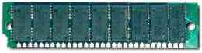
But these pins usually broke, so then they came out with SIMMs, the same thing but instead of pins they came with contacts (although many times we refer to contacts as pins)

In the 30-pin SIMM, you usually had 8 DRAM chips each one bit wide, but with many rows. For example if one DRAM chip had a label of 256x1 this meant that it had 256K rows. If you wired 8 of these together, you would have 256KB of RAM.

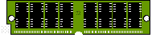
The 9th DRAM chip in the picture was used for Parity checking; basically, checking the number of 1s in each row.

When the 286 came out, it had a 16 bit external data bus. That meant that the CPU wanted 16 bits at a time from RAM. A 30-pin SIMM was only 8 bits wide. So you would need two sticks of 30-pin SIMMs to be able to communicate with the CPU. This is known as a bank of RAM.

Question: If you had a motherboard with a 286 CPU and had 4 memory slots for 30-pin SIMMs, how many memory banks would that motherboard have?

PROCEDURE:
Write the AIM and DO NOW.
Get students working!
Take attendance.
Go Over HW
Collect HW
Go over the Do Now

Question:
What changes would have to be made so that sticks of RAM, overall, would take up less space on the motherboard?

Answer:

To decrease the number of RAM sticks, a newer type of SIMM called the 72-pin (actually contacts, but the name pin stuck, pardon the pun) SIMM came out. Physically, the 72-pin was about an inch longer than the 30-pin SIMM, but the 72-pin SIMM was 32-bits wide as compared to the 8 bits wide on the 30-pin SIMM

Question:
How many 30-pin SIMMs did a 72-pin SIMM replace in a bank?

Answer:

Question:
The Pentium’s external data bus was 64-bits wide. How many 72-pin SIMMs did you need to make a bank in a computer with a Pentium CPU?

Answer:
Sometimes, a 72-pin SIMM was described as 1x32. This meant that it had a depth (rows) of 1Meg and a width of 32 bits. But these 32 bits made 4 bytes. 1Meg of row * 4 bytes meant that we had 4MB of RAM if it were labeled 1x32.

Here are some common 72-pin SIMMs and their sizes. Calculate the amount of memory in Megabytes. I’ll fill in the first two values:

1x32 (no parity) = 4MB
1x36 (parity) = 4MB
2x32 (no parity) =
2x36 (parity) =
4x32 (no parity) =
4x36 (parity) =
8x32 (no parity) =
8x36 (parity) =
16x32 (no parity)=
16x36 (parity) =

Question:
If someone ordered “four sticks of 4x32 fifties” and “two sticks of 4x36 sixties”, what kind of 72-pin SIMMs did they order?

Answer:

Even though 72-pin SIMMs improved upon the 30-pin SIMMs by extending the data width from 8 bits to 32 bits, the data width still wasn’t the same as the 64-bit external data bus of the Pentium and higher class chips. So a new package type was created to extend the width of the RAM stick.

Activity #1:
To know more about this package type, look up DIMM at www.pcwebopedia.com.
Also go to http://www.hardwarecentral.com/hardwarecentral/tutorials/49/3/ and answer the following questions:

- How many pins (actually contacts) are on the DIMM sticks?

- What is the data width of the DIMMs (in bits)?

- How many DIMM sticks of RAM would you need to make a bank in a computer with a Pentium CPU?

Another DIMM you may encounter are those commonly used in laptops.

Activity #2:
To learn more about these types of DIMMs, go to http://www.pcwebopedia.com/TERM/S/SO_DIMM.html and answer the following questions about SO-DIMMs.

- What does SO mean?

- What devices use SO-DIMMs?

- What is the data width of a 72-pin SO-DIMM?

- What is the data width of a 144-pin SO-DIMM?

- What is the data width of a 200-pin SO-DIMM?
Question:
Suppose you have a stick of 168-pin DIMM RAM and it is labeled 32x64. How many MB of RAM are in this stick of RAM?

Answer:

Question:
How many 168-pin DIMMs are needed to make a bank on a Pentium III?

Answer:

There was an improvement to DRAM called EDO DRAM

Activity #3:
Go to http://www.pcwebopedia.com/TERM/E/EDO_DRAM.html and answer the following questions:

- How did the speed of EDO DRAM compare to that of FPM DRAM?

- How does EDO DRAM do what it does?

Activity #4:
Go to http://www.compworks.faithweb.com/computers/pc/hardware/ram001.html and answer the following questions:

- What was the increase in performance of EDO DRAM over FPM DRAM?

Obviously, it was good to have EDO RAM. Can you just put EDO DRAM in your computer? Let’s see

Activity #5:
Go to http://www.uktsupport.co.uk/ctx/mb/8500tvg.htm and scroll down to the “Specification” section of theis motherboard, then scroll down to the “DRAM” subsection. Does this motherboard support EDO DRAM?

What has to be true so that you can install EDO DRAM in your computer?

As we stated before, DRAM (EDO or FPM) was not tied to the system clock. These types of RAM had an access speed or a set amount of time that the CPU waited before it got information requested from RAM

A new type of RAM was developed that worked with the system clock. This allowed the CPU to request information and know exactly when it was going to be ready from RAM

Activity #6:
To get some information on this type of RAM, go to http://searchcio-midmarket.techtarget.com/sDefinition/0,,sid183_gci214193,00.html and answer the following questions:

- What kind of RAM is synchronized with the system clock?

- What works make up the acronym for this type of RAM?

- How do we usually rate the speed of SDRAM?

4) How does this compare to how we rate the speed of FPM DRAM?

- Since SDRAM and FPM DRAM are rated differently in terms of speed, if we wanted to compare them to each other, we would have to have the same unit of measure. How can we convert from MHz to nanoseconds with respect to the speed of RAM?

- What is the speed in nanoseconds of 66MHz SDRAM?

Because SDRAM is tied to the system clock, just like the CPU and chipset, it doesn’t have an access speed; it has a clock speed just like the CPU. Five sample clock speeds are common for SDRAM: 66, 75, 83, 100 and 133 MHz

Activity #7:
Find the access speeds, in nanoseconds, for the SDRAM chips with clock speeds:
- 75MHz

- 83MHz

- 100MHz

- 133 MHz

Activity #8:
To prevent any incompatibilities between SDRAM and motherboards, Intel created the standards for communication between SDRAM and the motherboard. At www.techweb.com/encyclopedia, look up the standards:

- PC 66

- PC 100

- PC 133

These SDRAM chips contained an SPD chip. Go to www.techweb.com/encyclopedia and look up SPD

- What does SPD stand for?

- What is the purpose of the SPD chip on the SDRAM stick?

Before we move on to faster types of RAM, lets just mention one other type of RAM.

Activity #9:
Look up “ECC Memory” at www.techweb.com/encyclopedia. What words make up the acronym ECC?

What is a special feature of ECC memory?

The next improvement in SDRAM was to allow data to be transferred from RAM (or to RAM) twice during a clock cycle. This type of RAM is known as DDR SDRAM, as compared now to SDR SDRAM. What words make up the acronym DDR? ___________ SDR? ____________

Activity #10:
Go to http://www.mpcug.net/CrucialMemory.htm and scroll down to the DDR memory section (if you want you can read everything up to the DDR memory section).

How many pins (actually contacts of course, but they keep saying pins) are on DDR SDRAM sticks? ____ 184

What are the speeds at which DDR SDRAM run? 100MHz – 266MHz

Activity #11:
Let’s take a look at another type of RAM called Rambus DRAM, sometimes called RDRAM. Go to http://www.handson.ca/ram2.html.

How many pins are on RDRAM? 184

What are the speeds of RDRAM? 400MHz

What is the packaging of RDRAM sticks called? RIMMs

Activity #12:
Tigerdirect has a great memory configurator, where you enter in your system information and it tells you the type of RAM you should have, the maximum number of memory you could have, the number of sticks of memory you could have, etc. Go to www.tigerdirect.com. On the left hand side, click on Memory, then click on Memory Configurator. Then enter in the information for your computer. List the information about RAM generated for your computer.

