L E S S O N P L A N 03 Period _____ Date Name ________________________

CLASS: Computer Repair, Maintenance, Upgrade and Management DATE: Friday September 11th 2009

TOPIC: Expansion Cards AIM: What are some other visible components of the PC?

NOTE:

H.W. # 3:
1) What is the purpose of expansion slots?
2) What are examples of devices that plug into expansion slots?
3) What is a serial port?
4) What is the purpose of expansion slots?
5) What are some common expansion slot devices?

DO NOW:
Let’s review some legacy connectors or ports we may see on older PCs.
Look up the term serial port at www.techweb.com/encyclopedia. How does a serial port transmit data?

What is a standard associated with serial ports (Hint: look at one of the links)

What was a device that commonly attached to the serial port?

Why was this device given its own dedicated port?

A serial port processes a stream of data one bit at a time. To contrast this, look up the term parallel port. What type of device used to commonly attach to the parallel port of a computer?

One last dedicated port that you might see on the back pane of a computer is a game port. What does this dedicated port look like? Go to www.techweb.com/encyclopedia. Look at the back pane of the computer in the picture. Which is the game port?

Can you name all the other ports and connectors on the back pane of the computer (you should, it will be on the test)?

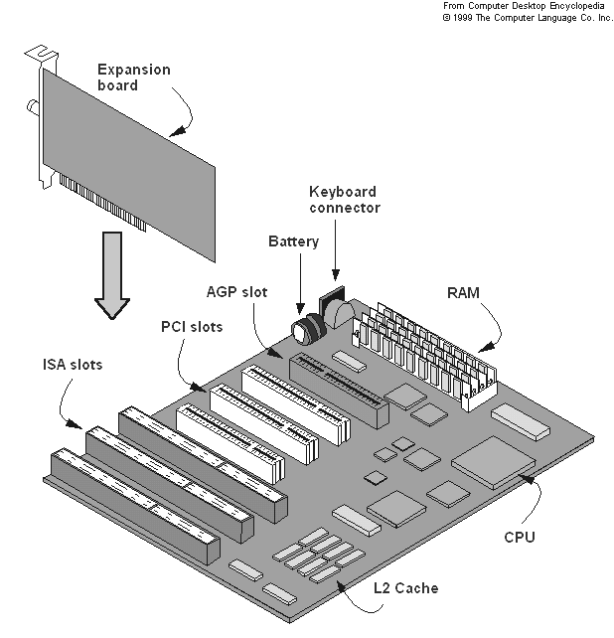
PROCEDURE:
Write the AIM and DO NOW.
Get students working!
Take attendance.
Go Over HW
Collect HW#1
Go over the Do Now

Take a look at the diagram at right. What is the purpose of the six slots in the diagram? To help answer this question look up expansion board at www.techweb.com/encyclopedia .
What are some common expansion cards on PCs?

What is the purpose of these two ports on a modem?
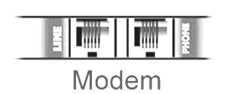

Sample Test Questions Based On What We Have Covered So Far:
- Which computer component contains all the circuitry necessary for all components or devices to communicate with each other?

- You want to plug a keyboard into the back of a computer. You need to plug the keyboard cable into a PS/2 port. Which style of port is the PS/2?
3) What is the maximum speed of USB 2.0 in Mbps?

4) What peripheral port type was originally developed by Apple and is currently primarily used for digital video transfers?

- What peripheral port type is expandable using a hub, operates at 480 Mbps, and is used to connect various devices (from printers to cameras) to PCs?
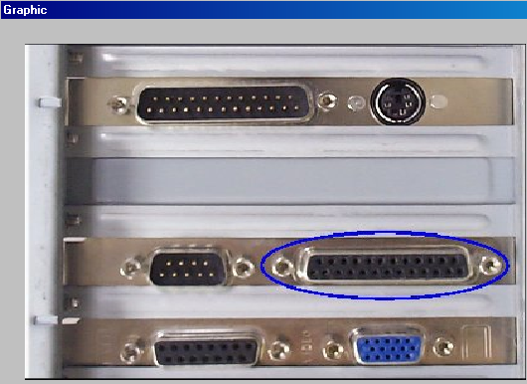

6) A 9-pin, male DB connector is likely to be a

7) What type of connector is “ovaled”in the graphic

8) In the graphic, what type of connector is boxed?

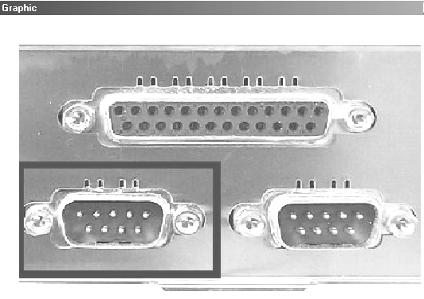

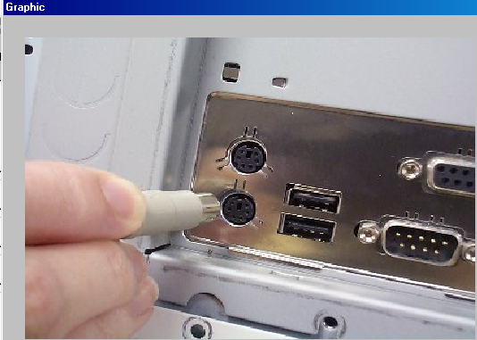
10) According to the associated graphic, what type of port is
this person about to plug into?

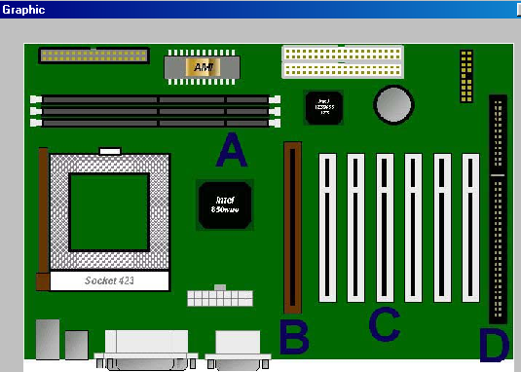

11) In the graphic, identify the AGP port?
E

12) In this graphic identify the PCI slot?

13) How many sticks of RAM can you have on the
pictured motherboard?

14) In this graphic, identify the hard drive controller.

15) What is the maximum cable length for USB devices?

16) How many pins are usually on a serial port connector?

17) How many devices does USB support?

18) What is the most important difference between standard USB and IEEE1394?

19) Which type of connector is used for a parallel connector on the end that connects to the printer?

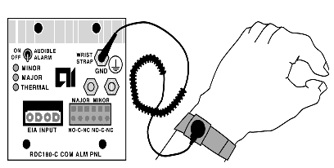
20) Which device would you plug into an AGP slot?

21) What is the purpose of the wrist strap shown in the picture at right?

22) The RS-232 interface on a computer is also known as what?

23) What is the total number of devices that can connect to a IEEE 1394 (FireWire) port?

24) IEEE 1394 is more commonly known as

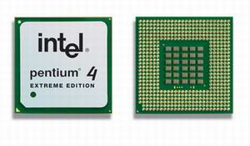
25) Analog dial-up modems commonly use which type of connector?

26) Describe the function of a hard drive inside a personal computer?

27) What device is shown at right?

28) What do the letters ESD stand for?

29) What device converts AC to DC, provides cooling, and provides DC power to peripheral devices and the motherboard?

30) What device allows a computer to send data over phone lines?

31) A serial mouse connects to a ______ port.
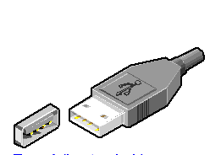

32) A PS/2 mouse normally connects to a

33) What is the connector at right called?

34) What connects to a three-row, 15 pin D-shell female connector?
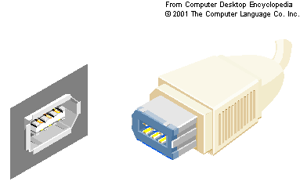
35) A microprocessor’s speed is rated in _____

36) What type of connector is shown at right?

37) A USB device can be located a maximum distance of
from the host.

38) You should not wear a wrist grounding strap when

39) If a computer appears to be running too hot, what device can help absorb excess heat generated by the microprocessor?

40) Serial ports transmit data bit(s) at a time

41) Parallel ports transmit data bit(s) at a time

42) A two-row 15-pin connector would probably be used as a

Assignment: Go to http://www.tigerdirect.com/applications/SearchTools/item-details.asp?EdpNo=3584477&Sku=A455-2812 and look at all the connectors on this motherboard.

