Change of Logarithm Base Spreadsheet Assignment
Math 1303

1. Problem statement:

Consider the change of base formula for using logarithms:

We seek a spreadsheet which will allow input of the b and the x for the left side of the calculation, then calculate and display the fraction of the right side of the equation and the decimal expression of the quotient.

2. Instructions:

Begin the worksheet using a solution template that includes a title, a description, the parameters of the worksheet, and the computations.

Cell Address Label
A1 Title:
C1 Change of Base of a Logarithm
G1 <your name>
A3 Description:
C3 This spreadsheet receives as input the base and a number for which the
C4 logarithm using that base is to be taken. Then it uses the change of
C5 base formula to do the calculations and displays the results.
A7 Parameters:
C7 Base = b
E7 Number = x
C8 10
E8 3.4
A11 Calculations
C11 log [base b] (x)
G11 Verification

Below is an example similar to what the spreadsheet will look like if you enter these labels correctly.
<your name>
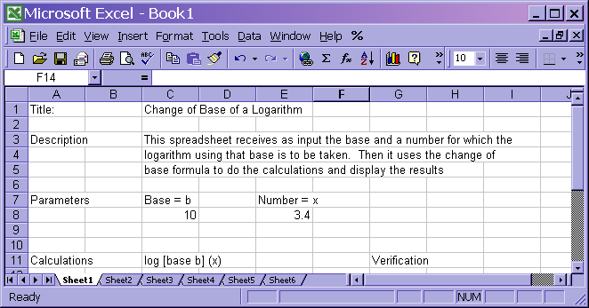

The calculations will use the following formulas:

The numerator of the fraction is given as log_{a}x, but we will simply use +log(x). In a similar manner for log_{a}b we will use +log(b). Note, that you will not use x or b in the above functions, rather you will use the cell address of the locations where you have stored those values. Use e8 and C8 respectively:

So: place the following formulas in the cells specified:
C12 =log(e8)/log(c8)
G12 =c8^c12

When these final formulas are entered, you should see a value in C12 which should be log_{b}x. The formula in G12 should give you the same value as in E8.

Save the spreadsheet as logbase.xls.

Print the spreadsheet with one of the specified problems from the next page.
Name _____________________________________ CPO __________________

MATH 1303 Spreadsheet Assignment

Staple this sheet (as a cover page) to your printout.

Record the logarithms determined by your spreadsheet for each of the given problems. Also record the value in the verification cell, G12.

Logarithm problem Result Verification
1. _______ _______
2. _______ _______
3. _______ _______

4. _______ _______

5. _______ _______

6. _______ _______

Elegance Points:

Use of if statement in cell c12 or cell validation for cells c8 and e8 to prevent negatives.

