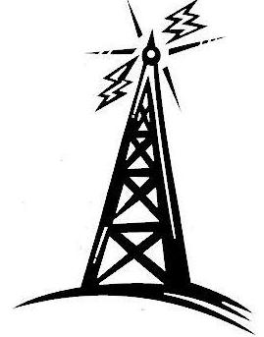  …CQ CQ CQ…  Calling all Amateur Radio Operators  If you are an FCC license Amateur Radio Operator, or you are interested in Amateur Radio (Ham Radio) the LeTourneau Amateur Radio Club is looking for members.  For more information, email Tommy Gober, N5DUX or drop a line to Chaplain Carl. | …CQ CQ CQ…  Calling all Amateur Radio Operators  If you are an FCC license Amateur Radio Operator, or you are interested in Amateur Radio (Ham Radio) the LeTourneau Amateur Radio Club is looking for members.  For more information, email Tommy Gober, N5DUX or drop a line to Chaplain Carl.
…CQ CQ CQ…  Calling all Amateur Radio Operators  If you are an FCC license Amateur Radio Operator, or you are interested in Amateur Radio (Ham Radio) the LeTourneau Amateur Radio Club is looking for members.  For more information, email Tommy Gober, N5DUX or drop a line to Chaplain Carl. | …CQ CQ CQ…  Calling all Amateur Radio Operators  If you are an FCC license Amateur Radio Operator, or you are interested in Amateur Radio (Ham Radio) the LeTourneau Amateur Radio Club is looking for members.  For more information, email Tommy Gober, N5DUX or drop a line to Chaplain Carl.

