COSC 2103 Programming Assignment #6 Due _______________
Parameter Panel
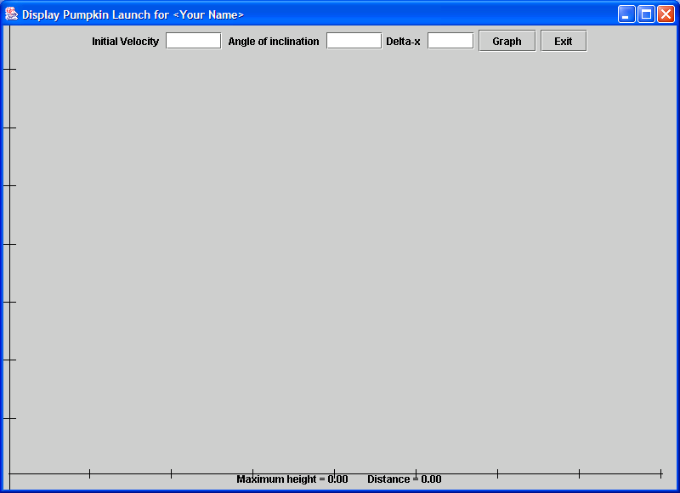
This program will use GUI elements and will display a the trajectory of a launched pumpkin at a pumpkin chunking contest.
Range for y,
-1 ≤ y ≤ 400
Range for x,
-1 ≤ x ≤ 400

At the top of the window will be a JPanel which contains the those the initial velocity, the angle of inclination of the launch, and the delta-x value for the gramp as parameters and the two buttons. This will be a sequence of JLabels and JTextFields for the parameters. The two JButtons will cause actions to take place, namely the graphing of the launch and the display of the results a the bottom of the window. This is another JPanel. The two JPanels are placed using
BorderLayout, NORTH and SOUTH.
Results Panel

You will use a class provided for you called OrderedPairs, provided on BlackBoard. This class provides utilities to set up the graphing window and draw the axes. Study the OrderedPairs class for the methods provided. Note that several of them are static functions – that is, we can call the method without using an instance of the object, just use the name of the class – in our case that is what we will do.

The program you write to do this will have some new features, since it creates a window and uses GUIs and is event driven. Recall that actually, this program is a class. In addition to having a function main, it will have a paint method, a constructor, and a method called ActionPerformed which has a parameter called actionEvent. It is within this method that the values in the JTextFields are evaluated with the Double.parseInt() method, labels in the results panel updated, and finally a call to the repaint() method. The paint() method will call the drawAxis method (specify all tic marks to be 50 units apart) and use the OrderedPairs.line() method to draw the triangle. (OrderedPairs objects are not needed since the line method is static). The method main() really only instantiates the class object of the program and specifies the exit mode. The constructor will instantiate the JLabel, the JTextField objects and register the event handlers.

Parametric equations are used for determining the position of the pumpkin as a function of time:

You would do well to view the different example programs found in the text which do many of these things. You can mimic much of what they do. A shell program is provided for you on BlackBoard along with the OrderedPairs class. You will submit a listing of your program and screen shots of each of the five different graphs specified to the right. When the function has graphed, press ALT-PrtScr to get a screen shot of only the window of your program. Then go to Word and paste the contents of the clip board into a Word document. Print the resulting page for submission.
Trial | Velocity | Angle | delta-x
1 | 100 | 37.5 | .5
2 | 135.7 | 72 | .1
3 | 150 | 45 | 1
4 | 150 | 47 | .5
5 | 200 | 85 | .3

A program satisfying all the above criteria will earn a score of 95. A higher score in the A range is achieved by earning elegance points. Elegance points will be given for increasing the capability of the program to use sliders to alter the parameters, with the text boxes and the results changing as the slider moves. Elegance points also given for placing numbers on the axes with the tic marks. If you add further parameter entry for maximum x value and maximum y value to be changed for the axes, this is also worth elegance.

Your program must be documented. At the beginning you will include comments which specify your name, your section, your CPO, the date due, and a description of the purpose of the program (note this description is in both the comments and in the output to the user). In strategic places throughout the program you should include comments which describe sections of the program. Another part of your documentation is well chosen identifiers. For example use interest_rate instead of rt.

When a program has column totals, make sure that the totals printed are indeed the totals of the numbers in the column above it. Remember that programs are due at the beginning of the class on the specified due date. Late work will be accepted with a reduction of 10 points per day (or portion thereof). String (character array) output should be left justified, numeric output right justified with decimal points aligned for tabular reports. Make sure that all work is obviously, uniquely yours. Severe grade reductions will be made for all programs which are too closely alike one another.

