COSC 2103 Programming Assignment #4 Due _______________

This program will implement a class for manipulating Binary numbers stored as an array of 0’s and 1’s. The outline of the class is saved on Blackboard as Binary.txt , which you will download, rename with .java and fill in the bodies of the methods. To test your class, you will run the program shown below which claims to test all the specified methods. This program is also available on Blackboard as Program4.java.

import hsa.*;
Change only the first line of this program so that your name is printed when the program runs.

Make no other changes in this test program.
public class Program4
{
public static void main (String [] args)
{
Stdout.println ("This program run for <your name>");
Binary b1 = new Binary (28);
Binary b2 = new Binary (7);
Stdout.println ("b1 = "+b1.toString ());
Stdout.println ("b2 = "+b2.toString ());
Stdout.println ("b2 as a decimal = "+b2.binToDecimal ());
Binary b3 = b1.add (b2);
Stdout.println ("b3 = " + b3);
Stdout.println ("b3 in decimal = " + b3.binToDecimal ());
Stdout.println ("b1 * b2 = " + b1.multiply (b2));
Stdout.println ("b1 * b2 = " + new Binary (b1.binToDecimal () * b2.binToDecimal ()));
Stdout.println ("b1 * b2 decimal = " + b1.multiply (b2).binToDecimal ());
Binary b4 = new Binary (b1.multiply (b2));
Stdout.println ("b1 + b2 = " + b1.add (b2));
Stdout.println ("b1 || b2 = " + b1.or (b2));
if (compareTo (b1.add (b2), b1.or(b2)) > 0)
Stdout.println ("b1 + b2 is larger");
else
Stdout.println ("b1 || b2 is larger");
Stdout.println ("b4 = " + b4);
Stdout.print ("b4 = ");
for (int i = 0 ; i < 10 ; i++)
Stdout.print (b4.getDigit (i));
Stdout.println (" ");
Stdout.println ("b1 as octal = " + b1.convertToOctal ());
Binary b5 = new Binary ("0101010101");
Binary b6 = new Binary ("1111100000");
Stdout.println ("b6 = " + b6);
Stdout.println ("b5 && b6 = " + b5.and (b6));
Binary b7 = new Binary ("100210101010101"); // intentionally invald String
Stdout.println ("b7 = " + b7);
b1 = new Binary ("0011"); // intentionally short string
Stdout.println ("b1 = " + b1);
b1.setDigit (9, 1);
b1.setDigit (12, 1); // intentionally invalid digit
b1.setDigit (3, 2); // intentionally invalid value
Stdout.println ("Now b1 = " + b1);
}

public static int compareTo (Binary left, Binary right)
{
int returnValue = 0;
if (left.binToDecimal () < right.binToDecimal ())
returnValue = -1;
else if (left.binToDecimal () > right.binToDecimal ())
returnValue = 1;
return returnValue;
}
}

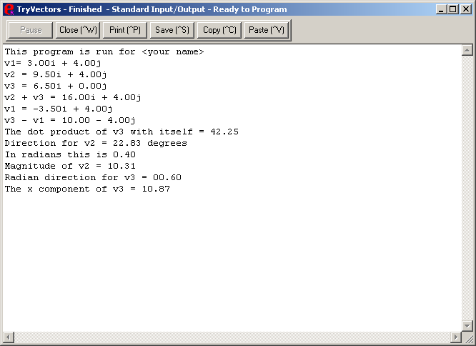
All the output goes to the Stdout stream. When the program is complete, the window has a print option which you should use to print out the results for submission.

Other IDE’s will provide different ways of printing the output for submission.

A program satisfying all the above criteria will earn a score of 95. A higher score in the A range is achieved by earning elegance points. Elegance points will be given for creating a Hexadecimal class which contains the same basic methods and is demonstrated with a similar program which exercises all the methods..

Your program must be documented. At the beginning you will include comments which specify your name, your section, your CPO, the date due, and a description of the purpose of the program (note this description is in both the comments and in the output to the user). In strategic places throughout the program you should include comments which describe sections of the program. Another part of your documentation is well chosen identifiers. For example use interest_rate instead of rt.

When a program has column totals, make sure that the totals printed are indeed the totals of the numbers in the column above it. Remember that programs are due at the beginning of the class on the specified due date. Late work will be accepted with a reduction of 10 points per day (or portion thereof). String (character array) output should be left justified, numeric output right justified with decimal points aligned for tabular reports. Make sure that all work is obviously, uniquely yours. Severe grade reductions will be made for all programs which are too closely alike one another.

